Some easier, some trickier, all missing angles – have a go
Q1.
Angle k
Look at the diagram.
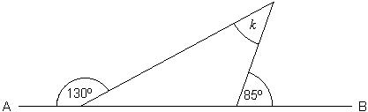
Not drawn accurately
AB is a straight line.
Work out the size of angle k

k = ...................... °
2 marks

Q2.
Three straight lines
The diagram shows three straight lines.
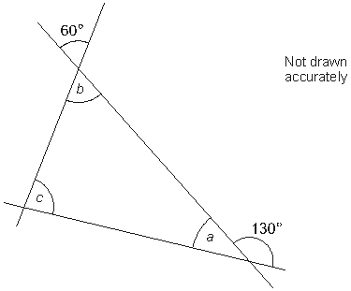
Work out the sizes of angles a, b and c
Give reasons for your answers.
a = ................° because ..........................................................................................
..........................................................................................
..........................................................................................
1 mark
b = ................° because ..........................................................................................
..........................................................................................
..........................................................................................
1 mark
c = ................° because ..........................................................................................
..........................................................................................
..........................................................................................
1 mark

Q3.
Angle p
This shape has been made from two congruent isosceles triangles.
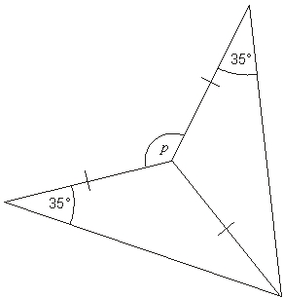
Not drawn accurately
What is the size of angle p?

p = .........................°
2 marks

Q4.
Four angles
Look at the diagram, made from four straight lines.
The lines marked with arrows are parallel.
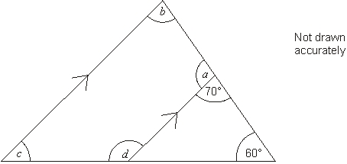
Work out the sizes of the angles marked with letters.

a = .........................° b = .........................°
c = .........................° d = .........................°
3 marks

Q5.
Rhombus
The diagram shows a rhombus.
The midpoints of two of its sides are joined with a straight line.
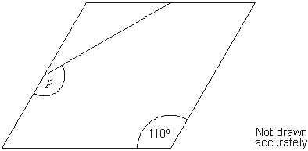
What is the size of angle p?

p = .............................°
2 marks

Q6.
Parallelogram
ABCD is a parallelogram.
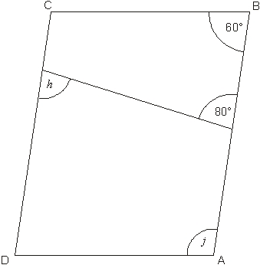
Not drawn accurately
Work out the sizes of angles h and j
Give reasons for your answers.
h = ...............................° because ...........................................................................
...........................................................................
...........................................................................
...........................................................................
1 mark
j = ...............................° because ...........................................................................
...........................................................................
...........................................................................
...........................................................................
1 mark

Q7.
Four kites
This shape is made of four congruent kites meeting at a point.
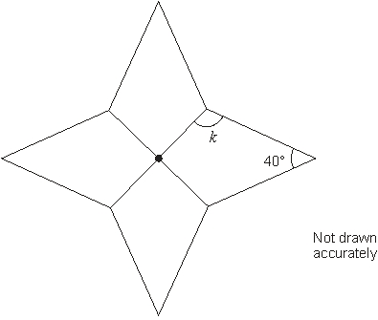
Calculate the size of angle k

k = .........................°
2 marks

Q8.
Angles
The diagram shows triangle PQR.
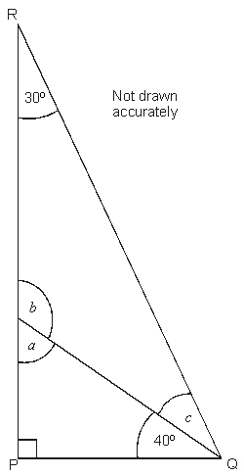
Work out the sizes of angles a, b and c

a = ………………° b = ………………° c = ………………°
3 marks

Q9.
Triangles
(a) A triangle has three equal sides.
Write the sizes of the angles in this triangle.
................°, ................°, ................°
1 mark
(b) A right-angled triangle has two equal sides.
Write the sizes of the angles in this triangle.
................°, ................°, ................°
1 mark
Q10.
Triangle
Look at the triangle.
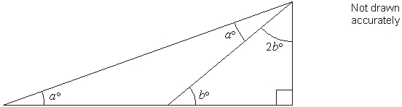
Work out the value of a

a = .........................
3 marks
Q11.
Three angles
Three shapes ﬁt together at point B.
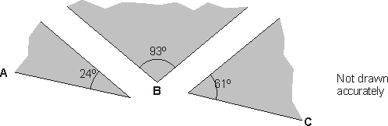
Will ABC make a straight line?
Yes No
Explain your answer.

1 mark

Q12.
Rectangle rest
The diagram shows a rectangle that just touches an equilateral triangle.
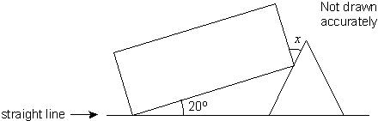
(a) Find the size of the angle marked x
Show your working.

.............................°
2 marks
(b) Now the rectangle just touches the
equilateral triangle so that
ABC is a straight line.
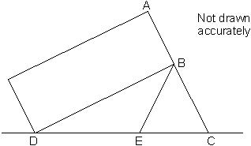
Show that triangle BDE is isosceles.

2 marks

Q13.
Star
The shape below has 3 identical white tiles and 3 identical grey tiles.
The sides of each tile are all the same length.
Opposite sides of each tile are parallel.
One of the angles is 70°
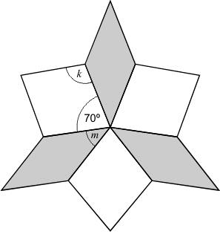NOT TO SCALE
(a) Calculate the size of angle k.

angle k = ...............................°
1 mark
(b) Calculate the size of angle m.
Show your working.

angle m = ...............................°
2 marks
Q14.
Clock

(a) The time on this clock is 3 o'clock.  What is the size of the angle between the hands?  ..........................° | 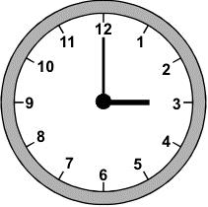
1 mark
(b) Use a whole number to complete this sentence:
At .......................... o'clock the size of the angle between the hands is 180°
1 mark
(c) What is the size of the angle between the hands at 1 o'clock?
..........................°
1 mark
(d) What is the size of the angle between the hands at 5 o'clock?
..........................°
1 mark
(e) How long does it take for the minute hand to move 360°?
1 mark

Q15.
Cutting a cake
Ben is 10 years old.
Cindy is 15 years old.
Tom is 20 years old.
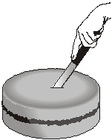
They are going to cut a cake into 3 slices from the centre.
The size of the slices will be proportional to their ages.
What will the angle at the centre of Ben’s slice be?

..................°
2 marks

Q16.
(a) Work out the size of the angle marked x

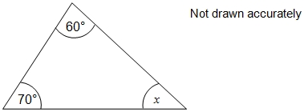
______________________________________________________________
______________________________________________________________
______________________________________________________________
Answer _____________________________ degrees
2 marks
(b) Work out the size of the angle marked y

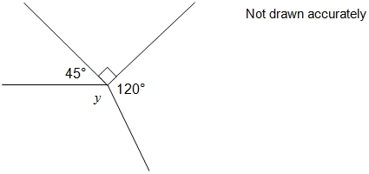
______________________________________________________________
______________________________________________________________
______________________________________________________________
Answer _____________________________ degrees
2 marks

Q17.
(a)
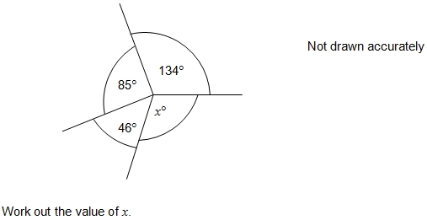
_____________________________________________________________
_____________________________________________________________
_____________________________________________________________
Answer _____________________________
2 marks
(b) Which of the following describes angle x ?
Circle your answer.
1 mark

Q18.
Two of the angles in a triangle are 70° and 40°
Jack says,
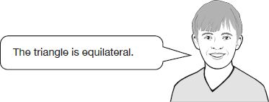
Explain why Jack is not correct.
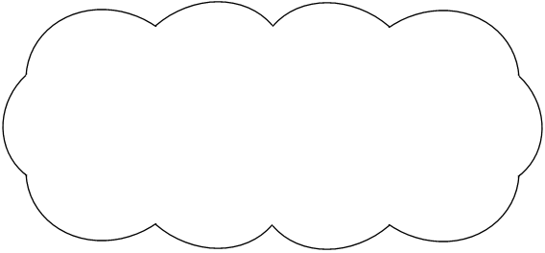
1 mark

Q19.

Layla completes one-and-a-half somersaults in a dive.
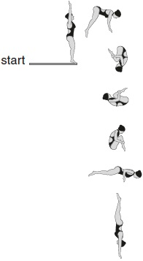
How many degrees does Layla turn through in her dive?
1 mark

Q20.

Calculate the size of angles a and b in this diagram.
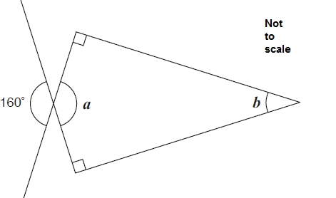
1 mark
1 mark

Mark schemes
Q1.
35
2
or Shows the values 50 and 95 or the value 145
or
Shows a complete correct method with not more than one computational error
eg
• 180 – 130 = 50,
180 – 85 = 105 (error),
180 – 50 – 105 = 25
• (130 + 85) – 180
1
[2]
Q2.
Gives a = 50 and gives a correct reason
eg
• Angle a is on a straight line with 130, so a = 180 – 130
• a is supplementary with 130, so a + 130 = 180
• The angle vertically opposite 130 is 130, 360 – (130 + 130) = 100,
(angles at a point) a is = 50 (also vertically opposite)
Accept: minimally acceptable reason
eg
• On a straight line
• Supplementary
• Opposite angles and angles at a point
Do not accept: informal reason without the correct
geometrical property identified
eg
• 180 – 130
• 360 – 260
2
Do not accept: incomplete reason
eg
• It is adjacent to the 130° angle
U1
Gives b = 60 and gives a correct reason
eg
• Angle b is vertically opposite the 60° angle, so it is also 60°
• The angle on a straight line with b is 120, so b is 360 – 120 – 120 – 60
(angles at a point)
Accept: minimally acceptable reason
eg
• Opposite
• Angles on a straight line and angles at a point
Do not accept: informal reason without the correct geometrical property identified
eg
• b is equal to the 60° angle next to it
Do not accept: incomplete reason
eg
• It is the same as the 60° angle
U1
Gives c = 70 and gives a correct reason
eg
• There are 180° in a triangle, so c = 180 – 50 – 60
• The exterior angle of a triangle is equal to the sum of the two opposite
interior angles, so c = 130 – 60
Accept: minimally acceptable reason
eg
• Angles in a triangle
• Exterior angle = sum of two opposite interior angles
• We’ve already got 50 and 60 in the triangle
! Follow through
Accept as 180 – (their a + b), alongside a correct reason referring to angles in a triangle, or as 130 – their b alongside a correct reason referring to an exterior angle of a triangle
Do not accept: informal reason without the correct geometrical property identified
eg
• 180 – (a + b)
• 130 – b
Do not accept: incomplete reason
eg
• It is in a triangle
• All the inside angles add up to 180°
U1
[3]
Q3.
140
2
or Shows the value 110 or 220
or
Shows or implies a complete correct method with not more than one
computational error
eg
• 360 – 2 × (180 – 35 × 2)
• 360 – (360 – 4 × 35)
• 70 × 2
•
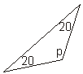
• 35 + 35 = 80 (error), 180 – 80 = 100
360 – 100 × 2 = 160
1
[2]
Q4.
Gives all four correct angles,
ie
a = 110 b = 70
c = 50 d = 130
3
or Gives any three correct angles
or
Gives all four values 110, 70, 50 and 130, but in the incorrect order
2
or Gives any two correct angles
or
Shows three of the angles 110, 70, 50 and 130, but with the links
to each letter incorrect or omitted
or
Gives four different angles (ie no two of the angles are equal)
that sum to 360
Accept angles indicated on the diagram
1
(U1)
[3]
Q5.
145
2
or Shows the value 35
or
Shows a complete correct method with not more than one computational error
eg
• 180 – 110 = 70,
180 – 70 ÷ 2
• (540 – 110 – 70 – 70) ÷ 2
• 180 – 110 = 70
70 ÷ 2 = 25 (error)
180 – 25 = 155
1
[2]
Q6.
Gives h = 80 and gives a correct reason
eg
• h is an alternate angle with the 80º angle marked
• The angle on the straight line with h is supplementary with
80 so 180 – 80 = 100, then h = 180 – 100
• For the bottom trapezium, h + 60 + 120 + 100 = 360,
so h = 360 – 280
Accept minimally acceptable reason
eg
• Alternate
• Supplementary to 80, on a straight line
• Quadrilateral 360 – 280
Do not accept informal justification without correct
geometrical property identified
eg
• It’s the same as the 80 because of
the parallel lines
• 180 – 100
• 360 – 280
Do not accept incomplete reason
eg
• It is the same as the 80º angle marked
• Angles in a quadrilateral add up to 360º
• It’s opposite the 80º on the other side
U1
Gives j = 120 and gives a correct reason
eg
• The angle on a straight line with j is 60 because it is an alternate
(or corresponding) angle with the 60 marked, so j = 180 – 60
• It’s a supplementary angle with angle B so it’s 180 – 60
• For the bottom trapezium, j + 100 + 80 + 60 = 360,
so j = 360 – 240
• In the parallelogram, angles A and C are equal, so j = (360 – 60 – 60) ÷ 2
• Angle C is supplementary with the 60º marked so is 180 – 60 = 120
j is the opposite angle in the parallelogram to angle C
Accept minimally acceptable reason
eg
• Alternate (or corresponding), on a straight line
• Supplementary to 60
• Quadrilateral 360 – 240
• Parallelogram 240 ÷ 2
• Parallelogram 180 – B
! For angle j, follow through
Accept as 200 – their h, alongside a correct reason referring to the quadrilateral containing both angles
Do not accept informal justification without correct
geometrical property identified
eg
• 180 – 60
• 360 – 240
• 240 ÷ 2
• 180 – B
Do not accept incomplete reason
eg
• It is the same as angle C which is 120º
• Angles in a quadrilateral add up to 360º
• j and 60 are angles on a straight line so
add up to 180º
U1
[2]
Q7.
115
2
or Shows the value 230 or 130
or
Shows the value 90, provided there is no evidence
that this value has been assigned to angle k
or
Shows or implies a complete correct method with
not more than one computational error eg
• 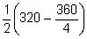
• 180 – 45 – 20
• 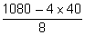
or
Forms a correct equation involving k, even
if the 90° angle has not been found
• 2k = 360 – 40 – x
• (k =) 160 – x
1
[2]
Q8.
Shows angle a as 50
1
Shows angle b as 130
! For the second mark, follow through
Accept follow through as 180 – their a, provided their a < 90 and is not 54 to 56 inclusive
1
Shows angle c as 20
! For the third mark, follow through
Accept follow through as 150 – their b
or their a – 30, provided this gives
a positive value
1
[3]
Q9.
(a) Gives the values 60, 60 and 60
Accept: single answer of 60 given
1
(b) Gives the values 90, 45 and 45, in any order
1
[2]
Q10.
15, with no evidence of an incorrect method
Do not accept incorrect method
eg
• 180 – 90 = 90
90 ÷ 2 = 45
45 ÷ 3 = 15
3
or Shows or implies at least two correct
deductions about a and b
eg
• 2a + (180 – b) = 180, 3b + 90 = 180
• 2a = b, b = 30
• b + 2b + 90 = 180, 2a + 2b + 90 = 180
• b = 30, a + b = 45
• 2a = 180 – (180 – b), a + a + 2b = 90
• 2a = b, a + b = 45
• (a =) 30 ÷ 2
Note to markers:
From the three triangles, the following
simplified deductions may be made about
a and b
1. 2a = b
2. b = 30
3. a + b = 45
or
Shows or implies a complete correct method
with not more than one computational error
eg
• 3 × b + 90 = 180, b = 25 (error)
180 – 25 = 155, 180 – 155 = 2 × a,
so a = 25 ÷ 2
= 12.5
2
or Shows or implies at least one correct deduction
about b or about a and b
eg
• b = 2 × a
• b = 30
• (180 – 90) ÷ 3 = 30
• 2b + 2a = 180 – 90
Accept b = 2a implied by values shown
eg
• a as 22.5° and b as 45°
1
(U1)
[3]
Q11.
Indicates No and gives a correct explanation
eg
• 24 + 93 + 61 = 178 but it should equal 180 for a straight line
• 24 + 93 + 61 is 2 degrees too small for a straight line
• 4 + 3 + 1 = 8, so they couldn’t add to 180
Accept: minimally acceptable explanation that states or implies the angles should add to 180 or that they add to less than 180
eg
• The angles don’t make 180
• They should add to 180
• Too small by 2
• The total ends in 8, but this should be 0
• It totals 178°, so it would be an obtuse angle
Do not accept: incomplete or incorrect explanation
eg
• 24 + 93 + 61 = 178 which is not straight
• The angles add to 188 not 180
• The angles add to 178° so it will look straight
U1
[1]
Q12.
(a) 50
2
or
Calculates, or shows on the diagram, that the other acute angle in the
white triangle is 40
eg
•
• 180 – 60 = 120,
120 + 20 = 140,
180 – 140 = 40
Do not accept 40 seen without being located on the diagram or without supporting working
or
Shows a complete correct method with not more than one computational error
eg
• 180 – (20 + 120) = 50 (error),
90 – 50 = 40
• 20 + 90 = 110,
110 – 60
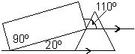
• 180 ÷ 3 = 60,
60 – 20 = 50 (error)
180 – 90 – 50 = 40
1
(b) Gives a correct justification
eg
• DBE is 120 (180 – 60),
EBD is 30 (180 – 90 – 60),
so BDE is 30 (180 – 120 – 30)
As BDE = EBD then triangle BDE is isosceles
2
or
Shows working to justify that DBE is 30
eg
• 180 – (90 + 60) = 30
Accept minimally acceptable justification
eg
• Angle at B = 180 – 90 – 60 = 30, so the angles in the triangle are 120, 30, 30
Do not accept for 2 or 1, angle of 30 not justified, or justified only by assuming the triangle is isosceles
eg
• The angles in triangle BDE are 30, 30 and 120
180 – 60 = 120, 180 – 120 = 60,
60 ÷ 2 = 30
1
[4]
Q13.
(a) Indicates 110
1
(b) For 2m indicates 50
For only 1m shows a complete, correct method, eg:
• 360 – 3 × 70 = 150, 150 ÷ 3
• 70 + m = 120
• 120 – 70
• 70 + 70 + 70 + m + m + m = 360
• 3 × 70 = 210, 150 + 210 = 360, 150 ÷ 3 = 60
• 360 – 70 – 70 – 70 = 160, ÷ 3
1
[3]
Q14.
(a) Indicates the correct angle, eg:
• 90
• A right angle.
• Right.
Accept the reflex angle eg:
• ‘270°’
• Three right angles.’
Accept angles in the range 87 to 93 inclusive.
1
(b) Indicates 6
Accept any indication of the correct time, eg:
• ‘18’
• ‘Eighteen hundred’
1
(c) Indicates the correct angle, eg:
• 30
Accept the reflex angle eg:
• ‘330°’
Angles in the range 27° to 33° inclusive.
1
(d) Indicates an angle in the range 147° to 153° inclusive, eg:
• 150
Accept the reflex angle eg:
• ‘210°’
Allow follow through from the previous part, provided this was not 0 and the answer to this part is a number between 0 and 360 inclusive. ie accept five times the previous response (minus a multiple of 360, where this is greater than 360).
or
Accept 360 minus five times the previous response (where this is less than 360).
1
(e) Indicates 1hour or 60 minutes, eg:
• Hour.
• 60min
Correct units must be given.
1
[5]
Q15.
80
2
or Shows a correct angle corresponding to a number of years other than 45
eg
• 8° is one year
• 40° is five years
• 15 years = 120°
• Tom 160
or
Shows or implies a complete correct method with not more than one
computational or rounding error
eg
• 10 : 15 : 20 80 : 120 : 160
• × 360
• 360 ÷ 9 × 2
• 0.22(…) × 360
• Answer of 79 or a value between 79 and 80
Do not accept for 1m, angle given without corresponding number of years
1
[2]
Q16.
(a) 180 − 70 − 60
M1
50
A1
(b) 360 − 45 − 90 − 120
M1
105
A1
Q17.
(a) 360 − 134 − 85 − 46
360 − 265
M1
95
A1
(b) Obtuse indicated
Correct or ft answer from a
A1ft
Q18.
An explanation showing an understanding:
• that this specific triangle has angles 70, 70 and 40
OR
• of the properties of an equilateral triangle − all angles are equal (60°)
and therefore that this triangle cannot be equilateral, e.g.
• The angles aren’t 60°
• There is not a 60° angle
• It has two different angles (70° and 40°) so it can’t be equilateral
• The angles aren’t the same
• An equilateral triangle has 60° + 60° + 60°
• All the angles are the same in an equilateral triangle
• It’s an isosceles triangle.
(In the context of this question, the term isosceles triangle is treated as not including equilateral triangles as a special type, as the national curriculum does not specify this at key stage 2.)
Do not accept vague or incomplete explanations, e.g.
• The other angle is 70°
• They aren’t (all) the same. (No reference to angles)
• An equilateral triangle has equal angles. (Does not say all.)
Do not accept explanations which include incorrect mathematics or incorrect information that is relevant to the explanation, e.g.
• 40 + 70 = 110 + 70 = 180
[1]
Q19.

540
[1]
Q20.

(a) 160
1
(b) 20
If the answers to a and b are incorrect, award ONE mark if
a + b = 180° unless b is between 33° and 37° inclusive, or 90°.
1
[2]

