The wonderful world around us!

This week you are going to take a deeper look into the natural world around us. From stunning wildlife and fascinating mini beasts, to natures own plants and trees. You are going to study their purpose and research jobs within the forest industry as well as exploring the way they make us feel through creative writing and poetry. You will have 3 days to complete the activities so feel free to select more than one activity to complete!

Have a read of the poem below. What images does it provoke you to have? How does it make you feel?

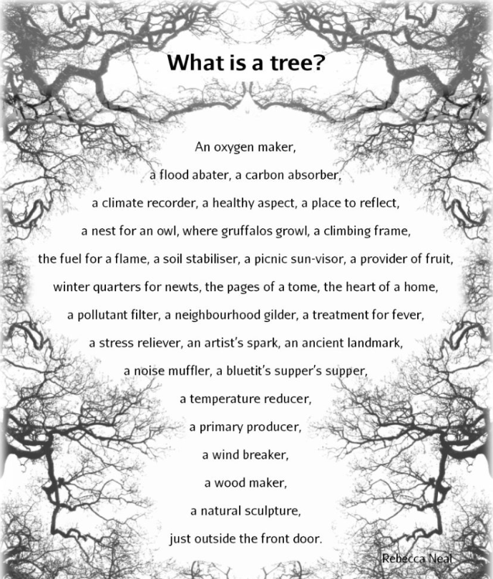

Nature poem
Go on a nature walk and get some inspiration to compose your own poem. It could be about a forest animal, a beautiful leaf you come across or a huge oak tree stood alone in a field. You could write a poem inspired by ‘What is a tree’ above, or an acrostic poem (where each line starts with the letter of an object), e.g.
Darting through the woodland
Ears twitch at every sound
Eyes like brown conkers
Running like the wind

Remember some poetic devices we have learned at school:
Onomatopoeia – where the word suggests the sound that it describes, e.g., whoosh, crack, whisper, snap.
Alliteration – using the same letters or sounds repeatedly in one line, e.g., ‘The sycamore sways in the sweet sunshine’.

Magic wand story
When out walking can you find a short stick to be your imaginary wand?! You could magically turn ordinary finds into something fantastical! For example, a piece of a pine cone becomes a single scale from the tail of a baby dragon, or an acorn cup the soup bowl belonging to a forest fairy. Can you write a short fantasy story based on this?
Story starter example:
It was an ordinary Sunday, one hot summer’s day, when my mum suggested we take a walk to our local forest. The sky was a brilliant bright blue and the air smelt like sweet honeysuckle. All of a sudden, as we were heading towards a small footpath, I caught sight of a strange looking tree. Unlike a normal tree, its bark was golden and looked as smooth as silk. The large leaves that hung from the thick, bronze branches glittered in the sunshine like diamonds! As I looked closer, I noticed a lone stick at the bottom of the tree that appeared to be glowing! Nervously, I picked up the stick and slipped it into my pocket….
Mini-beast Diary!
Do some research on a mini beast – it could be a ladybird, a worm, a snail, spider, an ant - the choice is yours. What does your mini beast eat? Where do you they live? What are their predators? You may want to go on a hunt to find one and study it for a while! Have a go at writing a day in the life as that mini-beast, writing from the mini-beast’s perspective.

What information can you find out about jobs in the forestry industry?
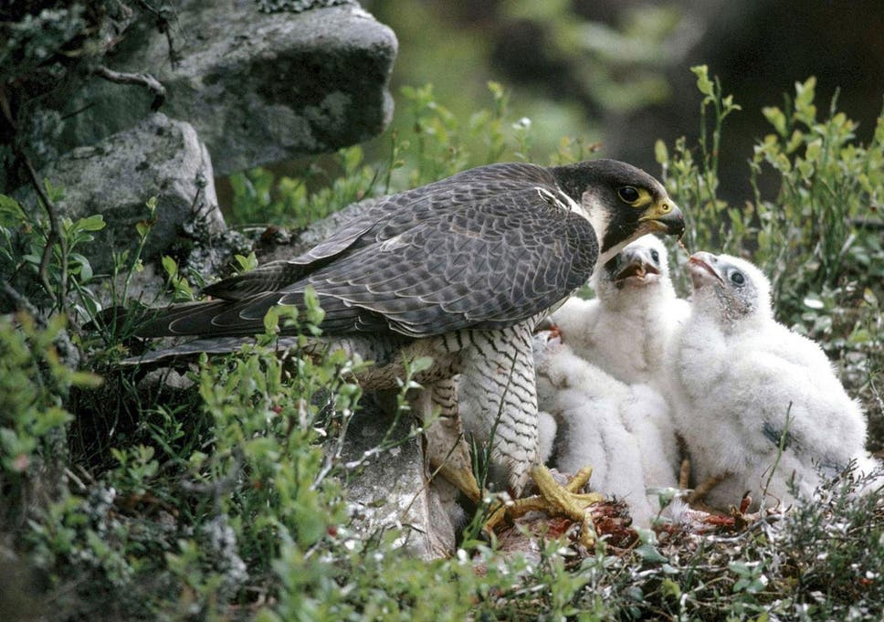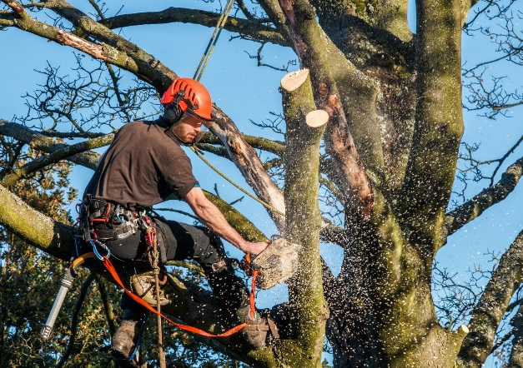
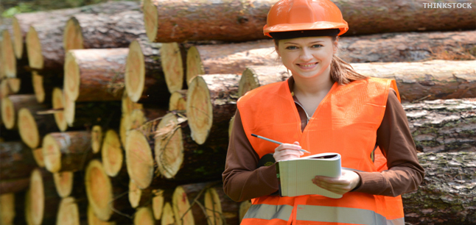
Search for roles including tree surgeon, forest ranger, wildlife ranger, horse logger, timber haulage driver and green woodworker. Which aspect of multi-purpose forestry – people, timber or wildlife – would you most like to work in and why?

‘Wood’ you believe it?
There are 30 things mentioned in this excerpt that come from trees. Can you find them?
I wake up as the sun peeps through the curtains at the window frame.
It’s going to be another hot day! I jump out of my wooden bed, on to the floorboards, nearly falling over a pile of books on the floor and head to the bathroom.
I have a wash using the palm oil soap and find a new loo roll, taking the old cardboard tube away for recycling.
When I’m dressed I head down for breakfast, sliding down the wooden bannisters as usual! “Hi Dad!” I call, and he puts down his newspaper and coffee and gets me a cup of tea.
“You’re noisy this morning” says Dad, reaching for the aspirins.
I look in the new oak kitchen cupboards but don’t fancy the brazil nut muesli for breakfast, so I make some toast and spread it with olive oil margarine and marmalade.
I check the inside of my lunch box. Mum has made me a hazelnut and chocolate spread sandwich and there are some dried apricots and a coconut chocolate bar too.
She’s forgotten the fresh fruit, so I grab a banana from the wooden fruit bowl. There’s a carton of apple juice for my drink. Time to go!
I check my schoolbag and I’ve got my pencils, eraser, exercise books and reading book. (I’ve got some chewing gum that my friend gave me too).
I say goodbye and then run next door to get a lift with my friend’s mum and we wait under the sycamore tree while she gets the car out, enjoying the shade.
I’d better use some of Mum’s shea butter sun cream so I don’t get burnt today. See you later!

If you would like the answer – pop me an email
What things do you see or use during the day that come from trees?

Have fun exploring and researching Year 3!

