**Art**

Could you create a ‘word art’ picture like the one below? You could list all the words that come to mind when you think of your time in lockdown; Fun, challenging, zoom, house party, quizzes, rainbows etc… and create a word picture to remember this special time in history. <https://wordart.com/>

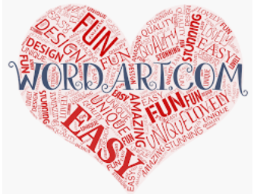

**Reading**

Take time to read a book. End each day with 10-15 minutes of reading. Could you talk to someone else in the house about what you have read? Could you predict what could happen next?

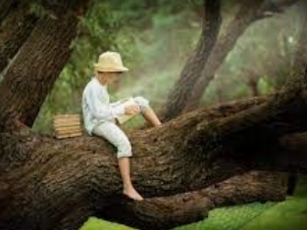

**Music:**

Could you create a personal theme tune that represents your personality?

Think of James Bond and his theme tune or Mr Bean.

If you were in a film, what theme tune would introduce you?

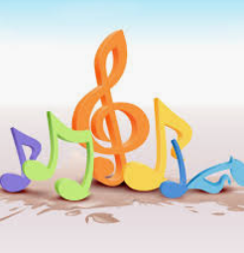

**Practical life skills:**

Could you learn a new ‘life skill?’

Use the washing machine? Make a cup of tea? Hoover your bedroom? Put the washing on the line? Wash the car? Load the dishwasher?

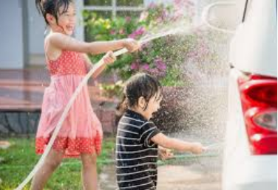

**Yoga**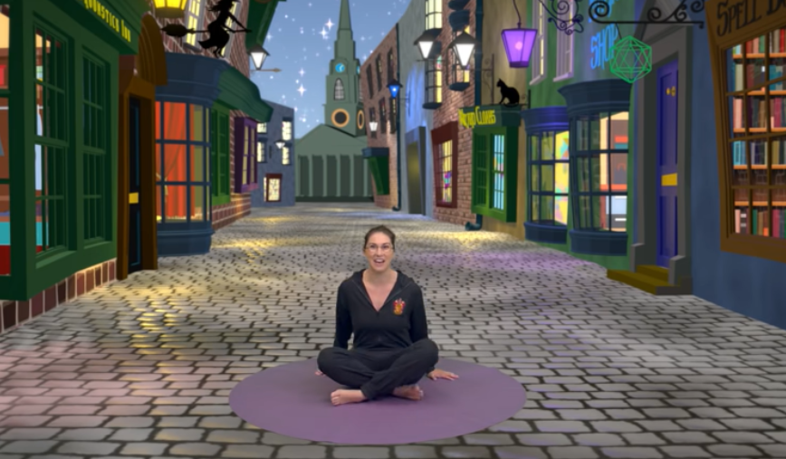

Harry Potter and The Philosopher's Stone | A Cosmic Kids Yoga Adventure!

<https://www.youtube.com/watch?v=R-BS87NTV5I>

**Photography**

Could you take a series of photos that represent your time in lockdown? You could use different effects and filters to enhance your pictures.

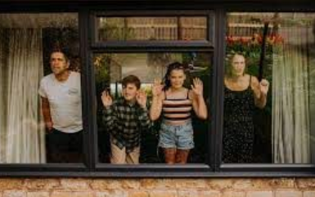

**DT**

**Lego Instruction Activity:**

How good are your building skills? Could you create something (small) in lego and then write the instructions as to how to build it. Pass the dismantled sculpture to a friend/family member and see if they can follow your instructions to make your sculpture.

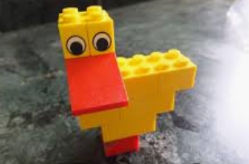

**Mrs B’s afternoon activities.**