**Home learning wb 5th July**

For Maths this week we are going to be looking at fractions. Start by watching the video introducing fractions, specifically looking at what a half is.

Task 1 – See attached resource identifying a half

Task 2 – See attached resource identifying a half part 2

Task 3 – See below for reasoning and problem solving questions

Task 4 – See below for extension activities linked to finding half of a shape/amount

Task 5 – Divide a shape challenge – see separate resource

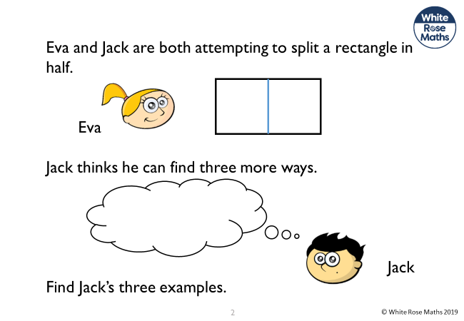**Task 3**

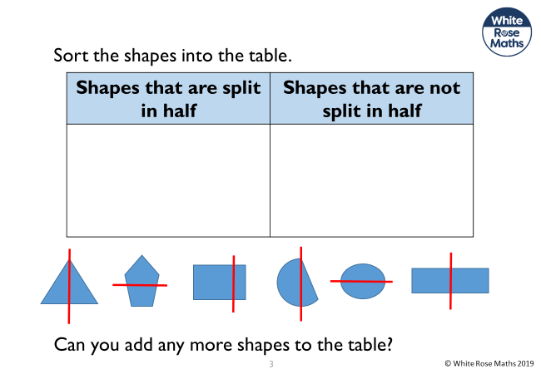

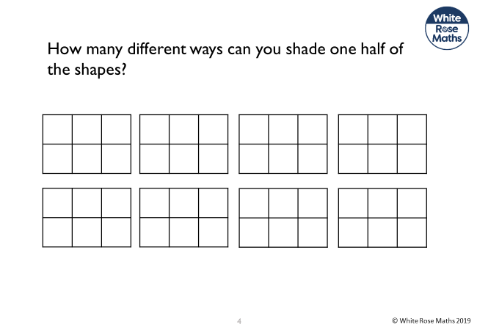

**Task 3 Answers**

1. **2.**

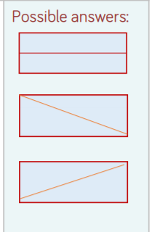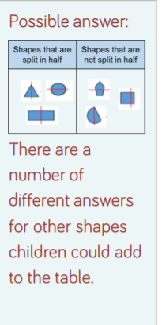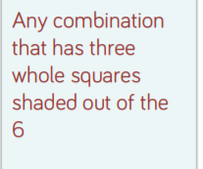

3.

**Task 4**

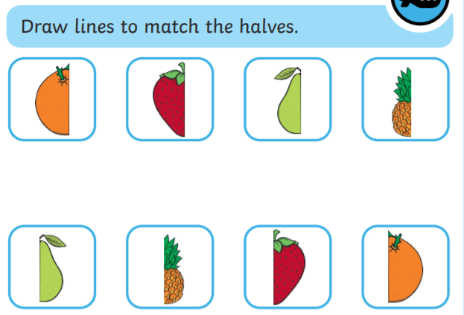

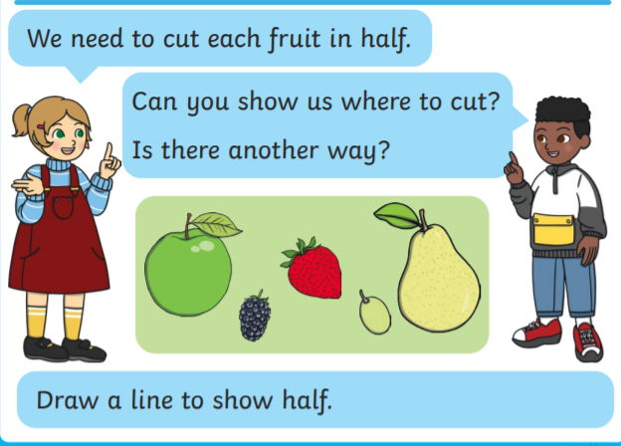

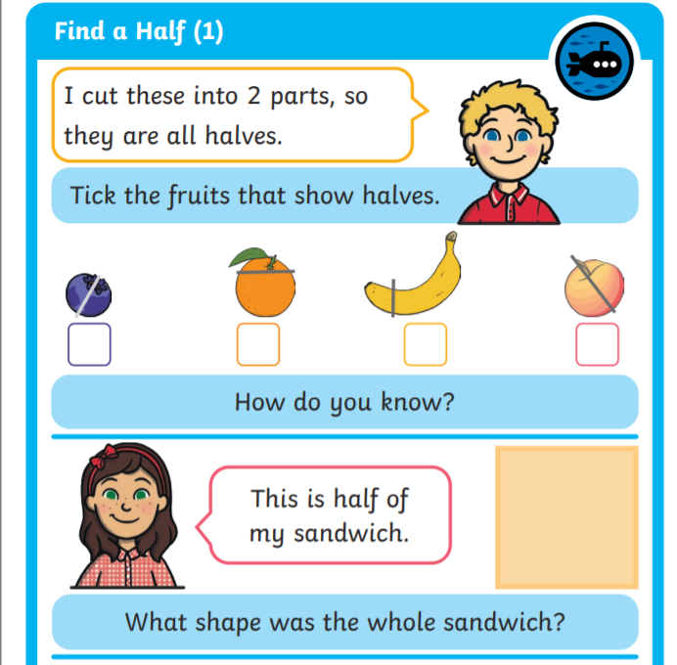

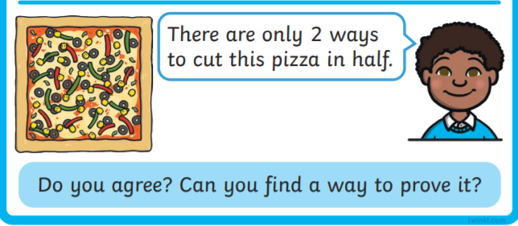

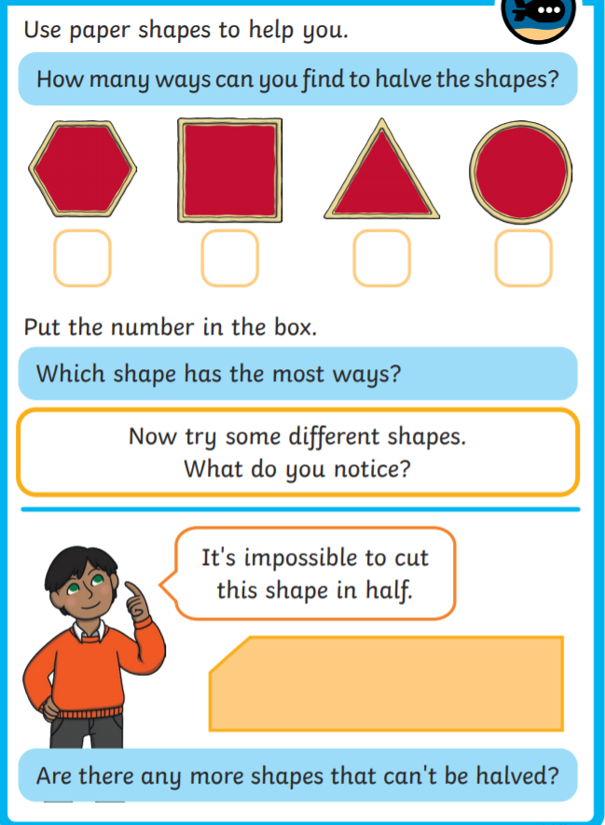

**Task 4 Answers**

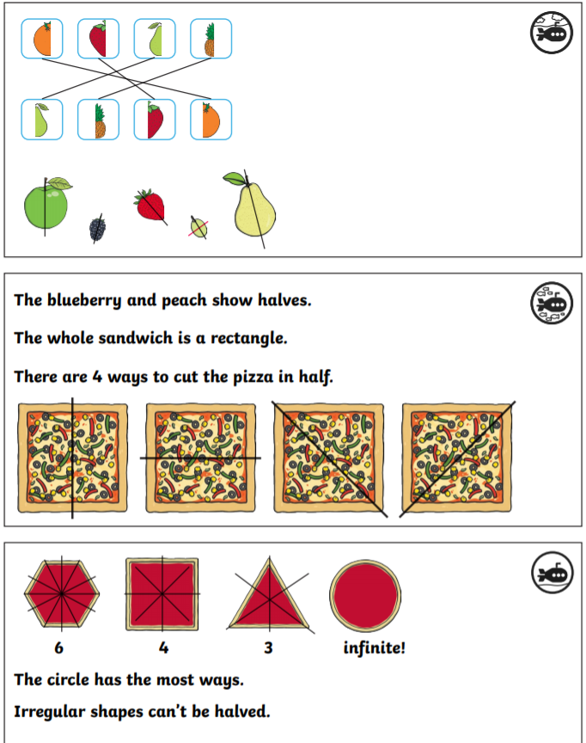

**English**

English this week will be looking at verbs. Watch the video where we will be discussing what a verb is and how to use them within your sentences.

Task 1 – Gingerbread man task. Can you find all the verbs after doing the different activities on the video?

Task 2 – What are the animals doing? Complete the sentences with the correct verb

Task 2 – Use the start of the story and continue it adding in verbs as you go ( see separate resource for the entire story)

Task 3 – Rewrite the story but using different animals and different verbs. E.g. Instead of gingerbread man it could be the carrot cake or something else. Be imaginative and see which verbs you can use in your writing.

Task 4 – Use this Pobble 365 image and create your own sentences – make sure you have a noun and a verb in there and you could include an adjective as well. Either write short sentences or you could write a story about the picture. Make sure to use verbs and be as adventurous as you can with them.

Task 1 – Text to highlight the verbs in

One day an old lady baked a gingerbread man. She gave him two currant eyes and a cherry for his nose, then popped him in the oven to bake.  
  
Later, she opened the oven to take him out, and found that he had jumped up on his bendy legs. He jumped off the baking tray, and ran out of the house!  
  
She called to her husband and they both ran after him, but he was running so fast that they could not catch him.  
  
He just laughed and shouted, "Run, run as fast as you can. You can't catch me I'm the gingerbread man!”

Answers: baked; gave; popped; bake; opened; take; opened; take; found; jumped; jumped; ran; called; ran; running; catch; laughed; shouted.

Task 2

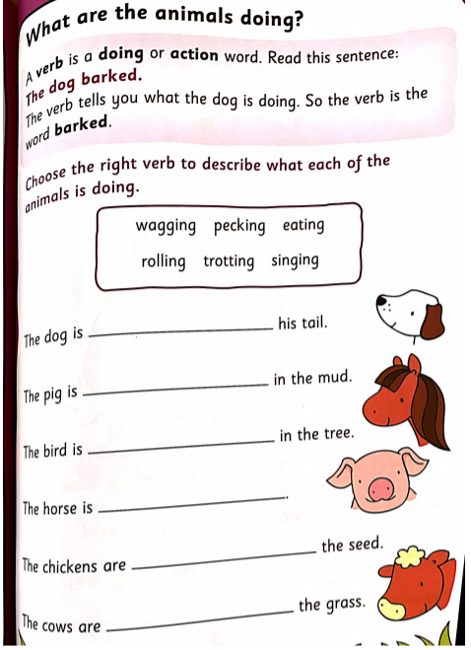

Answers: wagging; rolling; singing; trotting; pecking; eating.

Task 3

One day an old lady baked a gingerbread man. She gave him two currant eyes and a cherry for his nose, then popped him in the oven to bake.  
  
Later, she opened the oven to take him out, and found that he had jumped up on his bendy legs. He jumped off the baking tray, and ran out of the house!  
  
She called to her husband and they both ran after him, but he was running so fast that they could not catch him.  
  
He just laughed and shouted, "Run, run as fast as you can. You can't catch me I'm the gingerbread man!"

Soon he met a ________

**Phonics**

**Phonics**

Activities for all:

See attached pages on phonics activities for ‘ch’ ‘ear’ ‘s’ and ‘air’ phonemes.

I am attaching a phonics screening check for you to work through with your children. It should show you which graphemes they are most familiar with and which ones on their sound walls they need to continue to practise.

The website is here should you want to make some more yourself for practise at home.

<http://www.oxfordphonicschecksupport.co.uk/?> Go to generate your own phonics screening check and you can create your own.

Other phonics activities attached:

* Continue working through the phase 5 animal mosaic sheets
* Grapheme hunt – look at the different graphemes below. How many different words can your child come up with which contain the graphemes? Can they then use the graphemes to write a sentence?

Spellings activity:

* Continue with the Year 1 common exception words activities for different games you could play to practise reading and spelling common exception words

Grapheme hunt 1 ‘or’ phoneme

|  |  |  |  |
| --- | --- | --- | --- |
| Or | Aw | Au | Augh |
|  |  |  |  |

Grapheme hunt 2 ‘ch’ phoneme

|  |  |  |  |
| --- | --- | --- | --- |
| ch | tch | t |  |
|  |  |  |  |