Home learning wb 21st July
Hi all,
I can’t believe we have come to our final week in Year 1! It has certainly been a different ending to the year than the one I thought we would have. I am attaching some final activities for you to do now or over the summer holidays.
Have a brilliant Summer holiday. Keep reading and practising your phonics!
Can’t wait to see you all in September,
Miss Branch xx

Reading/English
Have a watch of the video ‘The day the crayons came home’. This is me reading out the sequel to ‘The day the crayons quit’. There are some questions you could then answer.
Have a look at the pobble picture below. Could you write some sentences about it? Remembering to use nouns, adjectives and verbs if you can.
Could you draw a picture and write about what Year 1 is like. Imagining you are then going to give this to a member of Reception so they can find out a little more about what learning is like in Year 1.
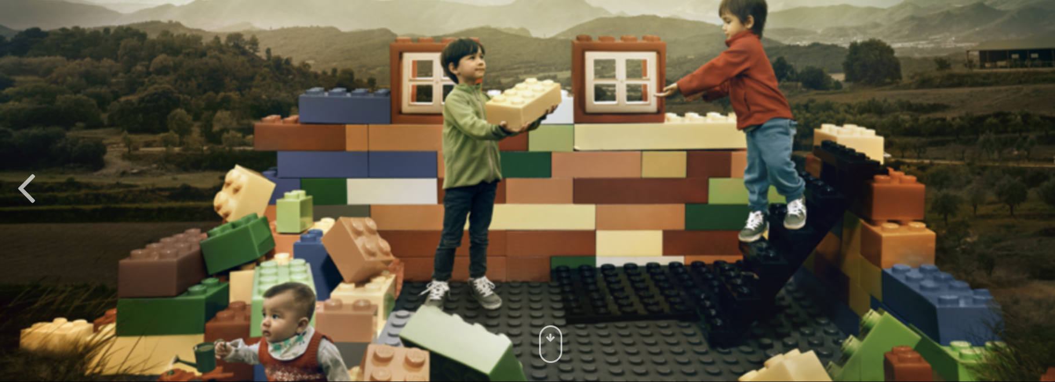
Maths
Have a go at some of the arithmetic questions – separate resource
There is also a fractions reasoning challenge page for you to have a go at as well.
Attached is a Summer maths activity booklet – there are lots of different activities recapping number work on numbers up to 20 and 100. Answers included in separate resource

Phonics
Have a look at the phonics screening check. You can use this to see which graphemes your child is familiar with and which ones may need further practise over the holidays.
Here is the website should you want to create and download some more - http://www.oxfordphonicschecksupport.co.uk/
Follow the link to generate own screening check.
Practise writing out days of the week, months of the year and the seasons over the holidays.
Complete the phase 5 consolidation sheet – different phonemes – can you then write out the word represented by the picture that contains the given phoneme. Can you then think of your own word which contains the same phoneme. Extension: Can you then write a sentence using that word?

Other activities
There is a summer wordsearch for you as well as some Summer mindfulness colouring
Could you create a summer holidays scrap book?

