Home learning wb 13th July
Hi all,
I can’t believe it is nearly the end of the year already! For this week’s tasks there are some transition activities so if you send me the activities back I can then send them on to your new teacher for next year.

Maths
In Maths, we are continuing with fractions – looking at quarters this week.
Watch the attached video and then work your way through the tasks below.
Task 1 and 2 – see attached tasks on quarters
Task 3 – see below
Task 4 – see below
Task 5 – consolidation task on halves and quarters – see attached

Task 3 – reasoning and problem solving tasks
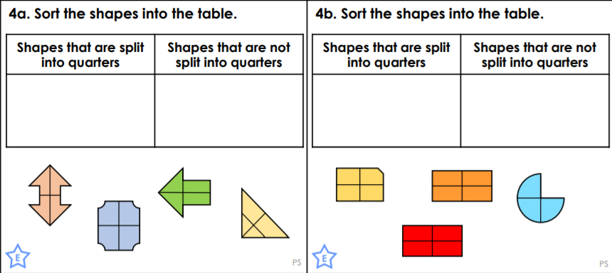
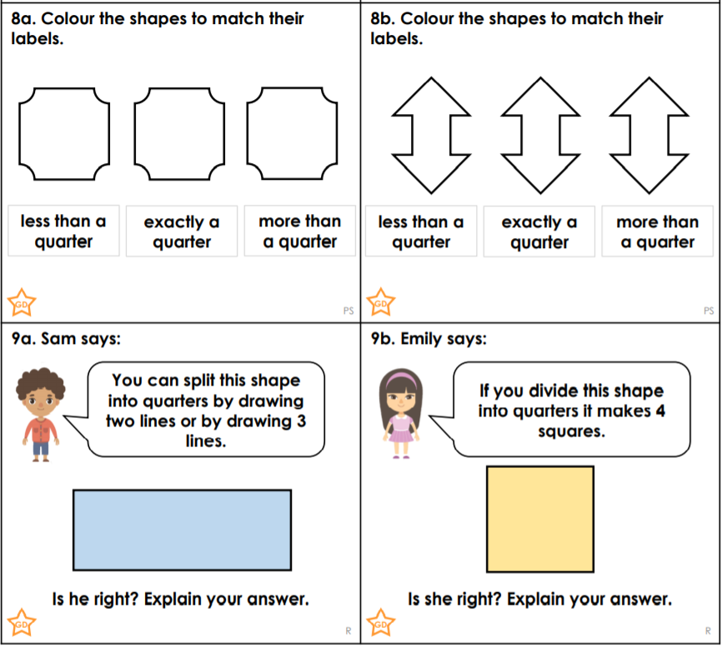

Answers – Task 3
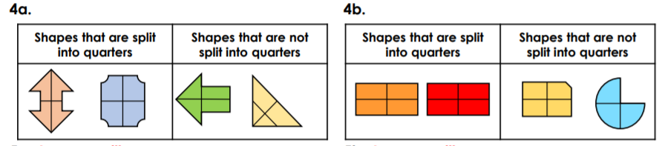
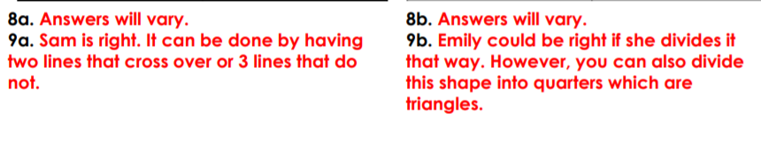

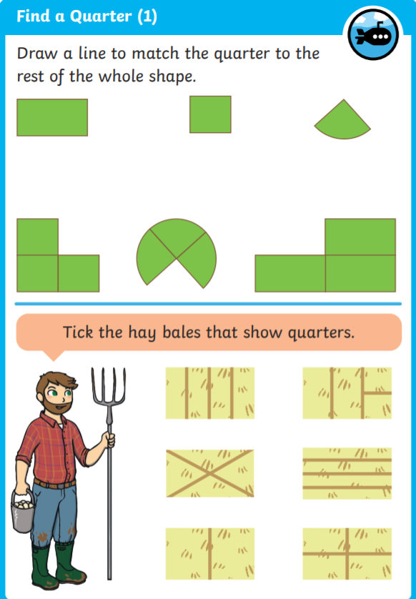
Task 4

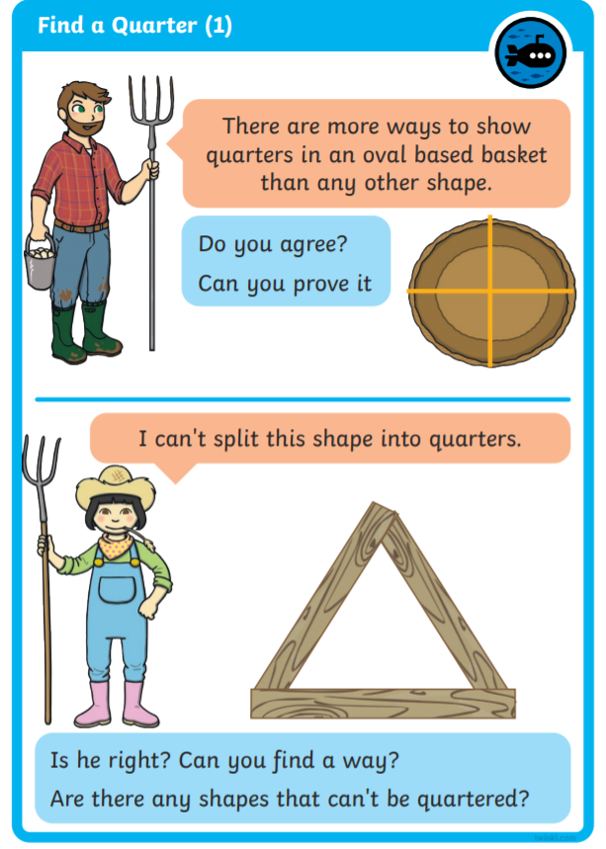

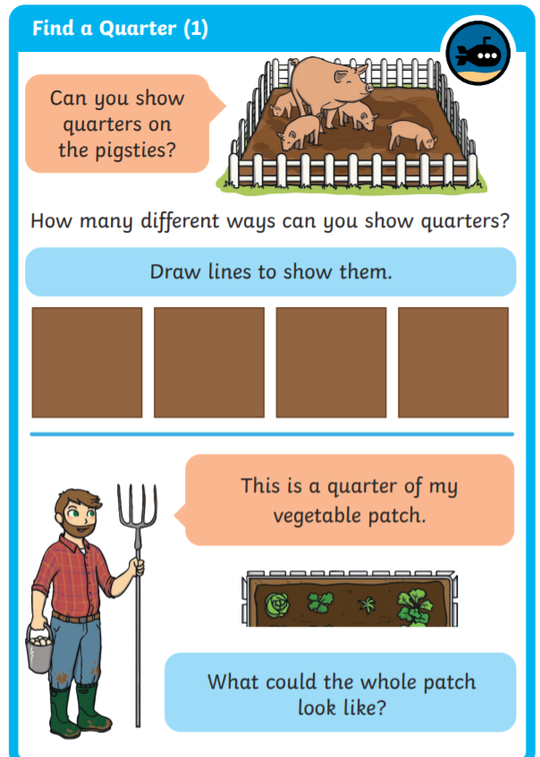

Task 4 Answers
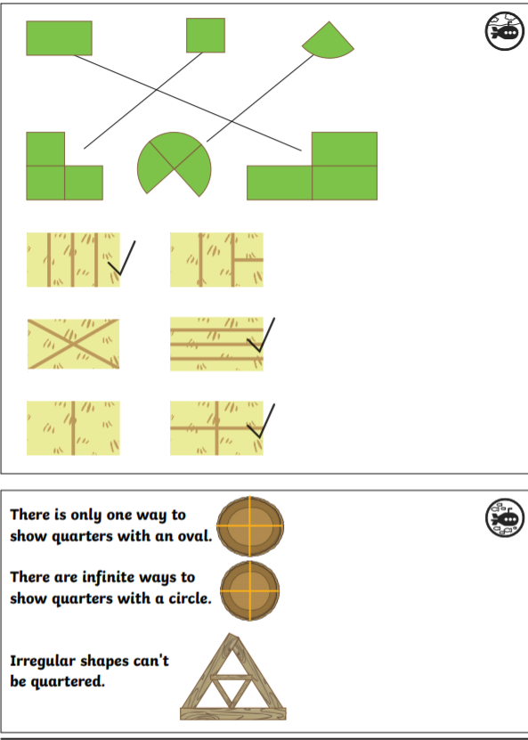

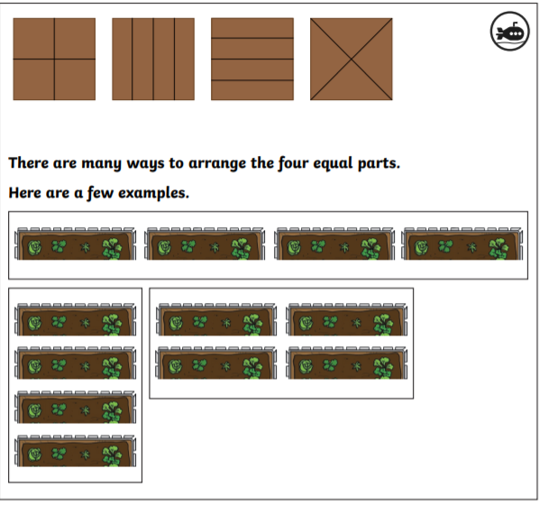

English – transition tasks
- Transition task – write a letter to your new teacher (Miss Jeremy) telling her all about you. Think carefully about how to lay out your letter and think about what you want her to know about you. Here are some ideas of the things to try and include:
- Age and birthday
- What you enjoy doing outside of school – hobbies
- What you enjoy in school – favourite subjects
- What you find hard in school
- What you have been getting up to during lock down
- Things that you are looking forward to about Year 2.
- Memories – Capture your memories from the last year – either in school memories or out of school memories or a mixture of both. Make a memory jar – using different coloured paper if you have it. You cold draw/write or a combination of both to capture your favourite memories. You could have different colours for different categories of memories – blue for achievements, red for memories from the classroom, red for favourite lessons etc.
- Saying goodbye to Year 1 – draw around your hand and think about the teachers and children you are saying goodbye to until Year 2. Think about the qualities the person has and write a message to that person on the palm of the hand. You could then write words to describe the person on the fingers e.g. kind, caring, helpful etc.
English – non-transition tasks
- Reading – The Unkind parrot and the next few English tasks link to this
- Describe the jungle where Percy lives. Using the information given to draw a picture and then write some sentences about the jungle where you think Percy would live.
- Write a story about a person or animal that is no good at sharing. Think about which character(s) you would have, what they can’t share, what happens to them in the end? Does someone teach them how to share?

Extra reading task – riddles. Have a look through these riddles. Can you and an adult work out what is being described?
Could you then have a go at writing your own riddles?

I have long ears and soft fur. I wrinkle my nose and I hop about. What am I?

I have six legs. I fly about. I visit flowers. I make honey. Who am I?

I slither on the ground. I often scare people. I can bite. I hiss when I am frightened. Who am I?

What has a bottom right at the top?

What is so fragile that even whispering breaks it?

What has a face and two hands, but no arms or legs?

What has a thumb and four fingers but no arm?

What has to be broken before you can use it?

What gets wetter the more it dries?

You can catch me, but you can’t throw me. What am I?

Riddle Answers
I have long ears and soft fur. I wrinkle my nose and I hop about. What am I? A rabbit!

I have six legs. I fly about. I visit flowers. I make honey. Who am I? A bee!

I slither on the ground. I often scare people. I can bite. I hiss when I am frightened. Who am I? A snake!

What has a bottom right at the top? Your legs!

What is so fragile that even whispering breaks it? Silence!

What has a face and two hands, but no arms or legs? A clock!

What has a thumb and four fingers but no arm? A glove!

What has to be broken before you can use it? An egg!

What gets wetter the more it dries? A towel!

You can catch me, but you can’t throw me. What am I? A cold!

Phonics
Attached is a phonics screening check, again go through it with your child to identify which graphemes they are familiar and confident with and it should show you any areas they are not so secure with.
If there are areas they are not confident with, you can use the power points I uploaded in previous weeks to practise particular sounds.

Continue practising writing out letters as both capital letters and lower case letters
Continue writing out days of the week, months of the year and you could also look at the different seasons and the spellings of those too.

Grapheme activities linked to ‘ee’ sound; ‘ai’ sound; ‘or’ sound – see separate resources
Grapheme hunt linked to these different graphemes.

or | aw | au | augh
torch | straw | haunt | taught

sh | ch | ss | s
ship | chute | tissue | sure

ai | ay | a_e | a
tail | spray | gate | acorn

