Choose 1 or 2 activities over the next week and a half to complete.
Science  Compare and group materials together according to whether they are solid, liquid or gasses.  Can you create a chart to show different materials and which category they would fit into? | PE  Can you plan your own sports day? You will need to plan the different activities thinking about what space and equipment you have at home. Is there someone at home who can join in with you? Perhaps you could make some awards for those who participate.
Art  100 words for 100 days.  We have now been off school for over 100 days. Can you create a collection of words that reflect your experience and create a picture to display them? I chose to do this using a free word art program online, but it could equally be done by hand.  Don’t forget to ask other people what words they would include. | Geography  In Geography let’s look at maps. There are lots of different maps such as OS maps, road maps, tube maps, cycle maps, bus maps, etc.  Which map would you use if you were locating your house or the school?  Which map would you use if you were planning a journey on the underground?  Which map would be most useful if you were looking for the local post office or information centre?  Which maps depict human features, and which depict both human and physical features of the environment?  Can you have a look at one or more of these types of map and plan your own route?
DT  Using lego design a simple build. Then create a set of instructions for somebody else to follow so that they can build it.  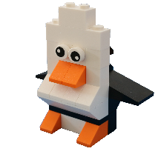 | PSHE  If your grown up gives you  permission, why not add to our ‘I am awesome’ Facebook post with something you have done that you are proud of during lockdown? We would love to celebrate all your hard work and determination.

