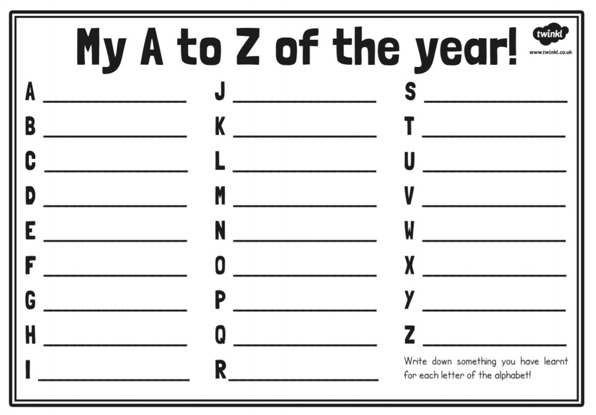

Write down something you have learnt, or a Year 4 memory that you have for each letter of the alphabet.