Problem 1:
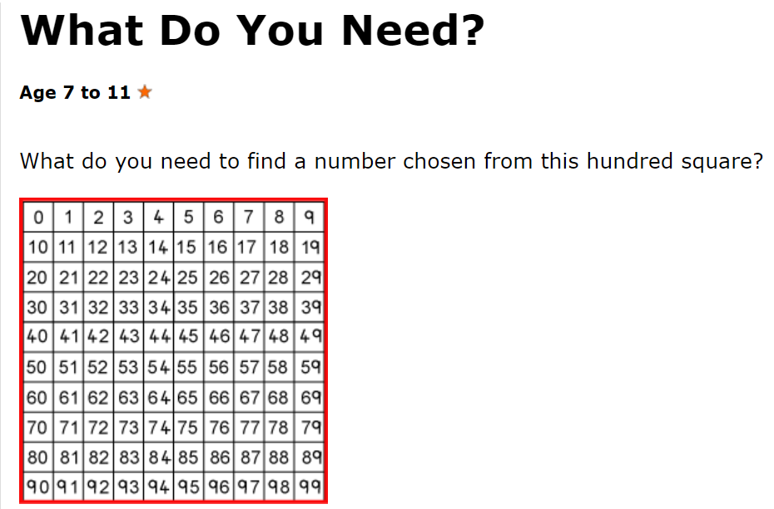

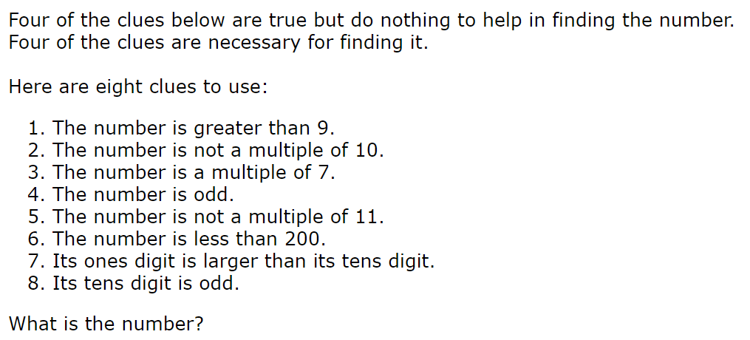

Problem 2:
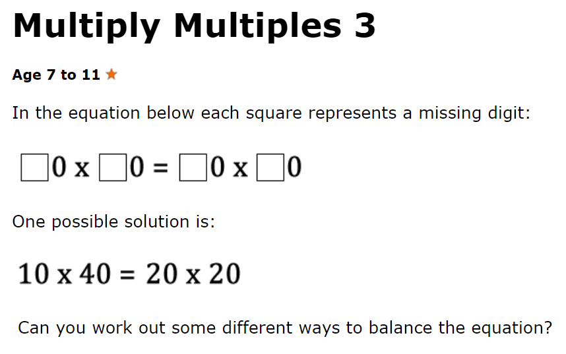
Problem 3:
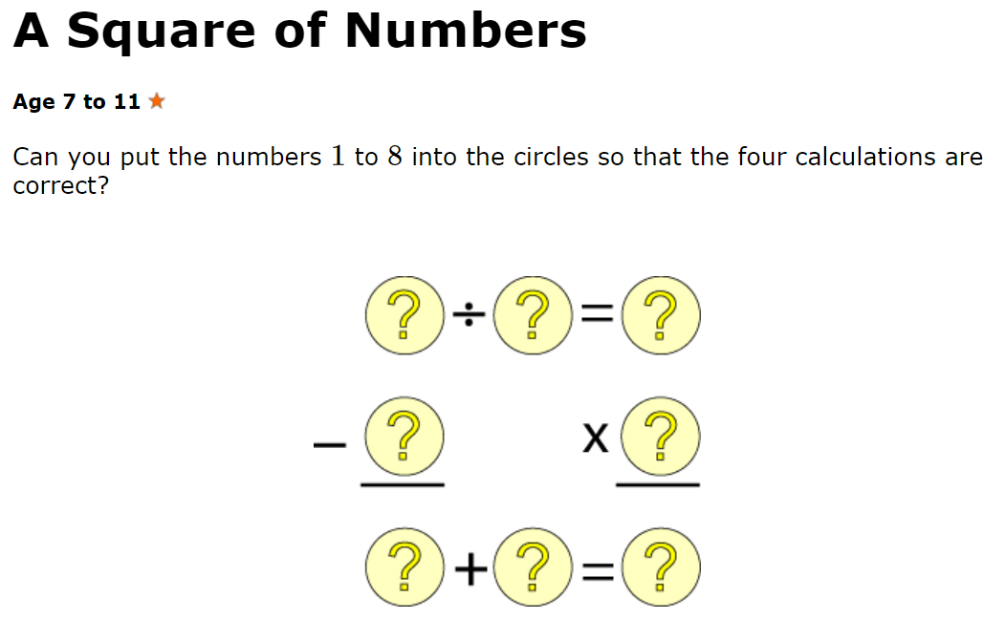

SOLUTIONS:
Problem 1: https://nrich.maths.org/5950/solution
Problem 3: https://nrich.maths.org/2005/solution

