Year 5 Summer
English Activity Booklet
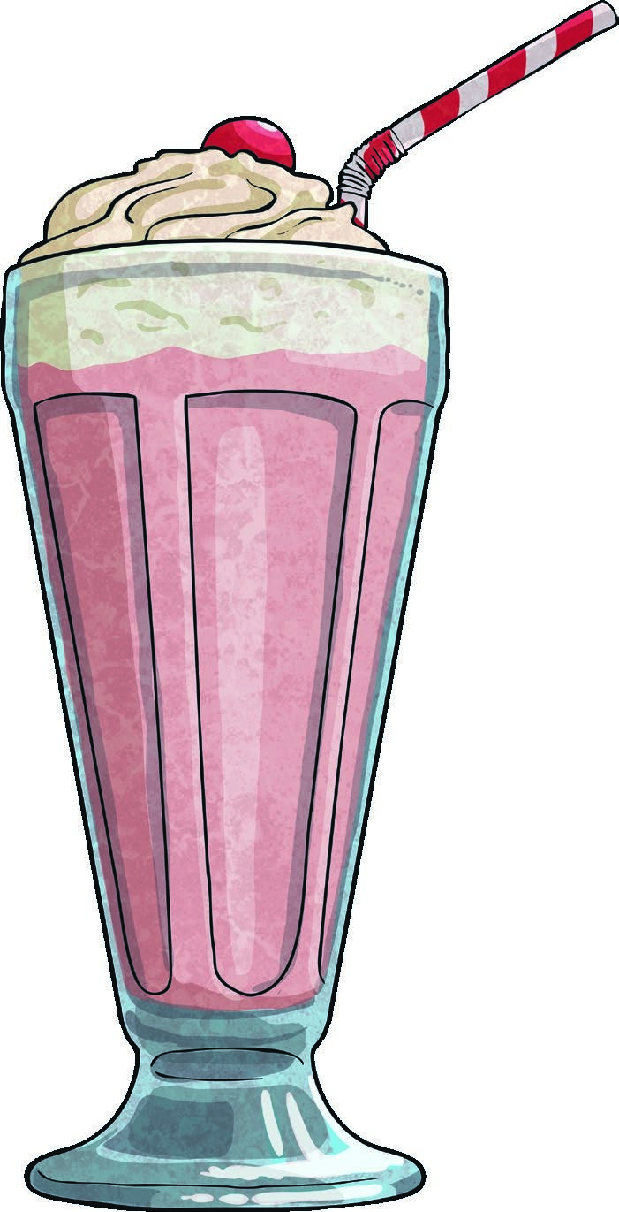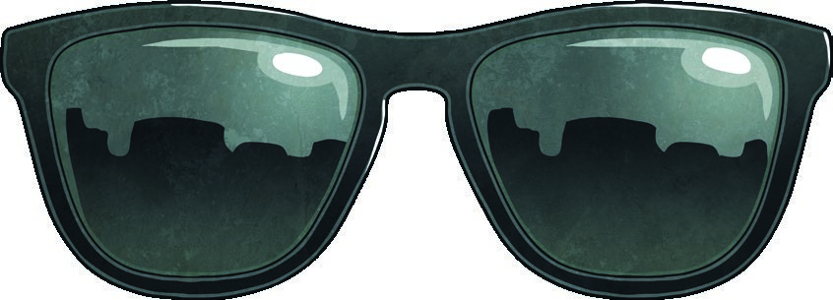
Postcards from Around the World
Hello class,
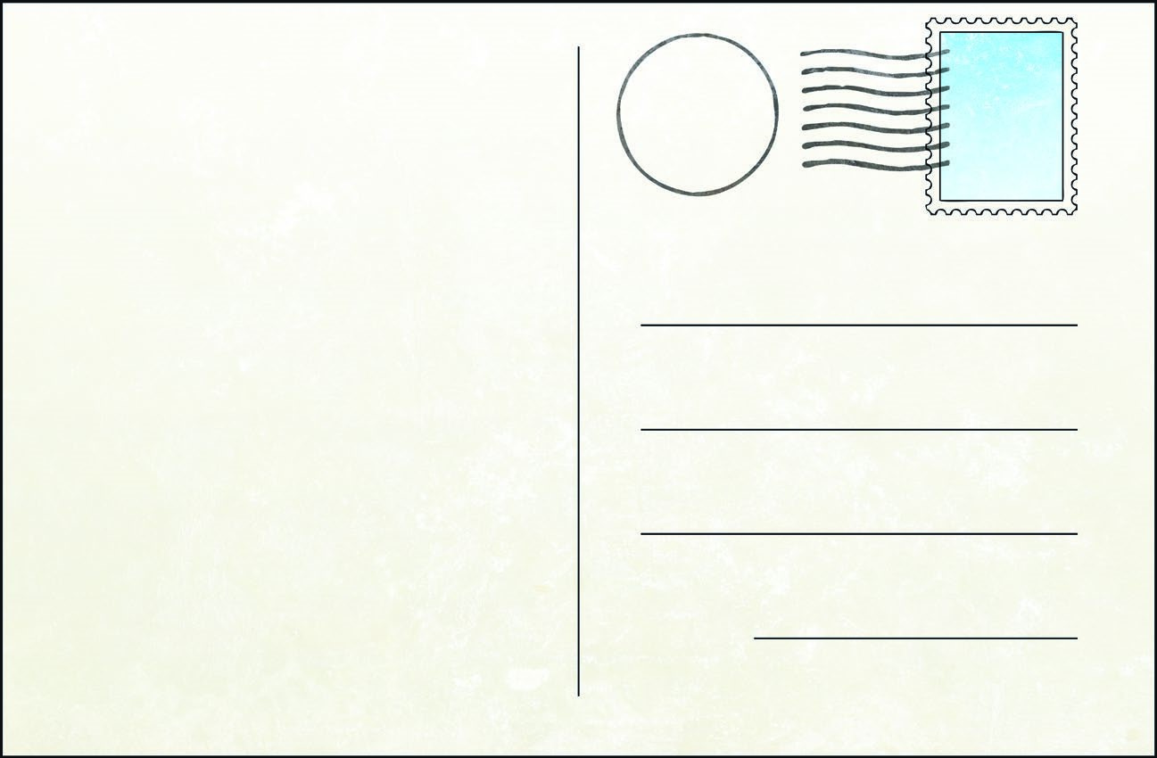
Well what can I say about Egypt? It is extremely hot and sunny here in Cairo. Yesterday I sailed down the Nile on an old fashioned Rivership and even saw huge Nile crocodiles relaxing on the riverbank - as you can imagine, we weren’t able to swim despite the heat! Today I went on a camel ride and saw the pyramids and the sphinx. The sphinx looks like a big cat or a lion but it has a human face! Tomorrow I’m going to the Egyptian Museum - I might see some statues of the Pharaohs if I’m lucky.
Love from Summer
Hello class,
France is such an interesting place to
visit. I’m staying in the capital city
(
Paris). Yesterday I went up to the top of
the Eiffel Tower - it was very tall so took
a long time to climb but the views were
stunning. Then I went to the Louvre
and saw lots of legendary paintings
including the Mona Lisa (which looked
a bit like my mum!). I can’t wait
until tomorrow because I’m going to
Disneyland Paris - I wonder which
characters I’ll see.
Love from Summer
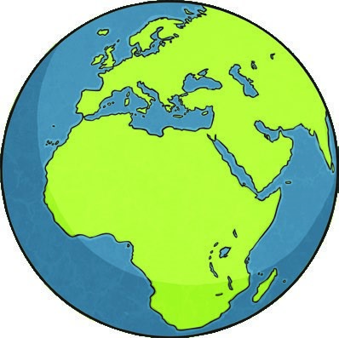
Postcards from Around the World
Hello class,
I’m having a great time here in
Scotland! I’ve been doing lots of
travelling around and have even been
to Loch Ness to look for the Loch Ness
monster - I thought I saw it but my
mum said it was just a log floating
in the water! Now I’m staying in the
capital city (Edinburgh) and tomorrow
I’m going to look around Edinburgh
Castle - I might even hear them firing
the cannons if I’m lucky!
Wish you were here,
Love from Summer
- Who is writing the postcards?
- Circle all of the cities that she has been to visit?

Paris London Madrid Edinburgh Cairo
- Why was she not allowed to swim in the Nile?

4
.
Find and copy the phrase that tells you she was excited about Disneyland.

5. ...and saw lots of legendary paintings...
Tick the word closest in meaning to ‘legendary’.
beautiful famous unknown exquisite
Ice-Cream Match-Up!
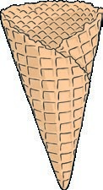
Can you draw lines to match each prefix to the correct root word to make each ice cream into a verb? Each prefix belongs to two different root words.
e
-
d

e
k
a
t
tr
a
in
dis
-
cod
e
-
mis
ov
e
r
-
clutt
e
r
e
x
e
rt
r
e
-
loc
a
t
e
e
quot
o
b
e
y
e
e
gr
a
r
a
ct
e
Could you use some of the words in summer themed sentences?

Summer Sun

Summer Sun
Robert Louis Stevenson
(from A Child’s Garden of Verses, 1885)
Great is the sun, and wide he goes
Through empty heaven with repose; And in the blue and glowing days More thick than rain he showers his rays.
Though closer still the blinds we pull
To keep the shady parlour cool, Yet he will find a chink or two To slip his golden fingers through.
The dusty attic spider-clad
He, through the keyhole, maketh glad; And through the broken edge of tiles Into the laddered hay-loft smiles.
Meantime his golden face around
He bares to all the garden ground, And sheds a warm and glittering look Among the ivy’s inmost nook.
Above the hills, along the blue,
Round the bright air with footing true, To please the child, to paint the rose, The gardener of the World, he goes.
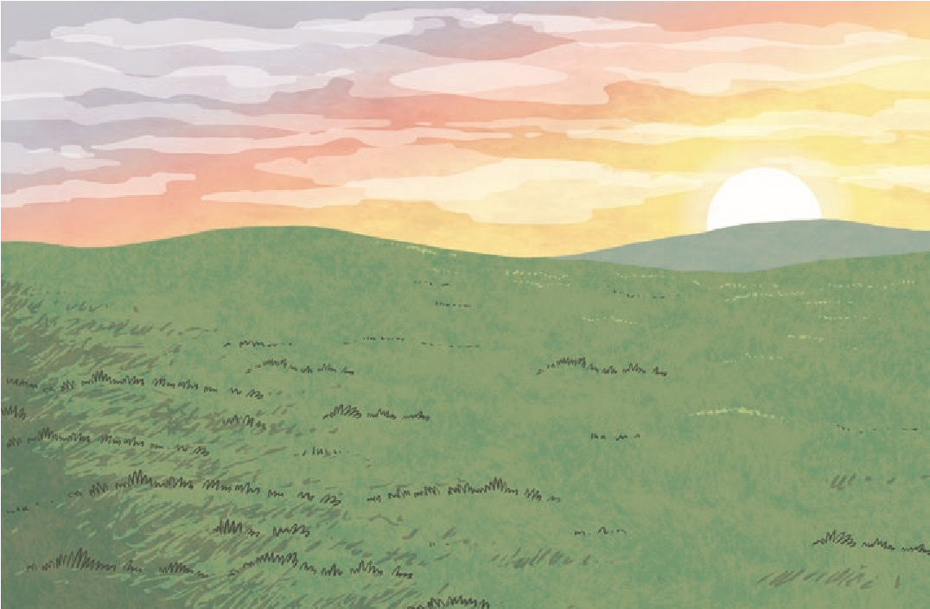
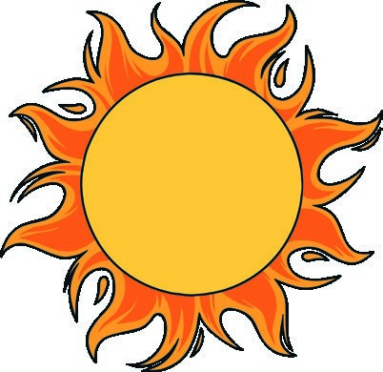
- Who is the ‘he’ in this poem?

- What does ‘slip his golden fingers through’ mean?

- Find and copy a phrase that shows that
the sun is comforting.

- ‘Among the ivy’s inmost nook’ Tick the word that is closest in meaning to ‘nook’?
wall barrier
creviceenclosure

Summer Sentence Scramble
Use your super sentence writing skills to create sentences with a relative clause. Read the main clause, add an appropriate relative pronoun from the list below and then add your own relative clause. The first one is done for you as an example.

Relative pronouns - who, which, where, when, whose, that
- We often visit the seaside when the sun shines.
- The girl jumped into the pool,

- We went on a long plane journey

- The boy sprayed his friend with the water pistol,
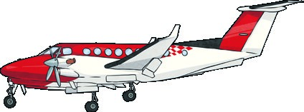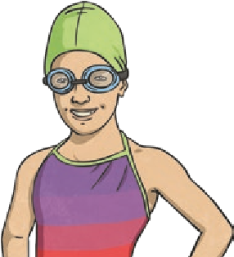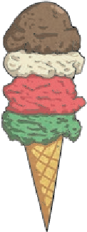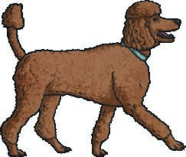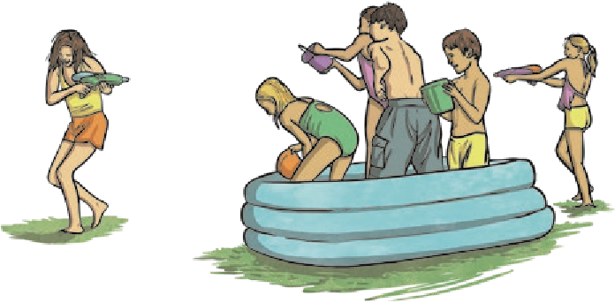

This time, read the main clause. Then re-write the sentence, adding an appropriate relative pronoun and embedded relative clause in the middle of each sentence. Don’t forget your commas if you need them! The first one is done for you as an example.
- We went to the beach, which was on the east coast, to go surfing.
- The ice-cream melted quickly.

- Our dog dug a deep hole in the sand.

- My dad paddled the dinghy out to sea.

Strawberries
This succulent, fragrant fruit is as beautiful as it is flavourful. Traditionally the strawberry season is quite short with a six-week season from early May until late August. The use of polytunnels and glass houses has extended the strawberry season. Although strawberries will be in plentiful supply throughout May the season will reach its peak in June and July. If good weather continues from July you can expect to see British strawberries until the end of September.
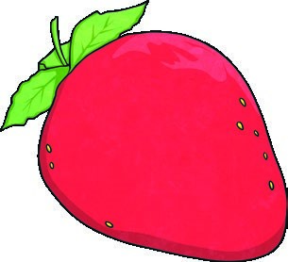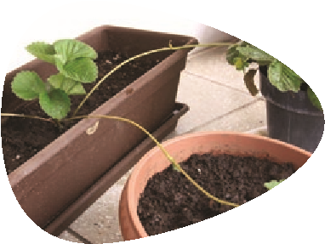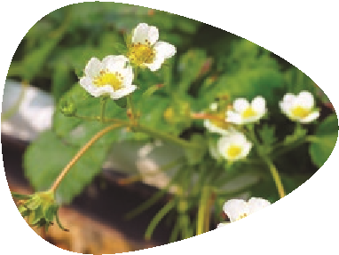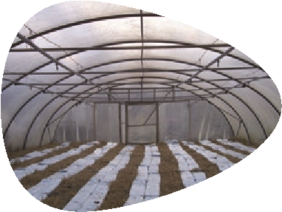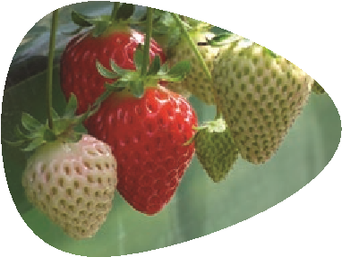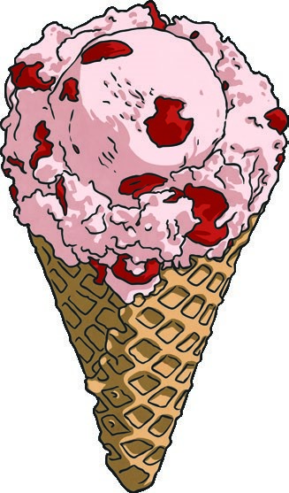
Strawberries grown on farms in the UK grow on runners from a parent
plant. It’s quicker than growing from a seed. It takes five to six months for
the baby strawberry plants to grow roots of their own and be ready to go
to their own polytunnel.
Polytunnels are like big plastic greenhouses in the shape of a tube. Giant
glass houses are also used. They let in lots of light but they keep the
strawberries protected from the weather and help stop pests and diseases.
Once the strawberries are planted they need to be watered every day. A
special method called irrigation is used to water the soil using special pipes.
The following year the strawberry plants are mature enough to start to
flower. Each flower can become a strawberry, but it needs to be pollinated
by an insect. The insect pollinates the flower by crawling on it to get the
nectar. At the same time it rubs the yellow pollen on to the inside parts of
the flower. This is what makes the fruit start to grow.
Thirty days after being pollinated, the baby strawberries start to form.
To start with they are small and green. As time passes and they get more
water and sunshine the fruits begin to grow and turn red. The polytunnel
stops the birds from eating the young fruits.
Strawberry

ice-cream is the third most favourite
ice-cream in the world at 5%

after vanilla 29% and chocolate 9%
)
(
Info from http://www.derinice.com
(
)
Candy Tale, garryknight, pang yu liu, Bods, sigusr0 (@flickr.com) - granted under creative commons licence – attribution

Strawberries
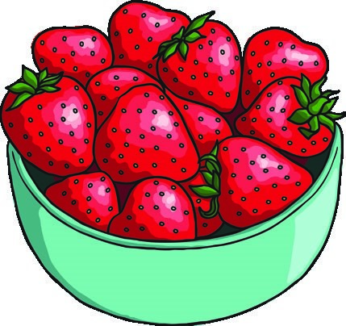
Strawberries are the best!
- Many children say that strawberries are their favourite fruit.
- Strawberries are a great source of vitamin C.
- Strawberries are low in calories.
- There is a museum in Belgium dedicated only to strawberries!
Is strawberry the favourite flavour of ice-cream in the world? yes no
Explain how you know.

- Find and copy two reasons why strawberries are good for you.
1.

2.

- ‘The following year the strawberry plants are mature enough to start to flower.’ Circle the word closest in meaning to ‘mature’ in this sentence. large old young ripe
Why are all strawberries picked by hand rather than with machinery?

The Water Fight
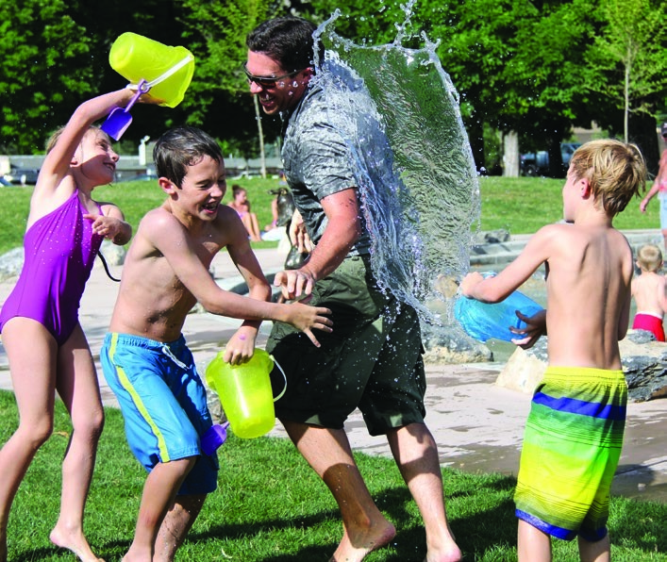
Use this picture as inspiration to carefully think and write a short paragraph about the water fight.
Sentence 1: Include a relative clause.

Sentence 2: Use brackets to indicate parenthesis.

Sentence 3: Include a modal verb.

Sentence 4: Ensure cohesion in your paragraph with the inclusion of an adverb of time.

Sentence 5: Include an adverb of possibility.

Summer Word Mix-Up
Work out the answers to each of the clues (unscramble the anagrams below to help you find the correct answers). When you’ve filled in the missing letters, place each numbered letter into the boxes on the next page to create a seasonal phrase.
1. I had an ice-cream, which had sprinkles on top.
The underlined word is a .

REALEVTI POONUNR

8
- Mum said that we must put sun cream on today.
The underlined word is a . LOMDA EVBR

11 9
- I met my friend, who had a sparkly swimsuit, at the water park today.
The underlined words are a .

IVLEATER EULASC

1
4. Later on today, we are going to have a BBQ because it’s so sunny.
The underlined words are a .

RABDELIVA FO METI

10
5. On the beach, there is a large café where we can buy ice creams.
The underlined phrase is an .

VAELADRBI FO LECPA

5

Summer Word Mix-Up
6. We visited our family in Scotland twice last year.
The underlined word is an .

VILRAADEB FO RUBMNE

2
7. I can’t wait to go on holiday (on a plane) this year.
The underlined words are contained within because they are
.

KETRACBS
12

SARNITSEEPH
6 7
8. As the campers sat around the fire eating, the rabbit hid in the bushes.
In this sentence the circled punctuation is a which helps to avoid .

MOMCA
3

TABMYIGIU
4 13
1 2 3 4 5 6 7 8 9 10 11 12 13 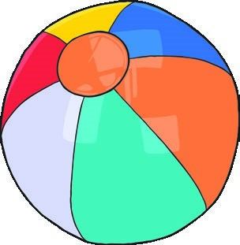

Summer Spelling Challenge
Ask a helper to cut off the sentences on the bottom of this sheet and then read them out to you one by one. Can you spell the words that fill the gaps in these sentences?
- The chocolate chip ice-cream was .
- I was excited to be going on a trip.
- We’re going to visit the water park this summer.
- We went on a camel trek across the in Egypt.
- I am sure that the sun will up tomorrow.
- There will be a if we don’t get some rain soon.
- The view from our hotel was .
- I was very of the shade that was cast by the beach umbrella.
- I can’t wait for our holiday to visit a island!
- The at the ice cream van was so long.
Read each sentence out twice:
- The chocolate chip ice-cream was delicious.
- I was excited to be going on a yacht trip.
- We’re definitely going to visit the water park this summer.
- We went on a camel trek across the desert in Egypt.
- I am sure that the sun will brighten up tomorrow.
- There will be a drought if we don’t get some rain soon.
- The view from our hotel was beautiful.
- I was very appreciative of the shade that was cast by the beach umbrella.
- I can’t wait for our holiday to visit a tropical island!
- The queue at the ice cream van was so long.

