Flotsam 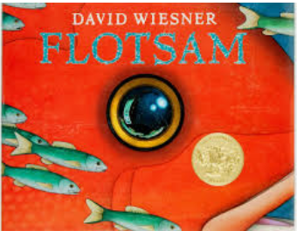
by David Wiesner
The book can be accessed here:
https://www.youtube.com/watch?v=3MTKWnxzqvM

You have a choice of writing options this week, all based on the beautiful illustration book Flotsum.
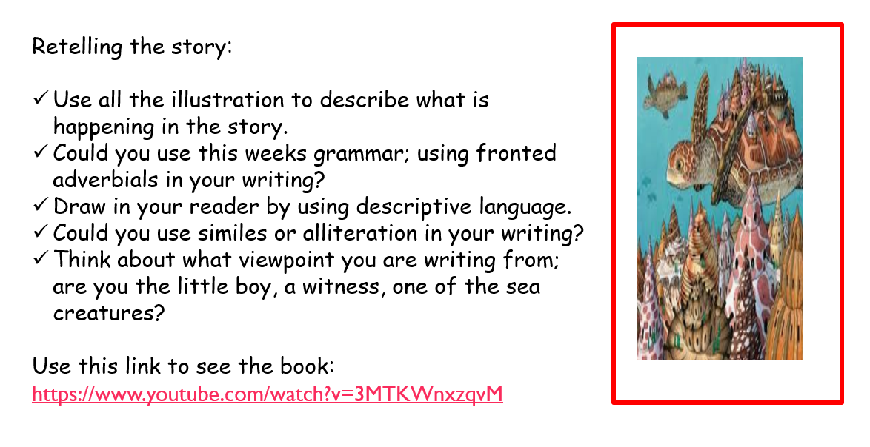
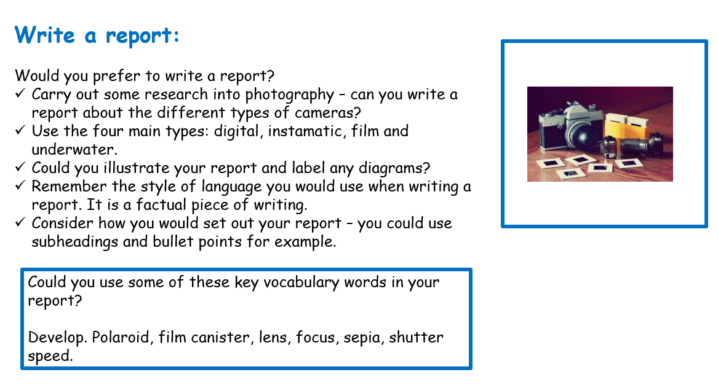

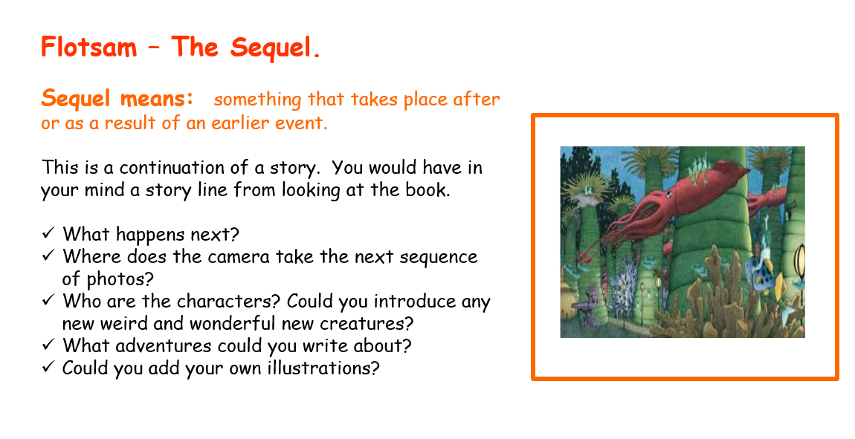

Spellings:
These have been set through either purple mash or spelling frame. Please also continue with Nessy if this is a learning platform that you are using.

Reading:
What are you reading at the moment? I would love to hear about the books you are enjoying. Could you write a brief book review. We could share our reviews with each other. I am jus about to start this book -
