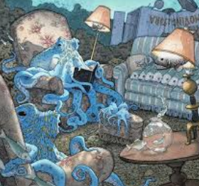

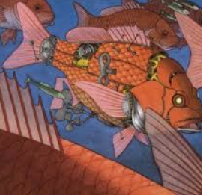

ART

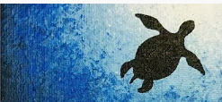

<https://www.youtube.com/watch?v=76viXMpZomc>

Could you create a sea life silhouette picture to accompany your writing this week? This tutorial could help you. You could use this as the centre piece to your writing.

**Mrs B’s afternoon activities**

**Linked to**

**FOTSAM**

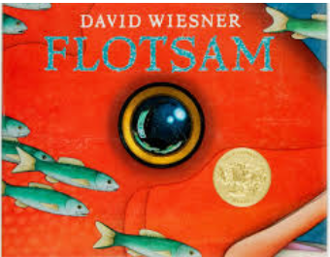

**DT**

Believe it or not, cameras have not always been digital! Can you find out what cameras used to be like? How have they have changed? Can you label parts of a camera? Can you make your own pinhole camera?

….could you send me photos of your creation!

<https://www.youtube.com/watch?v=mxY9ouCx_UE>

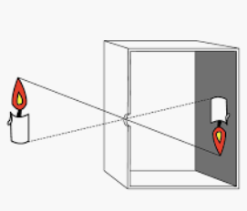

**Geography:** Choose two contrasting places in the UK: What are the similarities and differences between the two places? Think about how the land is uses, transport, buildings, geographical features etc.

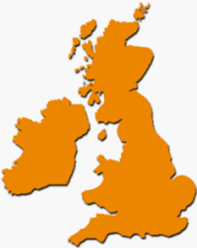

**Science:** Can you use the creatures in the book to create some food chains. Who are the producers, predators and prey? Draw them out and add labels and arrows

