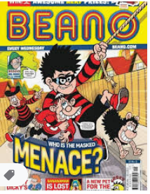 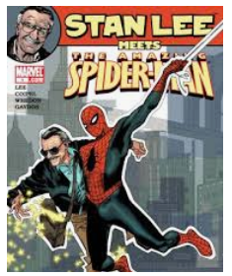 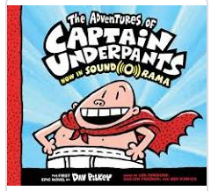 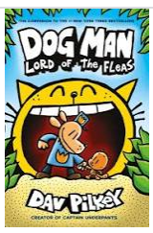

Cosmic, cartoon, comic, creators!!

This week, I would like you to become comic authors. Could you create your own comic strip?

The BBC bitesize video below will help you.

<https://www.bbc.co.uk/bitesize/topics/zkgcwmn/articles/zbk47nb>

Dora has helped me with planning this week whilst we have been at school in the keyworker bubble……here’s the beginning of her comic.

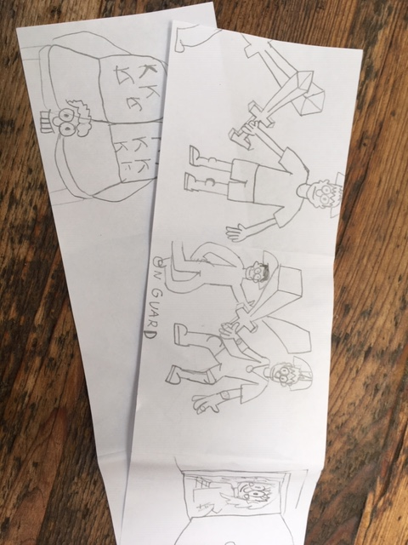

Follow these steps:

1. CHARACTERS: decide who is going to be in your comic – I would suggest 2-3 characters.

Think about how your characters looks, their personality traits, do they have any superpowers? Are the good or evil?

2. SKETCH: Now sketch your characters and mind map lots of adjectives to describe your characters. Think of characters from your favourite films, animation, comics, books – you could take the best bits from various characters and mould them together.

There are so many tutorials on-line to help you with sketching characters. The lionk below from ‘The Guardian’ newspaper is brilliant

<https://www.theguardian.com/childrens-books-site/series/how-to-draw>

3. PLANNING your story; Use the story mountain planning strategy to help you. What is the dilemma, the problem that needs solving? How will it be resolved? What happens along the road - from the problem occurring to the problem being solved?

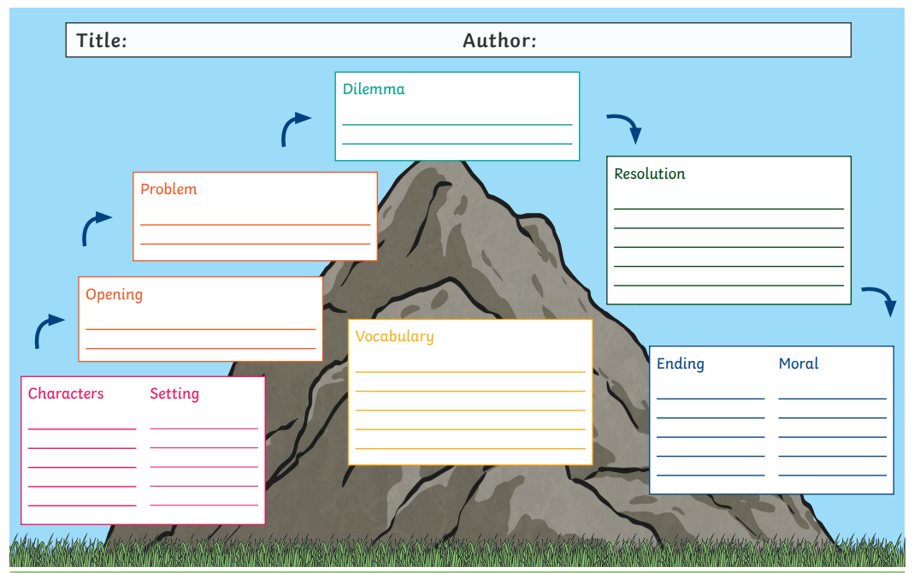

Comic writing involves your characters having thoughts which are depicted in thought bubbles -

**If I use my power of invisibility, I’ll be able to enter the building without being detected!**

You can also use speech bubbles –

I

**It’s time for action Captain comic, let’s alert the nation of the dangers ahead!**

You can set the scene and describe the actions of characters etc… using a box

**Edd has been sat in the exam hall for what felt like his whole life….**

SOUNDS: You would have noticed, that many cartoons and comics have exaggerated sound ‘bubbles’ to add effect. Could you add some sound alerts into your story?

 You can use ‘sound’ words like **POW! BAM! KAPOW! SPLAT! WHACK! BOOM! SMASH! CRASH!**

TEXT TYPE: You could use various text type (if using a computer) or handwriting to emphasis certain words.

**BOLD**  nervous E X H A U S T E D

Now it’s time for you to put it all together. Your images, text in speech and thought bubbles and scene setting boxes. Make your work bright and colourful. Could you add sound shapes too?

EXTRA WORK:

Could you become a comic superhero?

