Tuesday’s Writing task:
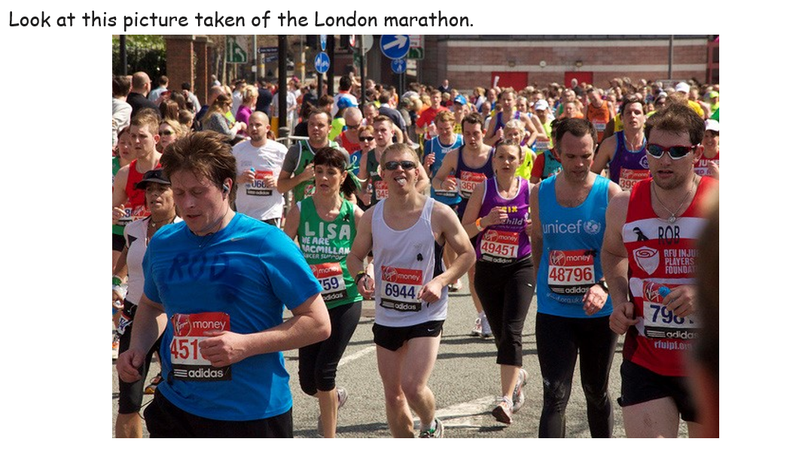
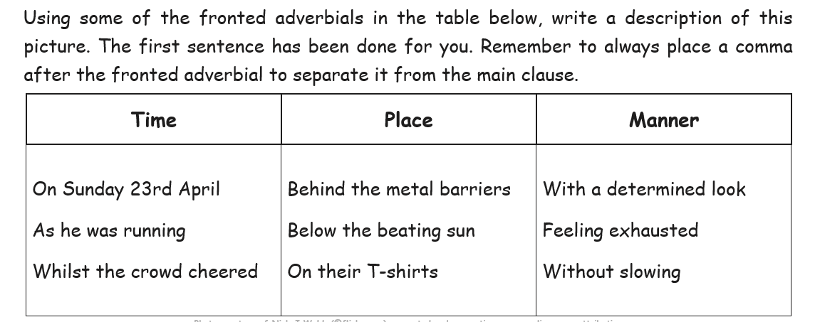

I have done one for you:
On Sunday 23rd of April, thousands of people hit the streets of London to take part in the annual London Marathon.

Could you create your own sentences using a fronted adverbials of time, place and manner?
CHALLENGE: Why not make up your own fronted adverbial and not use the box above!

