The Most Disgusting Sandwich in the World!
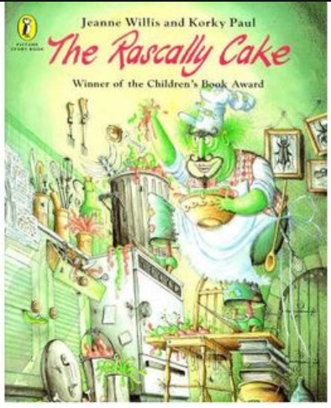https://www.youtube.com/watch?v=2fQuF07EsF4
This week I would like you to become familiar with writing instructions; this is procedural writing. This style of writing needs to be clear, chronological and step by step.

Monday: Today you need to watch the BBC bitesize lesson video on command sentences and imperative verbs.
https://www.bbc.co.uk/bitesize/articles/zbxgn9q
This will guide you in your writing later in the week. I would like you to note take today, what features do you need to include in your writing?
NOW: carry out the activity – matching the features. (worksheet in the resources folder on website).

Tuesday and Wednesday:
You have learnt about imperative verbs and how to write instruction / procedural writing.
I would like you to invent the most awful sandwich you could think of, the kind of sandwich Mr Rufus Skumskins O’Parsley would devour!
- List all the ingredients you will need for your sandwich.
- Next, list all the equipment you would need to prepare your sandwich.
- Now think of the individual steps someone would need to follow in order to make your sandwich.
- Could you conclude by adding any helpful hints and tips at the end?
- You should be quite persuasive in your language, you really want people to enjoy your sandwich, try and be convincing!

Thursday:
- Comprehension Activity – see resource pack on website.
- Purple Mash Activity.
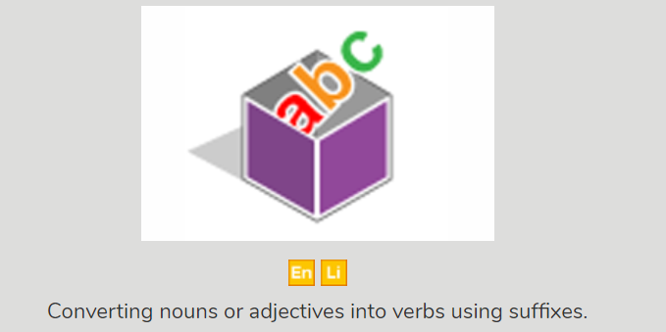

Friday:
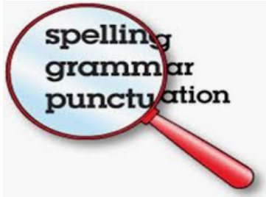
I have included in the resource pack an English Activity pack. This consolidates many topics we have covered in our grammar lessons.

