Hi all,
I am attaching some phonics, English and maths tasks for the week beginning 15th June. The activities I posted last week about the Environment are to cover the next 3 or 4 weeks so I will attach some more foundation ideas at a later date.
Hope you are all well,
Miss Branch.

Maths
Continuing with numbers to 50, I am attaching some tasks which are all about ordering numbers to 50.
Task 1 – see separate resource Ordering numbers to 50 and answers attached
Task 2 – see resource below along with answers
Extension reasoning and problem solving task – see attached resource
If you want another activity, there is the homework extension task all about ordering numbers to 50 – attached.

Maths Task 2
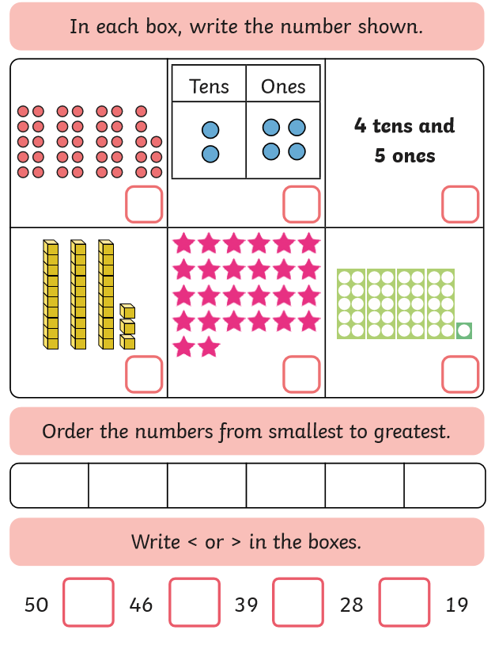
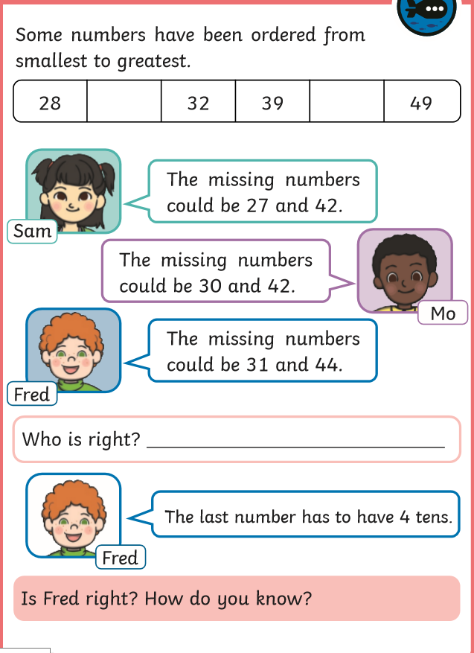

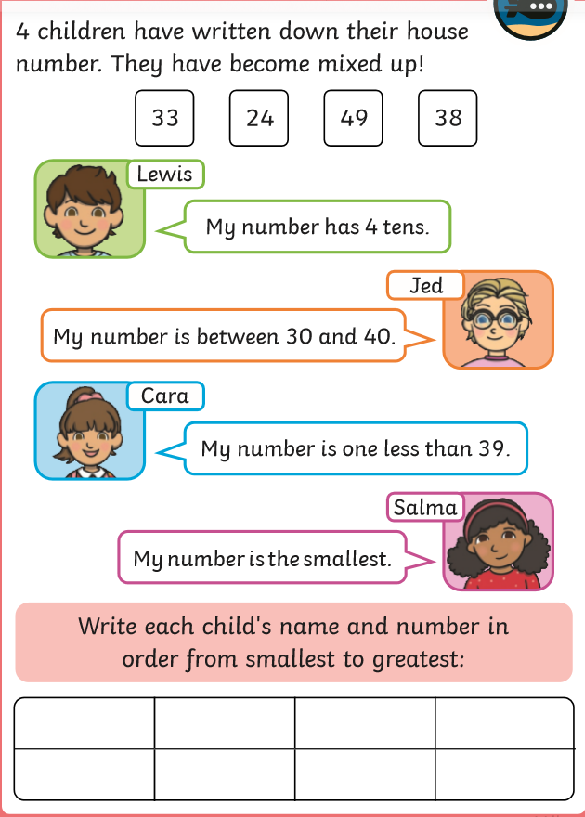

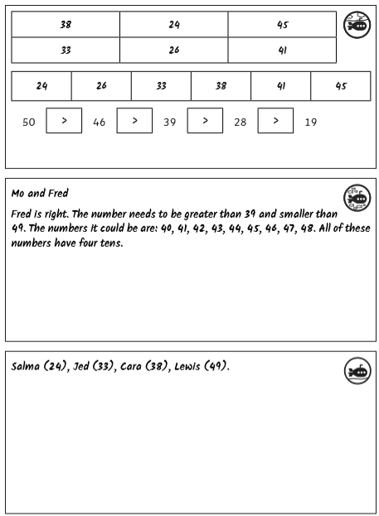
Maths task 2 answers

English
The English project for the week is all about places around the world. Here are some different writing and reading tasks to choose from.
Activities to choose from:
- Use an atlas, can you find the different countries that make up the UK?
- Can you complete an A to Z for different places around the world. You could include cities, countries, towns and villages.
- Think about a place in the world you have visited or would like to visit. Can you write an information page about it? Think about where it is, what the food is like, what the weather is like, what famous landmarks there are etc. See example below for a way you could set this out.
- Create your own village/town/country. If you could create your own village or town what would you call it; what would it’s flag be? How would you get there from England? What animals would live there? Can you create a fact file about it – see below; you could then draw a picture of it as a map or build it using Lego.
- Write a letter or postcard to a family member or friend who lives in a different part of the UK or a different part of the world. Describe what it is like where you live and ask questions about what it is like where the family member/friend lives.
- Look at the different flags from around the world. https://www.worldometers.info/geography/flags-of-the-world/ Which is your favourite and why? Could you then recreate your favourite – draw it, paint it, make a collage of it.

Name of the place: | Picture of the place’s flag
What animals would you find here? |  | Why would people want to visit this place?
What famous landmarks are there? |  | Any other information about the town/city/country?

Places around the world
Letter | Places
A
B
C
D
E
F
G
H
I
J
K
L
M
N
O
P
Q
R
S
T
U
V
W
X
Y
Z

Phonics
For phonics this week, please continue using the power points which were attached to the website each week for consolidation.
Activities will focus on different graphemes for the ‘ee’ phoneme.
Activities:
- What different words can you think of around the home and garden which contain the different ‘ee’ graphemes. Can you complete the table below with as many words as possible.
- See attached alternative spellings for ‘ee’ grapheme sheets 1 and 2
Other activities you could do:
- Continue to practise writing out lower case and upper case letters
- Continue to write out days of the week
- Practise writing the different months of the year

‘ee’ | ‘ea’ | ‘ey’ | ‘e-e’ | ‘y’

