Hi all,
I hope you are all well. I am attaching some activities for the week. Some of them we will be doing in school, such as the English poetry writing task so if you wanted to email your poems in to share with the rest of the class that would be brilliant. Just email them to k.branch@henhamugley.essex.sch.uk
Speak soon,
Miss Branch

English
Task 1 – Using the attached senses sheet can you fill it in. Find a quiet spot outside either in your garden or out on a walk. Think about what you can hear, see, smell etc.
Task 2 – Use your ideas and try and add adjectives to the nouns. For example if you heard birds how would you describe them? If you saw branches on the trees how would you describe them?
Task 3 – Can you then use what you have written and write a poem all about summer? The poem could rhyme if you want it to, it could a shape poem where you draw something that reminds you of summer and then you write your description inside. You could base it on the winter, winter poem we wrote as a whole class. Here it is to remind you:
Winter
Winter, winter,
Soft white snow,
Winter, winter,
Where will you go?
Winter, winter,
Golden leaves off the trees,
Winter, winter,
Really cold breeze,
Winter, winter,
Fingers frozen cold,
Winter, winter,
Leaves frozen and gold,
Winter, winter,
I love you,
I hope you love me too.
Task 4: Using the creative writing challenge card, can you plan and write a letter to your future self. See more information below.

Task 4
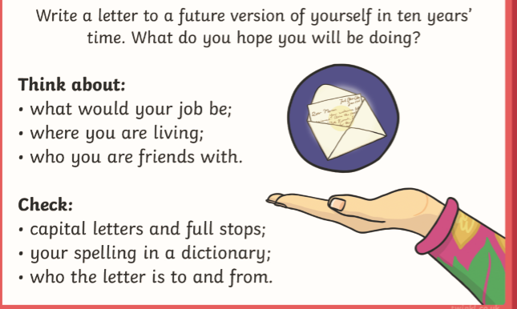

Don’t forget to lay it out like a letter:
Date
Dear…………………………………,

Reading task
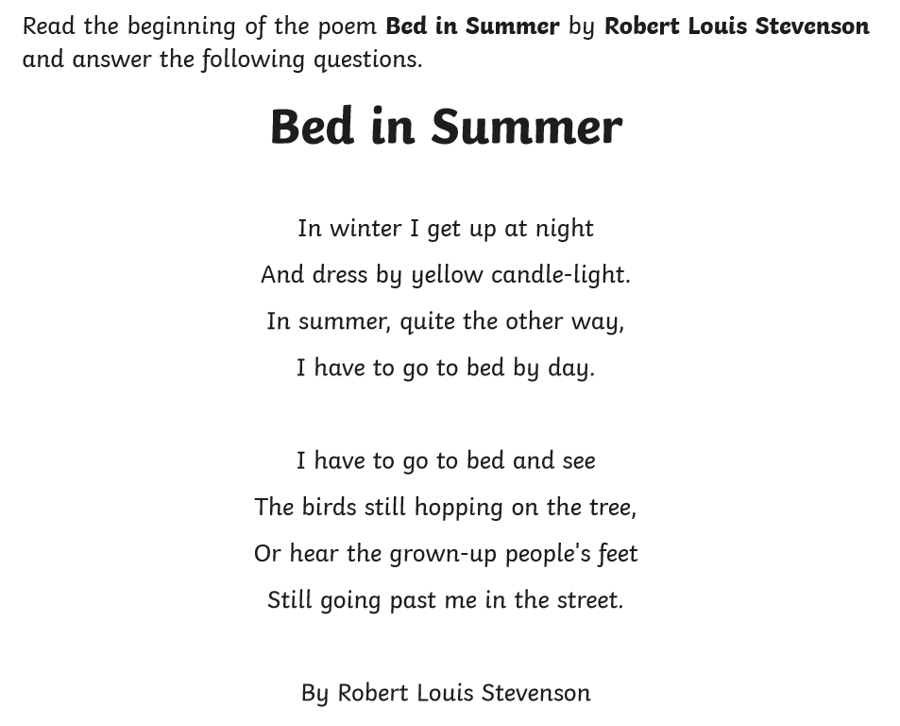
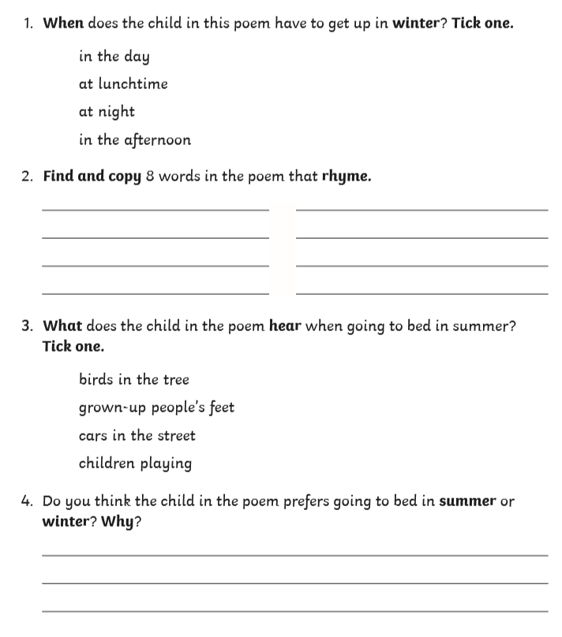

Reading task answers
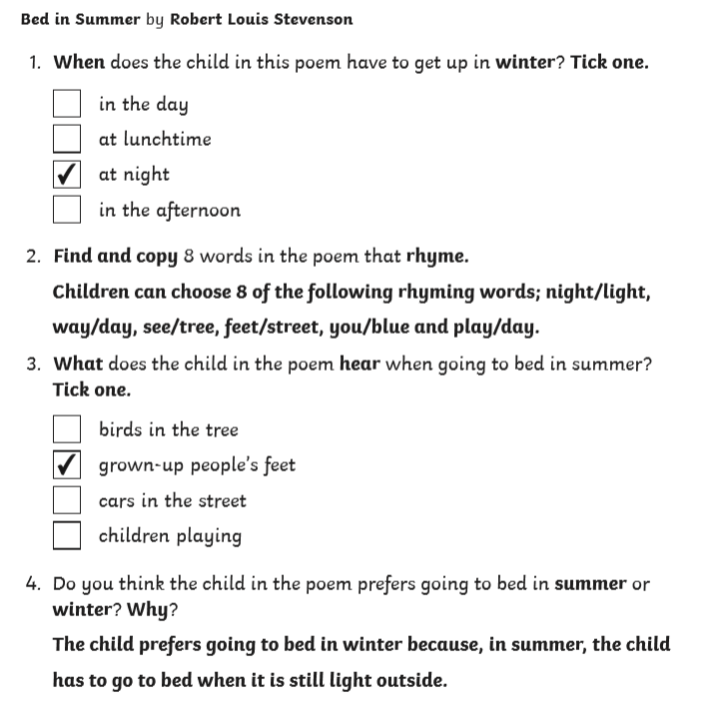

Phonics
For phonics, keep going over the power points for consolidation and here are a couple of summer themed tasks where you will need to use different graphemes to complete the words.
Also, keep practising writing out days of the week and months of the year.
Finally, there is a spelling activity linked to alternative spellings of the ‘igh’ grapheme.
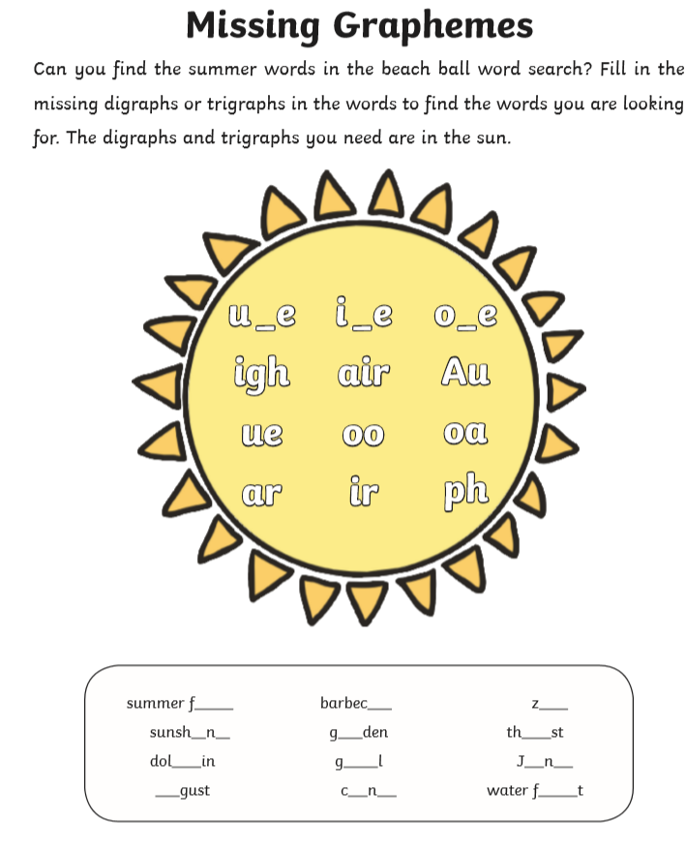

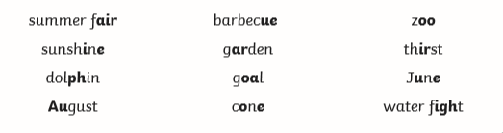

Summer phonics wordsearch
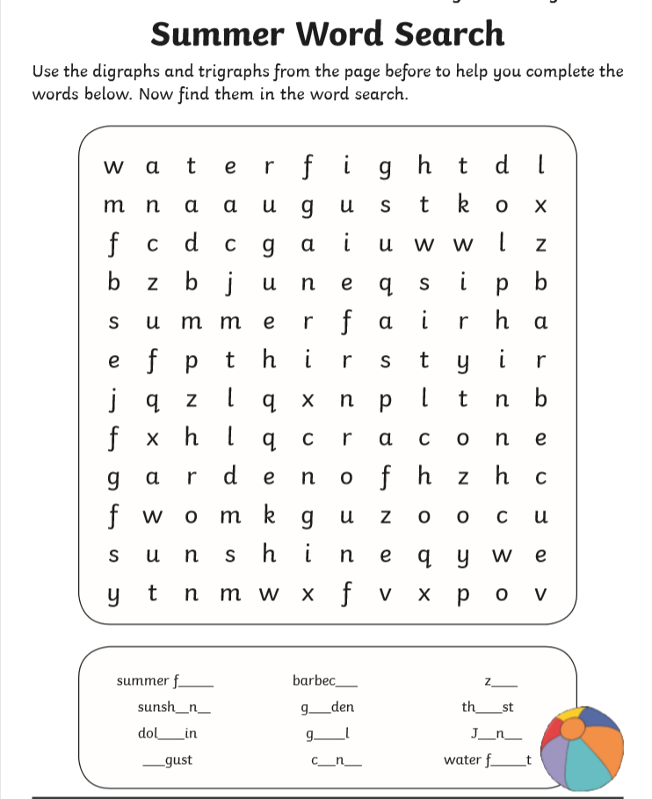

Maths
Maths this week is all about counting in 2s. Here are some tasks linked to this below:
Task 1 – see separate resource entitled counting in 2s.
Task 2 – see below
Task 3 – see below

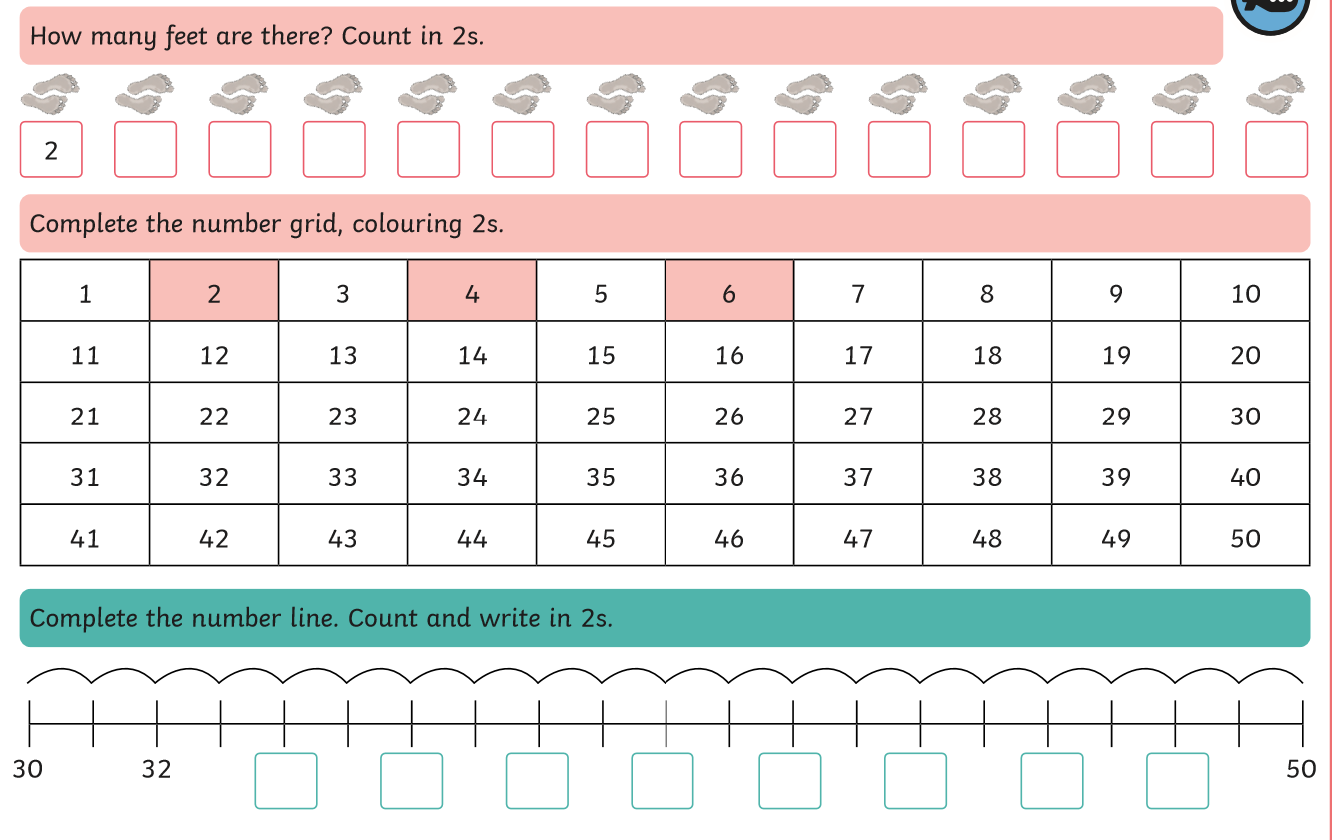
Task 2

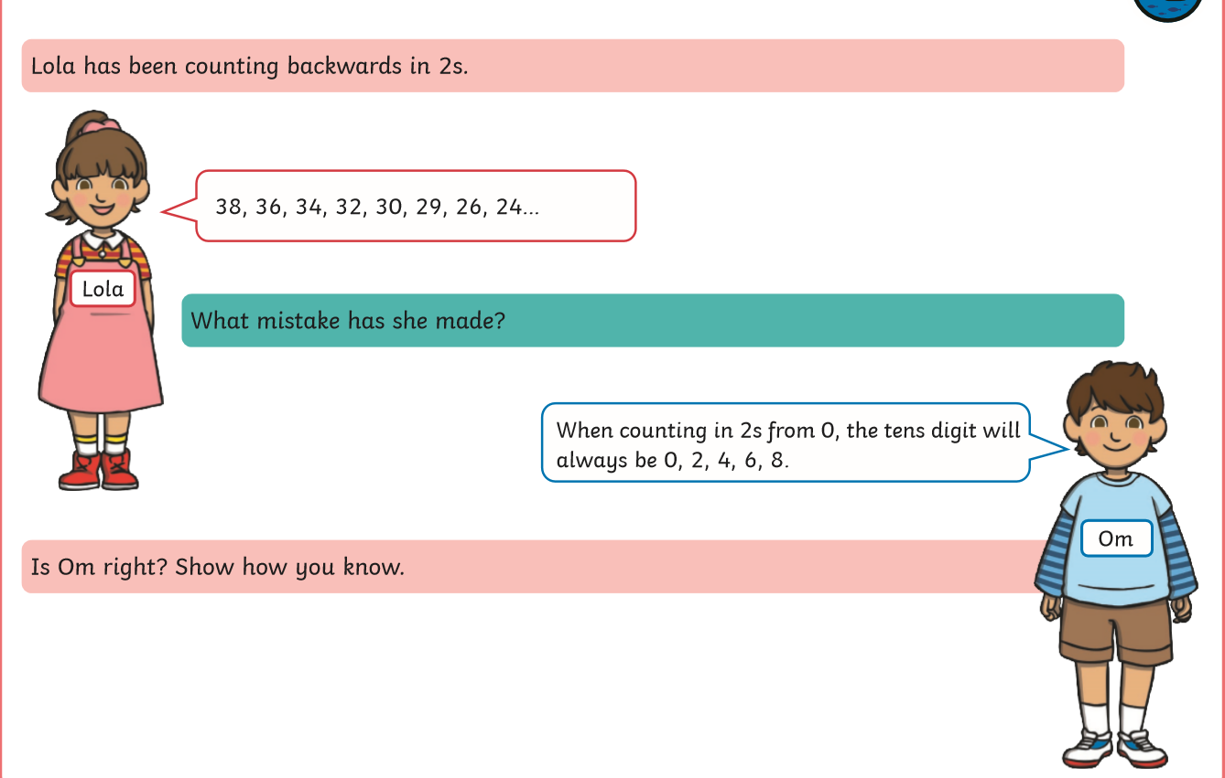

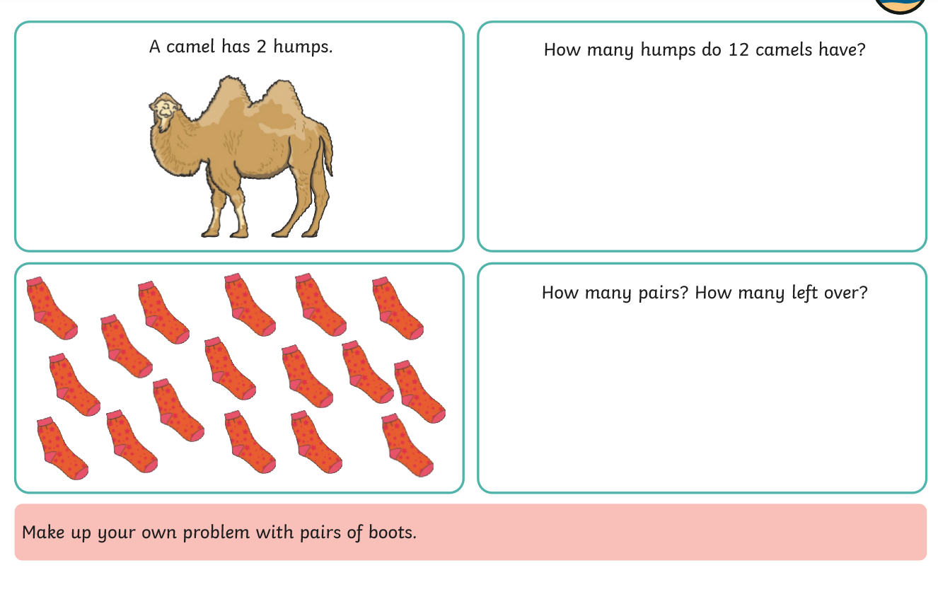

Answers to Task 2
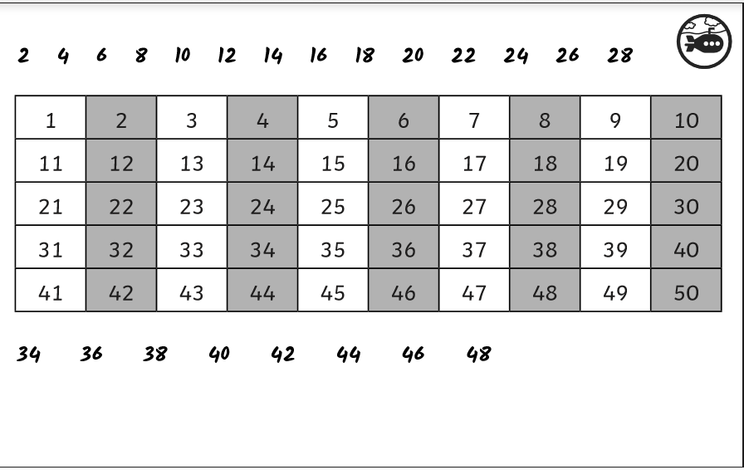

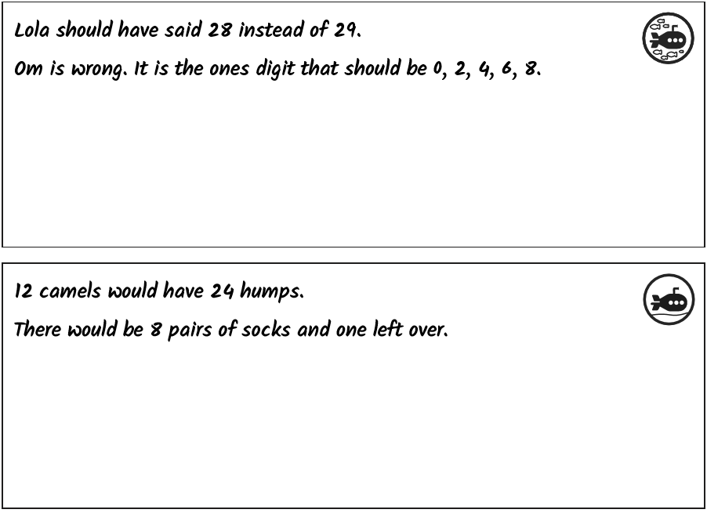

Task 3

Biscuit Decorations

Andrew decorated 20 biscuits to take to a party.
He lined them up and put icing on every second biscuit.
Then he put a cherry on every third biscuit.
Then he put a chocolate button on every fourth biscuit.
So there was nothing on the first biscuit.
How many other biscuits had no decoration? Did any biscuits get all three decorations?

Hints to start you off:
Perhaps you could sketch the biscuits?
The second biscuit has icing on it. Which other biscuits have icing on?
Which biscuits have a cherry on them as well as the third one?
What about the biscuits with a chocolate button on them? Which ones are they?

Answer:
7 biscuits have nothing on them.

