Year 3 Science Experiments
Here is a list of science experiments that you could complete at home. There are many more ideas online so feel free to have a look and choose a different one. Please complete at least one experiment and don’t forget to take a picture of it to send to me!
Website links to fun experiments
- https://teachbesideme.com/experiment-cleaning-pennies/#:~:text=Vinegar%20and%20lemon%20juice%20both,gotten%20a%20little%20bit%20cleaner.
- https://www.science-sparks.com/skittles-experiment/
- https://www.science-sparks.com/changing-colour-flowers-with-transpiration/
- https://funlearningforkids.com/oil-water-science-exploration/
- https://premeditatedleftovers.com/naturally-frugal-mom/disappearing-egg-activity-kids/
Climbing Rainbows Experiment
Equipment
- Tupperware or container
- Different coloured felt tip markers
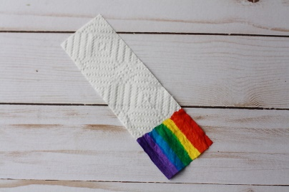
- A wooden stick (kebab stick?) or pencil
- Paper towels
- Scissors
- Tape
- Water
Method
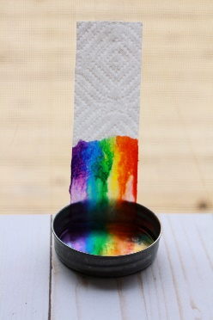
Cut a strip of paper towel approximately 2×5 inches in size. On a short edge, use markers to make a strip of blocks in the colours of the rainbow. Let the marker dry. (We found that if the paper towel is still wet with the ink the experiment does not work as well!). The
next step can be done two different ways. You
can tape the top of the paper towel to a vertical
surface and put only one end in the dish. Or you may
opt to create an arch using a wooden stick. Rest it
lengthwise across and the Tupperware with the coloured
edges just touching the bottom of the container. This way requires both short ends to have coloured edges.
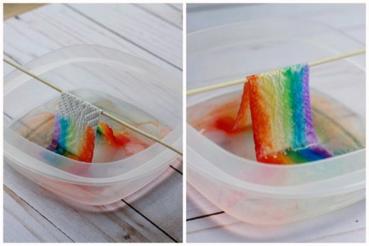

Gently pour water into the bottom of the container and watch what happens! As the paper towel absorbs the water, the capillary action will carry the water along with the marker ink up the paper towel. After the colours climb up or meet in the middle, you have your very own rainbow!

