Year 3 Homework w/c 29th June
Dear parents and kids,
Here is the planning for this week. I have also attached videos for English and Maths – I hope you find them useful! There are also videos uploaded by different members of staff on the school website – under the Children tab – Whole School Online Activity Videos from staff. These are cross-curricular activities, including reading and art. Enjoy!
Numeracy
This week, we are going to continue learning all about fractions using the BBC Bitesize and White Rose websites. I will be providing worksheets for you to complete.
Monday
Today you will be going on a Fraction Hunt around your house/garden/local environment! Fractions can be found and created everywhere, and I want you to see how many you can find.
Here are some that I created!
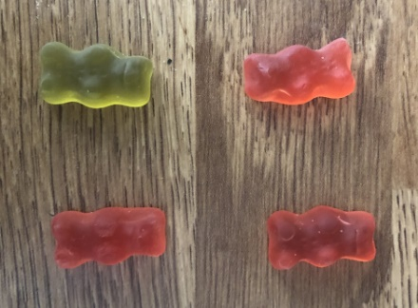
$\frac{1}{4}$ of the gummy bears is green.
$\frac{3}{4}$ of the gummy bears is red.

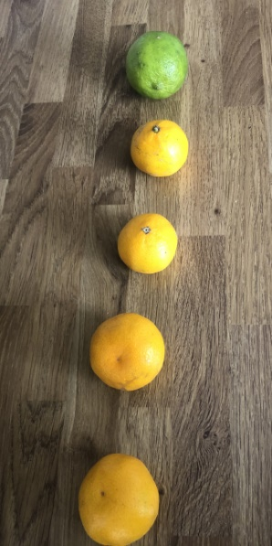
$\frac{1}{5}$ of the fruit is green.
$\frac{4}{5}$ of the fruit is orange.

Take some pictures and send them over to me via email. Don’t forget to add unit and non-unit fractions!

Tuesday
Please use the link below to learn about Tenths.
https://www.bbc.co.uk/bitesize/articles/zmcny9q
I have transferred the resources onto a Word document for you – Tuesday Tenths Activity. For Activity 2, please complete the interactive animation activity, answering the questions as you watch.
Wednesday
Now you are confident with tenths, you are now going to be moving forward with Tenths as decimals. You will now be using a White Rose Maths link to find the relevant video.
https://whiterosemaths.com/homelearning/year-3/
Once you are on that website, please select:
Summer Term Week 6 (w/c 1st June) – Lesson 1 Tenths as decimals
Watch the video and complete the activities as you go along. You will be drawing and reading a place value grid with tenths included. Unfortunately, we do not have access to the White Rose resources so you will need to wait until the end of the video and then complete ‘Wednesday Tenths as Decimals’ resource.
Thursday
Today you are going to be using your fraction knowledge to calculate unit fractions of amounts. Remember – unit fractions have a numerator of 1 i.e. ½ ¼. Use the link below to access the BBC Bitesize page:
https://www.bbc.co.uk/bitesize/articles/zrytnrd
In the examples, it shows you how to calculate unit fractions of amounts using counters. I understand that you will not have counters at home, but you can use household objects including lego, coins or even pasta!
It is only compulsory for you to complete Activity 1 (Thursday Unit Fractions) but feel free to move onto the additional activities if you so wish!
Friday
Today, I would like you to continue calculating unit fractions of amounts. This is the first time that we have done this, so I felt an extra day would really secure your understanding. Please work through the word problems on resource ‘Friday unit fractions’. Don’t forget that you can use physical objects (manipulatives) to help you.
If you feel like you have already grasped this concept with ease, then please move onto the ‘Week 5 Numeracy Extension’ questions.

Literacy
Quick note – if I have not received your pen pal letter, please make sure you send them across to me ASAP .
This week in literacy you are first going to be studying the different uses of apostrophes. We started this earlier on in the year, so it should be something you are familiar with. You are then going to move on a fun playscript writing activity provided by none other than the fabulous Mrs Richardson!
Monday
Today you will be looking at the use of apostrophes for contractions. Use the link below to access the BBC website:
https://www.bbc.co.uk/bitesize/articles/z4p2mfr
There are 2 videos for you to watch before completing Activity 1 and 2 on the website. For Activity 3, you can either click on the link taking you to the twinkl website, or use the ‘Monday literacy contractions’ resource followed by ‘Monday literacy extension’ for those who would like an additional challenge.
Tuesday
Now you will be looking at the use of apostrophes to show possession. Please use the link below:
https://www.bbc.co.uk/bitesize/articles/zmq9kmn
Watch the 2 videos and make sure you read the learning section, as we have not yet used apostrophes to show possession for plural nouns. Activity 1 is to be completed on the website. Activity 2 and 3 (an optional extension activity) can be found on the class page.
Wednesday
To recap the learning from the past 2 days, please complete the 2Dos assigned to you on the use of apostrophes.
Thursday & Friday
Over the next two days, you will be writing a play script based on an episode of Pingu! Please see the resource ‘Pingu Playscript Activity’ for more details!
Spellings
This week you will be assigned a test on contractions via Purple Mash.
In addition, I would like you to use the Spelling Frame website to practice ‘Possessive apostrophes with plural words’ which is a Year 3&4 spelling rule 20.
Apologies for the wrong information last week – the game on this website are not, in fact, free . However, after clicking ‘Spelling Tiles’, there are a range of educational activities for you to complete.

Science + Foundation subjects
Please continue working through the Foundation Subjects Activities.

Have a good week!

Mrs B

