Year 3 Homework w/c 15th June
Dear parents and kids,
What’s happened to the weather?! I hope your home learning packs are still engaging and helping to structure your days. As always, if you have any feedback on the work or ideas for projects that you would like to complete, please let me know!
Numeracy
This week, you are going to be using a new website to help you with division. The webpage is divided up into sections which you will work through. You will be working through videos and complete some practice activities and a quiz each day. Please let me know how you get on with it and if you enjoy the website! I am trying to use different media to keep you engaged so your feedback is always welcome. I hope you find the informative videos helpful!
https://www.khanacademy.org/math/cc-third-grade-math/intro-to-division
If you would like some additional challenges to work on throughout the week, please see resource ‘Maths extension problems’.
Monday
Using the link above please watch the videos:
- Division as equal groups
- Visualizing division with arrays
- Division in context
At the end of each video, you can select the ’Next video’ option. At the end of the last video there will be a ‘Take quiz’ option (quiz 1) – please complete this.
Tuesday
Please watch the 3 videos in the ‘Relating multiplication and division’ section and complete the 4 Practice activities. Final finish with Quiz 2.
Wednesday
Today there are no videos in the ‘Divide by 1, 2 or 4’ sections. Please complete the 3 practice activities then Quiz 3.
Thursday
Again, there are no videos today. Please complete the 4 practice activities in the ‘Divide by 5 or 10’ and ‘Divide by 3 or 6’ sections. Finish with Quiz 4.
Friday
To finish this topic, I would like you to complete your multiplication ‘daddy grid’. If you find that you are completing this with ease, try adding in 13, 15 and 20 into the grid for a challenge! Please then complete the multiplication 2Do assigned to you. This is very similar to the national test you will be completing at the end of Year 4. I have customised them for you so you may have more than one to do!
Literacy
This week in literacy you are going to be using ‘The Truth about Trolls’ resource to help you work on your reading and creative writing skills. Please download the activity pack.
Summer Reading Challenge
The Reading Agency charity is running a free program over the summer to engage and encourage children (and adults!) to read more. Using the power of ‘silly’ provided by the ‘Silly Squad’ they want to help kids stay kids and embrace the fun just when we need it most. Please see info below.
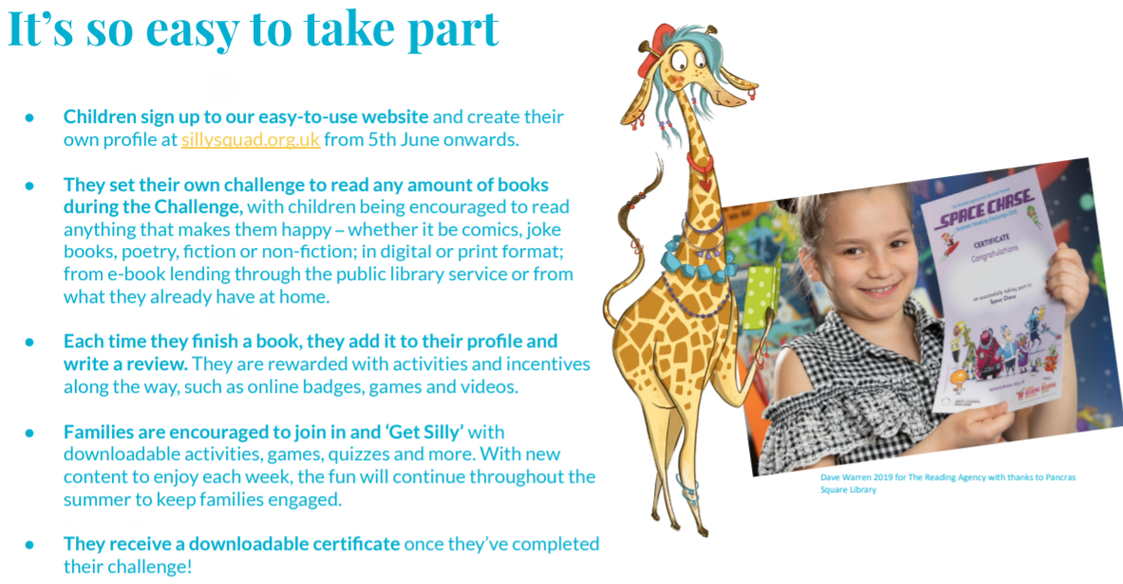

Spellings
You are going to continue working through the Year 3 & 4 common exception words. Please complete the 2Do assigned to you. Why don’t you try writing them out in silly sentences? Can you write a short paragraph using all the words?
I have uploaded a worksheet to help you practice the words before completing the 2Do. Please see ‘Common Exception Word Practice.’

Science + Foundation subjects
Use the resources ‘Foundation subjects’ and ‘Year 3 Science Experiments’ to continue working through the possible activities.

Have a good week!

Mrs B

