Wild Horses!
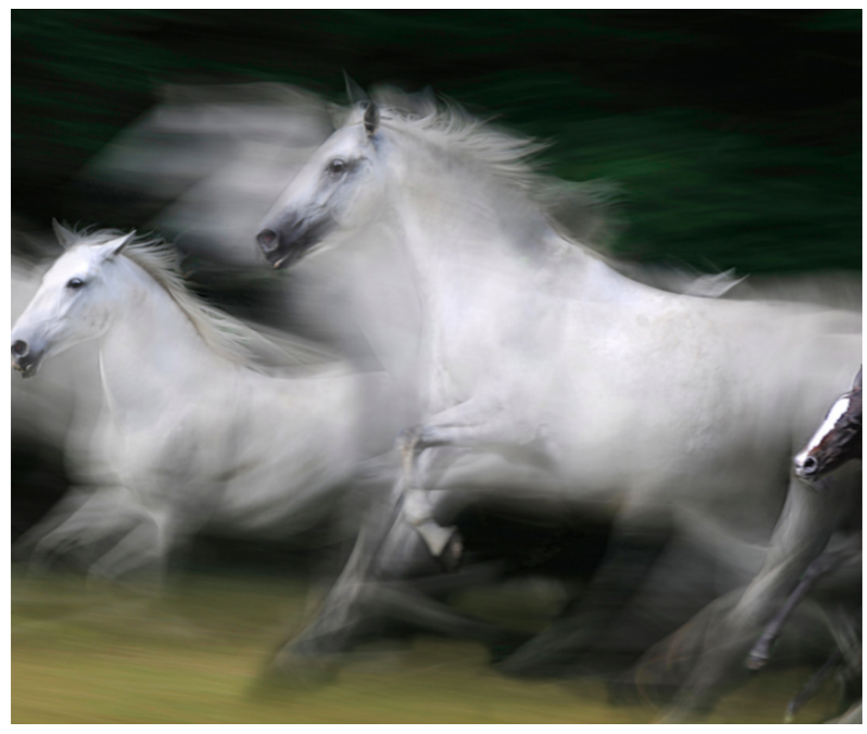
This week I have again used Pobble 365 to create a series of writing tasks around the illustration above – ‘Wild Horses’. The list of writing opportunities is not exhaustive – maybe you have your own ideas for a writing task you could undertake? Don’t forget to celebrate your learning with me – email it across and I promise I will reply!
Question Time!  Who is the girl watching the horses?  Why is she out all alone?  Why do you think the horses are travelling so quickly?  Have you ever seen wild horses?  Why do you think there are few horses seen in the wild?  Do you think there are more in other parts of the world?  Do you think there used to be more wild horses in the past?  Do you know of any other animals that are found in the wild, but are also used for domestic purposes? |  | Story Starter:  Their speed was such that they appeared a blur to the little girl watching them. She sat on a stone wall, knees pulled up to her chest, bracing herself slightly against the strong breeze.  The herd of wild horses moved as one: a frothing, raging river cascading across the countryside. They reminded her of a waterfall she had visited with her parents last summer. The foam that formed on top of the surging water as it bubbled away in the plunge pool like a witch’s evil potion was the same colour as their long, flowing manes.  The horses seemed to be startled by something. What were they running from? Or was it perhaps that they felt a sense of great urgency to reach a certain destination?  The girl sat and pondered at the question…
Sentence Challenge:  Collective nouns are names for a collection of people or things. For example, a herd of wild horses.  How many different collective nouns do you know?  Can you think of the collective nouns for 10 different animals? | Sick sentences:  These sentences are ‘sick’ and need help to get better. Can you help?  The horses ran across the field. They were white. They were moving very quickly. | Perfect Picture:  Can you draw a picture of something else that might move extremely quickly?  Try to show that the thing is moving very quickly in your picture.  Write a description to accompany your picture. | For all these tasks, please try to think about and include:  - Write in paragraphs, grouping related material together.  - Expanded noun phrases with prepositional language  - Fronted adverbials  - Ensure standard English forms for verb inflections, e.g. we were instead of we was, I did instead of I done.  - Proof read your work for spelling and punctuation errors  - Subordinate clauses

Look very carefully at the Year 3 / 4 Common Exception Word List.  Identify 8 spellings that you are still working on and focus on these this week. Think about some of the strategies we have learnt in class. How creative can you be in how you practise them?  Or why don’t you try:  https://www.ictgames.com/littleBirdSpelling/ | Let’s recap apostrophes.  You can use:  https://www.bbc.co.uk/bitesize/articles/zmt2mfr  I have included the recommended written activities from Bitesize with all the Year 4 information for this week.  There are apostrophes activities set on Purple Mash too. | Spelling rule  Recap -sion  division  invasion  confusion  decision  collision  television  abrasion  expansion  erosion  excursion

