Singular or Plural Sentences
In the sentences below, an apostrophe has been used to show possession. However, in one option it shows an apostrophe being used with a singular noun and in the other it shows the apostrophe being used with a plural noun. Tick the sentence that shows the apostrophe being used with a plural noun.
- The babies’ bottles were all lined up on the side ready for feeding time.
The baby’s bottles were all lined up on the side ready for feeding time.
- While they were trying to escape, the mouse’s tails were chopped off by the farmer’s wife.
While they were trying to escape, the mice’s tails were chopped off by the farmer’s wife.
- The boy’s new T-shirts were on the bench. The boys’ new T-shirts were on the bench.
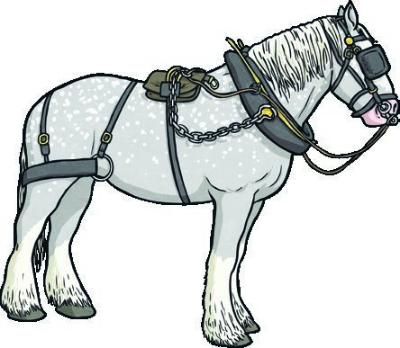
- The teachers’ work has to be finished after assembly.
The teacher’s work had to be finished after assembly.
- The horse’s shoes needed replacing. The horses’ shoes needed replacing.
Page 3 of 8

Singular or Plural Sentences
- The girl’s dresses were hung up in the wardrobe. The girls’ dresses were hung up in the wardrobe.
- The foxes’ home is underground.
The fox’s home is underground.
- The dragons’ strong wings beat swiftly through the sky.
The dragon’s strong wings beat swiftly through the sky.
Parent Note  When completing this exercise with your child, discuss the difference in meaning between the two sentences. If you child can give a clear explanation, it shows that they have mastered the difference between using apostrophes with singular and plural nouns. | 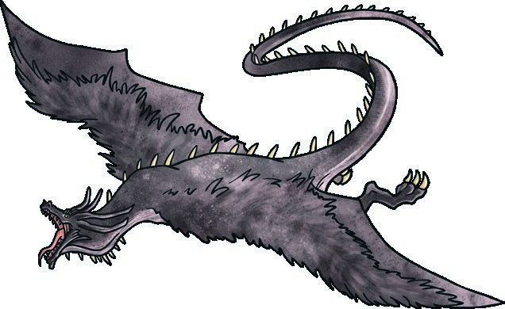
Page 4 of 8

Year 3 and 4 Punctuation: Apostrophes for
Possession with Plural Nouns
Learning From Home Activity Booklet Answers

Singular or Plural Sort
Singular | Plural
boy’s  witch’s wolf’s  actor’s  elephant’s alien’s | boys’  witches’ wolves’ actors’  elephants’ aliens’

Challenge
Accept any answer where a possessive apostrophe is used with a plural noun, e.g. The aliens’ spaceships zoomed through the night sky.

Singular or Plural Sentences
- The babies’ bottles were all lined up on the side ready for feeding time.
- The wolves’ howls echoed through the misty forest.
- The boys’ new T-shirts were on the bench.
- The teachers’ work has to be finished after assembly.
- The horses’ shoes needed replacing.
- The girls’ dresses were hung up in the wardrobe.
- The foxes’ home is underground.
- The dragons’ strong wings beat swiftly through the sky.

Complete the Sentence
- The lions’ manes waved in the gentle breeze.
- The ants’ colony was hidden high in the branches of a tree.
- In the forest, the wolves’ howled at the iridescent moon.
- Mum scowled as she looked at the boys’ dirty T-shirts.
- In the evening, the dogs’ loud barking disturbed all the neighbours.
- Everybody ate lots of food at the children’s party.
- Bang went the gun at the start of the men’s 100m race final.
- The ponies’ fur was washed and brushed ready for the parade.
Be the Teacher!
In the forest, the wolves’ howls echoed as the trees’ branches swayed in the wind. Underground, in the foxes’ home, they huddled together to get warm. In the trees, the squirrels’ feet pattered as they scrambled up and down the branches looking for food. In a clearing, the children’s hands shivered with cold. On the children’s heads, were warm, woollen hats and scarves around their necks. The scarves’ tassels fluttered like snowflakes. On their feet, all the shoes’ laces were frozen in the cold weather. From close by, the adults’ shouts floated on the wind. The boys’ faces began to smile as it was time to go home and get warm.
Correctly placed apostrophes have been circled. All other apostrophes should have been crossed out by the children.

Page 8 of 8

