Tenths
© Classroom Secrets Limited 2020
1. Magnus eats of a pizza and Lucy eats of the same pizza. 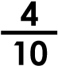 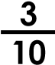
He says,
Altogether, we have eaten .
7
10
Magnus
Is Magnus correct?
2. Brendan has made a representation of .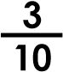
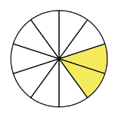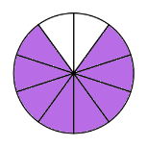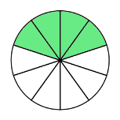
A
B
C
D
E
F
Which representation belongs to Brendan?
3. Lucy has made a pyramid of tenths. Each fraction shown in a rectangle is the sum (total) of the fractions in the two rectangles below. Complete the fractions.
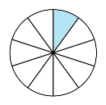
10
3
10
2
10
10
10
10
Visit kids.classroomsecrets.co.uk for online games to support learning.
Join our Group: Coronavirus Home Learning Support for Teachers and Parents

