While you are at home, pick 1 or 2 activities a week to complete.
History  Do you know who Tim Berners Lee is and why he is important? Research this figure and create an informative poster OR create an informative Powerpoint Presentation on your computer. | Music  Can you create a range of musical instruments out of recycled materials?  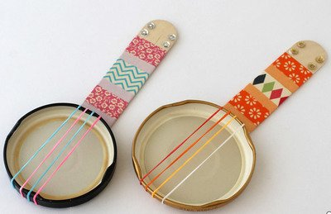  Make sure you send me some of your finished results!
Design and Technology  Can you design a new vehicle? I have attached a worksheet that you can use to design, make and evaluate your design. Make sure you send pictures of your finished product!  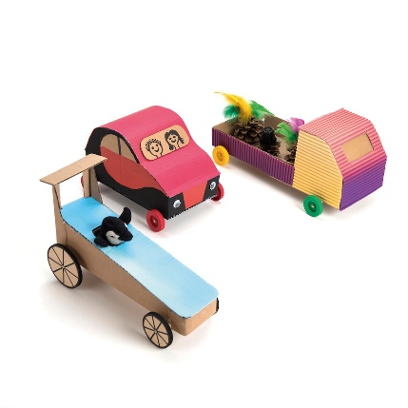 | Science  Can you explore the four seasons: Autumn, Winter, Spring and Using Summer? Using pictures from magazines or newspapers, can you create a picture collage for each season?  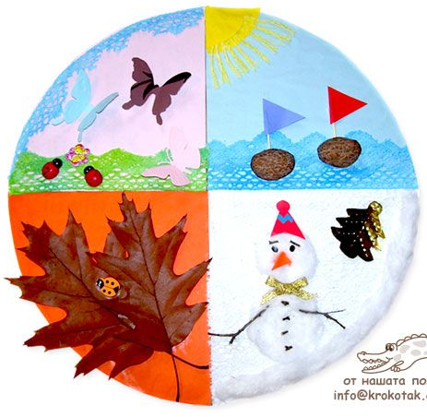

Art project
This week I have a special art project for you created by a wonderful author and illustrator called Christian Robinson. He has an amazing YouTube channel called ‘Making Space with Christian Robinson’ in which he invites anyone, big or small, to join in making something together. Each video offers a way to creatively engage with topics such as friendship, gratitude, limitations, and mood. You can use simple materials like scissors, scrap paper, and crayons to make your own art or simply enjoy watching the process behind Christian’s creations.
This week the video is Making Space: Anger. Christian says,
“When anger arises, there are usually other emotions just below the surface. It can be difficult to express yourself with words when emotions run high. Perhaps pictures can give us another way to show how we feel.”
Join Christian as he endeavours to heal feelings of anger while creating an “iceberg of emotions”.
Find Christian’s video by typing ‘Making space with Christian Robinson’ in YouTube and find the latest video entitled ‘Making Space: Anger.’
Make sure you send pictures of your finished piece.
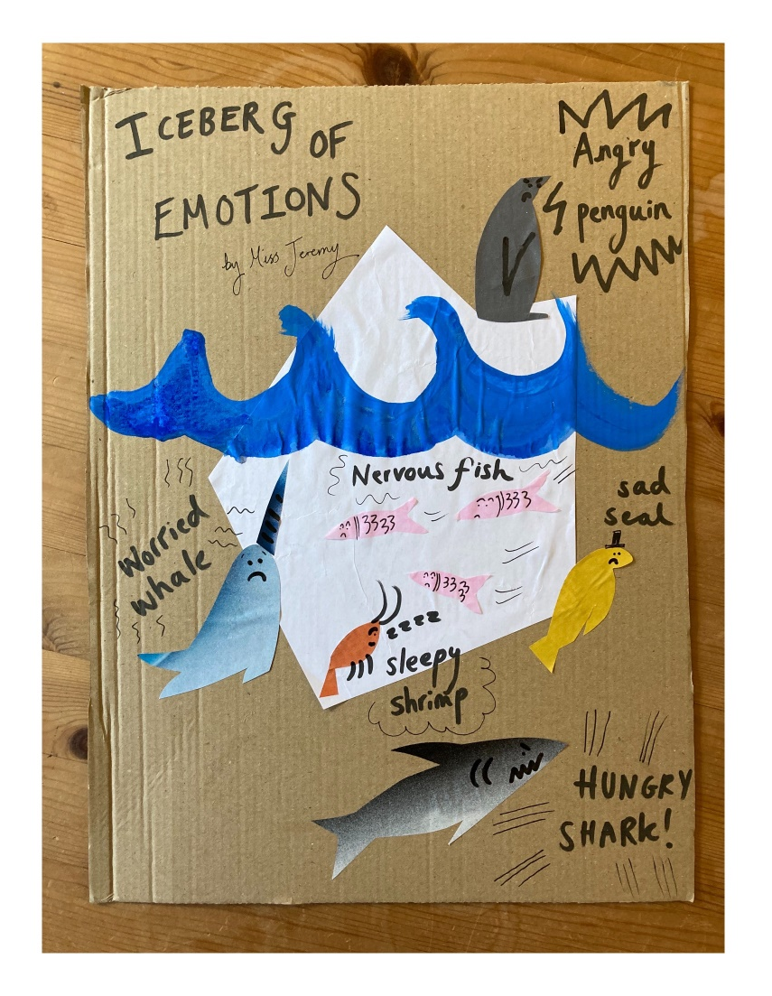
This is my ‘Iceberg of Emotions’. I had so much fun doing it! I hope you do too! Miss Jeremy x

