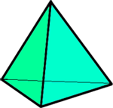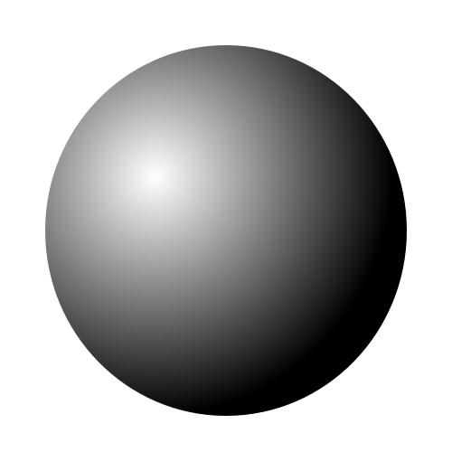



**Shapes!**

**Cuboid**

- **Shape** of faces…………..........  
  
…………………………………………………….

- Number of **faces**….....………….

- Number of **edges**…………….…..

- Number of **vertices**…………….



**Shapes!**

**Triangle based pyramid**

- **Shape** of faces…………..........  
  
…………………………………………………….

- Number of **faces**….....………….

- Number of **edges**…………….…..

- Number of **vertices**…………….



**Shapes!**

**Sphere**

- **Shape** of faces…………..........  
  
…………………………………………………….

- Number of **faces**….....………….

- Number of **edges**…………….…..

- Number of **vertices**…………….



**Shapes!**

**Cube**

- **Shape** of faces…………..........  
  
…………………………………………………….

- Number of **faces**….....………….

- Number of **edges**…………….…..

- Number of **vertices**…………….



**Shapes!**

**Cylinder**

- **Shape** of faces…………..........  
  
…………………………………………………….

- Number of **faces**….....………….

- Number of **edges**…………….…..

- Number of **vertices**…………….



**Shapes!**

**Square based pyramid**

- **Shape** of faces…………..........  
  
…………………………………………………….

- Number of **faces**….....………….

- Number of **edges**…………….…..

- Number of **vertices**…………….

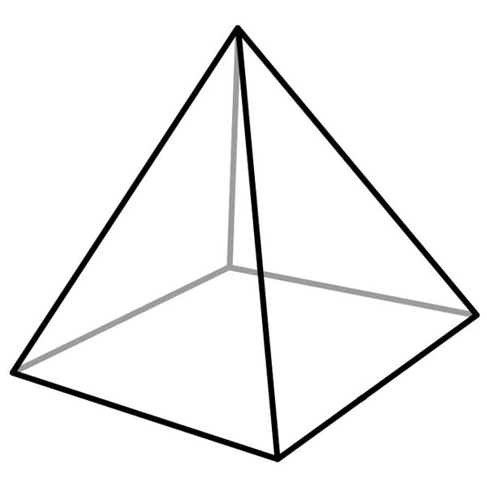



**Shapes!**

**Pentagonal prism**

- **Shape** of faces…………..........  
  
…………………………………………………….

- Number of **faces**….....………….

- Number of **edges**…………….…..

- Number of **vertices**…………….



**Shapes!**

**Cube**

- **Shape** of faces…………..........  
  
…………………………………………………….

- Number of **faces**….....………….

- Number of **edges**…………….…..

- Number of **vertices**…………….

