Once upon a time a 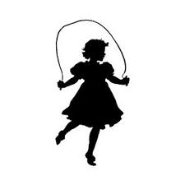 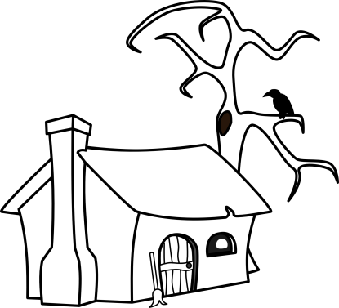 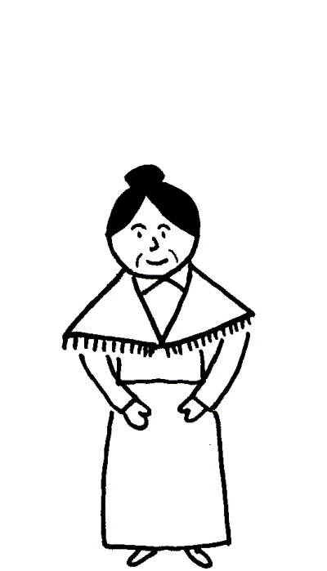
Early one morning 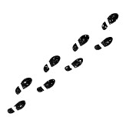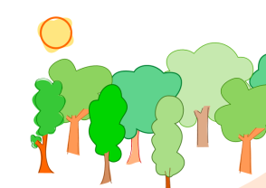 when she helped 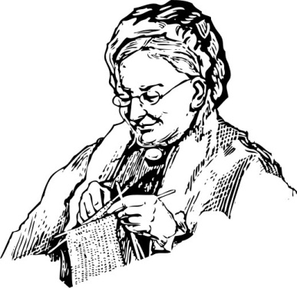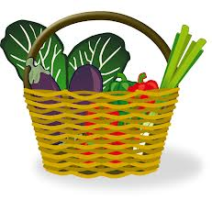
So the kind gave her a .
Say the words “cook, little pot, cook” and it will give you .

But once you have eaten enough say “Stop, little pot, stop.”

all the way to show her .

“cook, little pot, cook” said Poppy.
Soon was full of
“Stop, little pot, stop” and the
One day was visiting her 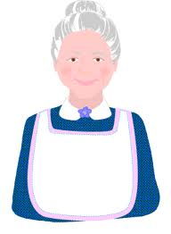 when felt hungry.

“cook, little pot, cook” said her mother.

Soon the was full of
Unfortunately, could not remember !

Oh dear! There was porridge everywhere...
It poured on to the 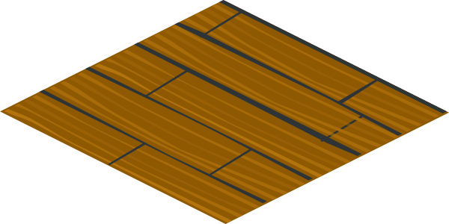down 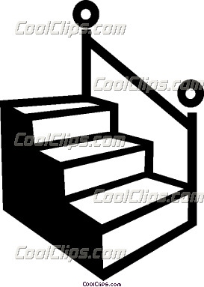 down 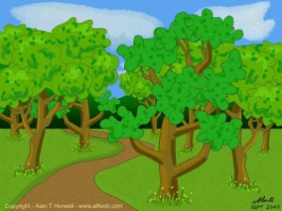 until there was EVERYWHERE!
When ”STOP, LITTLE POT, STOP!

Luckily the
In the end had to for a whole 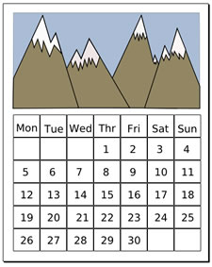 and they lived
happily ever after!

