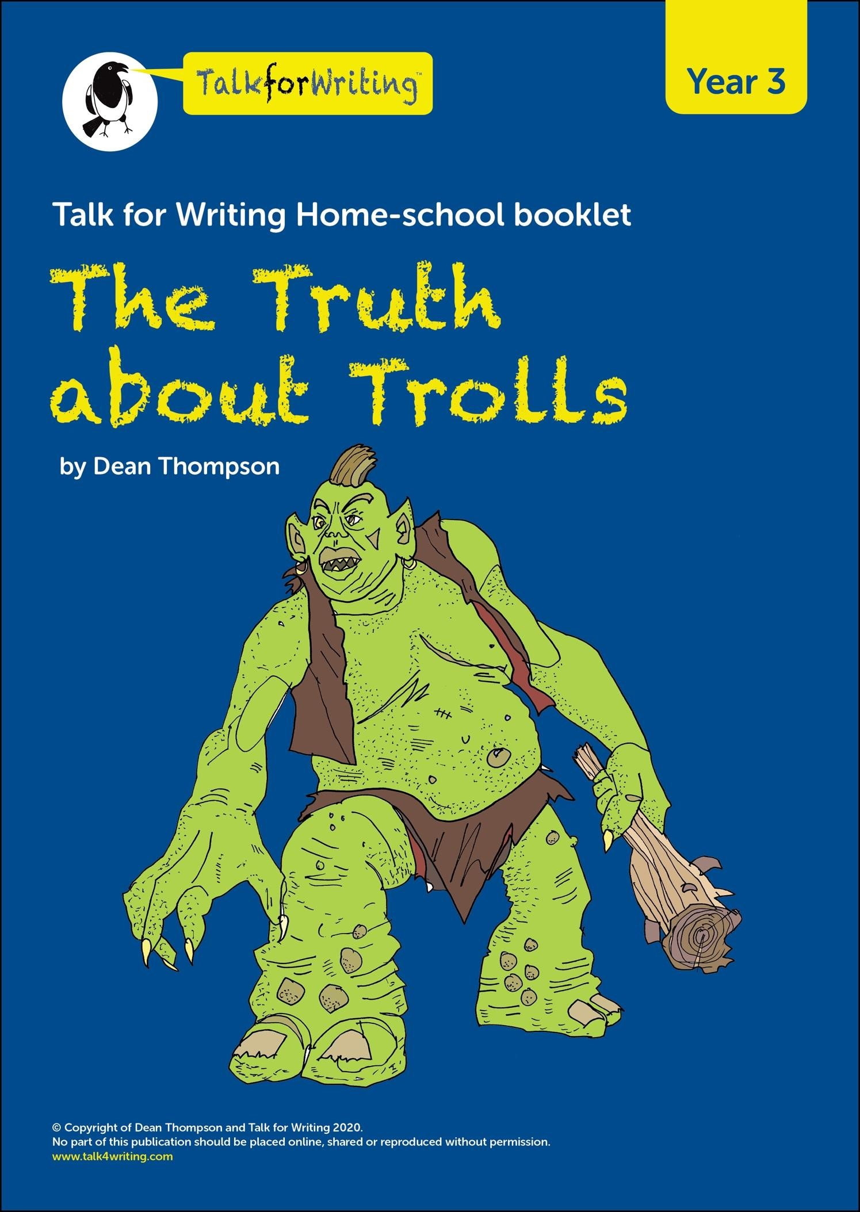
Introduction
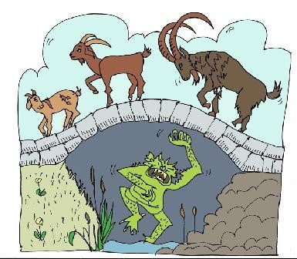
There are many stories that have trolls in them. Trolls, like dragons, giants and unicorns, have been talked and written about for hundreds of years. One very wellknown story, I am sure you will know, is about a very angry troll that tried to stop goats going over a bridge to feed on the rich, green grass.
But is this what all trolls are really like?
The information that follows has been written by Professor Folklore, an expert on Trolls from the University of Myth and Legend.
He provides some basic information on these strange, often misunderstood mythical creatures. You can decide what you think maybe true and what needs more research to establish the truth.
Professor Folklore needs other experts to write more about trolls so that the ‘truth’ can be shared across the world. He wondered whether you could also become an expert on trolls. Can you dream up some of your own interesting and amazing information to set the record straight and not let trolls just be known as nasty, mean creatures?
You can listen to a recording of the story of The Truth about Trolls text below here: https://soundcloud.com/talkforwriting/trolls/s-7815f2MesfN

The Truth about Trolls
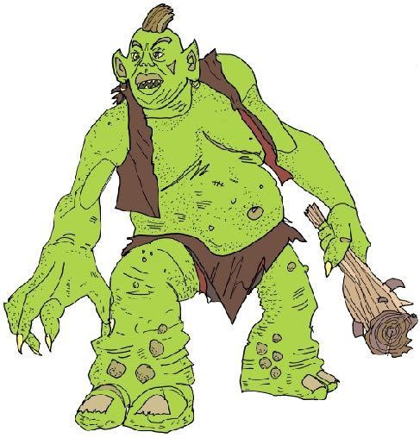
Many people believe trolls are angry, mean beasts that terrify goats and people. However, this is not true. Here is the truth about trolls.
What do trolls look like?
Like the ogre, trolls are huge. They look fierce and ugly but to another troll they are kind and beautiful. The adult troll has small, beady eyes, a bulbous, warty nose and sharp, yellow teeth. Most trolls have long, curly horns on their heads similar to a goat. Interestingly, a few trolls do not have any horns at all. No one knows why.
Where do trolls live?
Trolls are usually found in very cold countries like Iceland. They make
their homes in caves near volcanoes which provide both warmth and shelter. They live peacefully in small family groups, hidden away from people. One troll, who was very grumpy, lived alone under a wooden bridge. Because he bullied the local goats, he gave all trolls a very bad name.

What do trolls eat?
Trolls enjoy eating all types of seafood. Trolls fish in total darkness so that they are not seen by anyone. They mostly eat their food raw. Sometimes, when the volcanoes have erupted, they cook their food on the hot rocks. In addition, they gather large mushrooms and dig up juicy roots that grow in the forest. Surprisingly, goats are not on the menu!
Did you know?
Amazingly, trolls like to have fun. They love singing and dancing. When they sing, it sounds like a rumble of thunder. When they dance, it feels like an earthquake. Sadly, because of the troll that upset the goats, all trolls now hide away from view.
They can still be seen, though, if you look really hard and believe. The rocks here are actually just sleeping trolls!
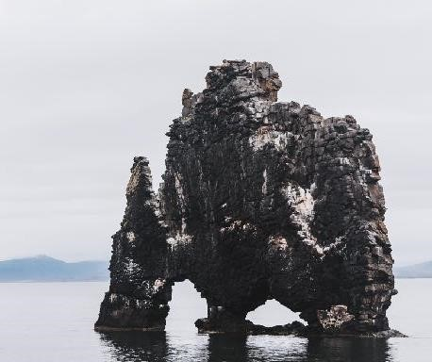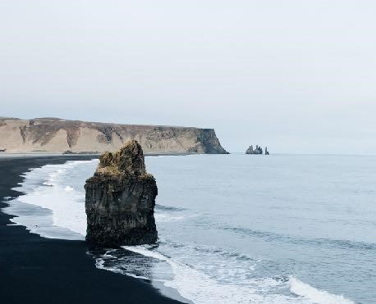

Glossary
Here’s some help with the tricky technical vocabulary:

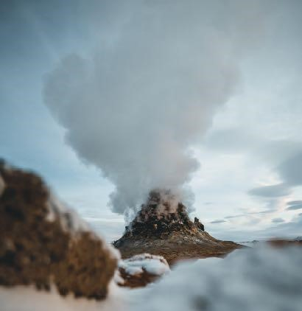
earthquake: Sudden shaking of the ground when the Earth’s surface moves. Can cause terrible destruction.
volcano: a hole in the Earth, usually a mountain, where very hot, molten rock (magma) and hot gas from the centre of the Earth erupts – can cause terrible destruction erupt: the action that happens when a volcano spits out hot molten rock (magma) and gas – can cause terrible destruction

cave: Hole or space in rock big enough for a person to go into.

Further Information on Earthquakes from BBC Bitesize https://www.bbc.co.uk/bitesize/topics/z849q6f/articles/zj89t39 Further Information on Volcanoes from BBC Bitesize
https://www.bbc.co.uk/bitesize/topics/z849q6f/articles/zd9cxyc

Monday What do the words mean?
- Read the information on trolls. All of the words below are in bold. See if you can work out what they mean and jot down your ideas here.
- If you are stuck, there is a list of similar words below to help you. If you are still stuck, you could ask someone else in your home to tell you, use a dictionary or the internet.

Target Word | Definition that fits with the information text
mean
terrify
ogre
fierce
bulbous
warty
shelter
peacefully
bullied
raw
gather

Similar Words Help Box

scare uncooked collect quietly (not at war) nasty home

big and swollen lumpy angry giant frightened

Tuesday
Grammar Games

★ Let’s investigate some of the words and phrases that help you to write interesting information text.

The Adjective Game:
Adjectives are used describe a noun. For example:
The tired, old man wandered over the busy road.

To make information writing interesting for the reader you can add adjectives to describe different nouns. In ‘The Truth about Trolls’, the writer, Professor Folklore, has decided to describe the eyes, nose and teeth of the trolls using two adjectives.

These have been separated using a comma as this is a list.
small, beady eyes _________ , __________ eyes bulbous, warty nose _________ , __________ nose
sharp, yellow teeth _________ , __________ teeth

Try and think of some interesting adjectives to describe different bits of a troll. Try to make your troll seem friendly or unfriendly.

The troll has:
__________________ , ___________________ horns
__________________ , ___________________ hair
__________________ , ___________________ ears
__________________ , ___________________ hands

Challenge 1: Choose some other parts of a troll to describe using two adjectives.
_______________ , ________________ _____________
_______________ , ________________ _____________
_______________ , ________________ _____________
_______________ , ________________ _____________

Challenge 2: Could you use two adjectives that start with the same sound – this repetition is called alliteration?

For example,
bright, bulbous eyes
huge, hairy ears

Writing Tip – “Has every word earned its place?”
Make sure both adjectives you have used to describe your troll are telling the reader something different. For example, large, big nose doesn’t work because large and big are really saying the same thing.

Challenge 3: Sentence of 3 game

You can see that 3 features have been used to help describe the troll: The troll has beady eyes, a bulbous nose and yellow teeth.
Now use your nouns and adjectives from above to write new sentences of three to describe your troll.
The troll has ____________________ , __________________ and __________ .

You need a comma after the first of the three things. Then use and after the second of the three things you are describing.

The troll has wicked eyes, a hooked nose and terrible breath.

Additional Creative challenge: Use your ideas to draw your troll – label the different features.

Wednesday

Engaging Adverbs Game

Adverbs can be used at the start of a sentence to make the information
engage the reader. In ‘The Truth about Trolls’, Professor Folklore has used Interestingly, Surprisingly and Amazingly to start some of his sentences:

Interestingly, a few trolls do not have any horns at all.
Surprisingly, goats are not on the menu!
Amazingly, trolls like to have lots of fun.

Try and think of something interesting, something surprising and something amazing about your trolls and use adverbs based on these emotions to introduce this information when you write your own engaging sentences.
Remember to use a comma after the adverb at the start of the sentence.

Interestingly,

Surprisingly,

Amazingly,

Thursday Drop-in Game

Please use the below link for help on what a relative clause is:
https://www.theschoolrun.com/what-is-a-relative-clause

Have a go at dropping extra information into a sentence using a relative clause that starts with who. In ‘The Truth about Trolls’, Professor Folklore first wrote:

One troll lived alone under a bridge.

Then he added in another bit of information using who.

One troll, who was very grumpy, lived alone under a wooden bridge.

What else could you ‘drop-in’ to tell the reader something else about the troll?

One troll, who __________________________ , lived under a bridge.
Use this sentence to drop-in extra information for the reader starting with who.

Remember to use a comma before and after the dropped in information. Tip – use a different coloured pen for your drop-in information.

Friday
Now, let’s think about writing some new information about trolls.

In ‘The truth About Trolls’, Professor Folklore used questions as subheadings to help organise his writing and make it easier for the reader.

Here is the underlying structure of the professor’s information text about trolls.

Underlying Structure
Heading: The Truth About Trolls
Introduction to get reader interested in topic
What do trolls look like?
Where do trolls live?
What do trolls eat?

Did you know?
Keep your best facts for the end!

★ Challenge: What other sections could you add?

- What is troll’s school like?
- What jobs do trolls do?
- How do trolls look after their babies?
- What do trolls do on holiday?
- What is in a troll’s cave?
- ?????????????????????

- Use the planner below to jot down some ideas for your information on trolls.

- You can use the ideas from the word and sentence games.
Remember you are the new expert!

Underlying structure | New Ideas
- Heading  - Introduction to get reader interested in trolls | Heading  Introduction to get reader interested in trolls
What do trolls look like?

Where do trolls live?
What do trolls eat?

Did you know?
Keep your best facts for the end!

- Use the model text and your plan to draft and edit your new information on trolls.

Challenges:

Remember to:
- give the reader a picture in their head by using adjectives to describe the features of your troll;
- build up a picture for the reader using a sentence of 3 to describe your troll;
- engage your reader by using adverbs of emotion at the start of a sentence – see below.
- drop-in extra information for the reader by using a relative clause starting with who.

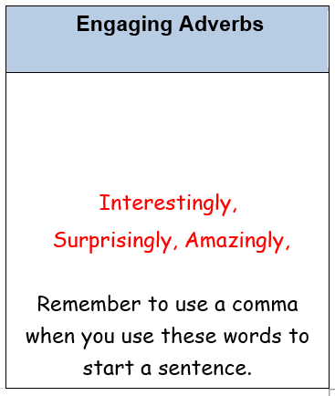

- Read your work through and check that it flows and makes sense
- Remember to check the spelling and punctuation and illustrate your text with pictures or drawings.

