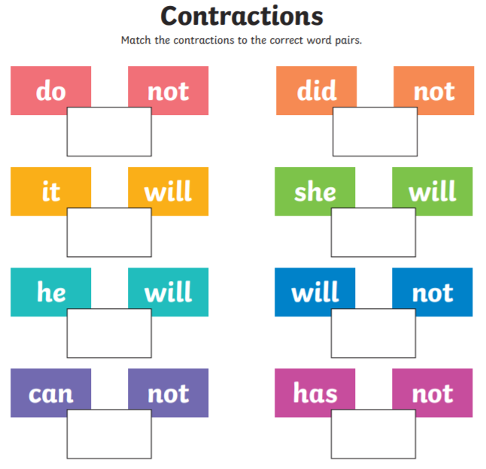

Extension activity – please see resource ‘Monday extension activity’.

