Maths:
Please find below maths activities for the week, though if you prefer, you may wish to look at:

https://classroom.thenational.academy/year-groups/year-4/
https://www.bbc.co.uk/bitesize/levels/zbr9wmn
https://whiterosemaths.com/homelearning/year-4/
https://kids.classroomsecrets.co.uk/category/year-4/
https://www.themathsfactor.com/
https://www.mathletics.com/uk/resources/fun-engaging-student-workbooks/

Try to begin each day with a mental maths challenge. I have attached some different multiplication and division challenges as I know many of you are now multiplication grid experts, or you may like to choose an activity from

https://www.topmarks.co.uk/maths-games/hit-the-button
https://www.timestables.co.uk/
https://www.topmarks.co.uk/maths-games/7-11-years/times-tables
https://mathsframe.co.uk/en/resources/resource/477/Multiplication-Tables-Check
You can also use Purple Mash.

Day 1:
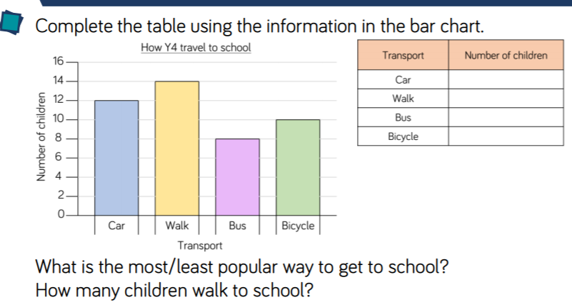
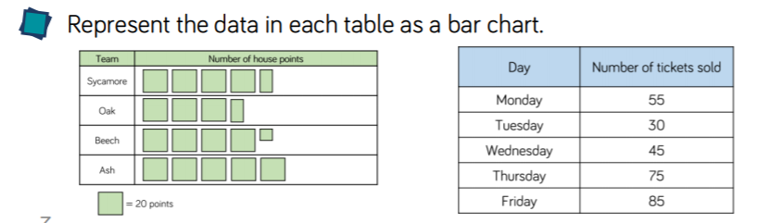

Remember to give each bar chart a title, and labelled axes.

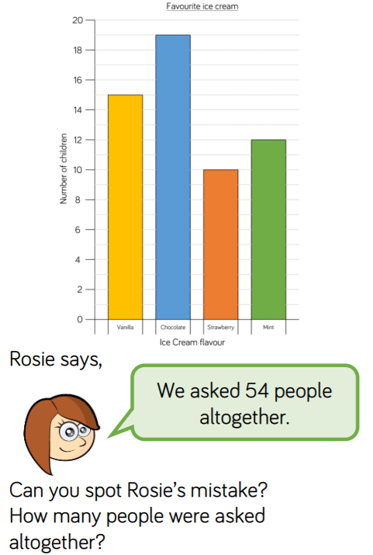
Challenge:

Answer:
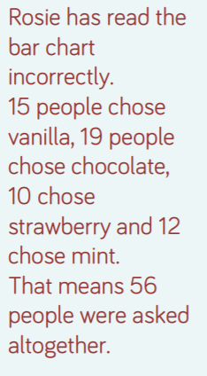
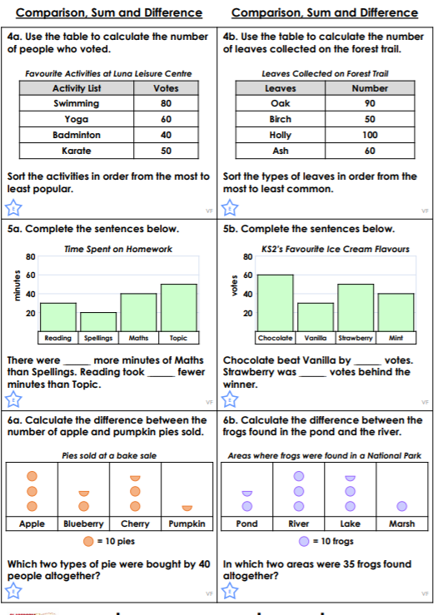
Day 2:

Answers:
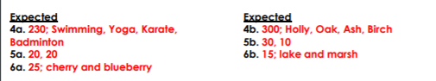

Challenge:
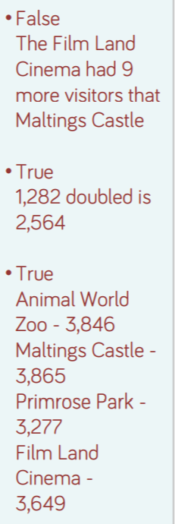
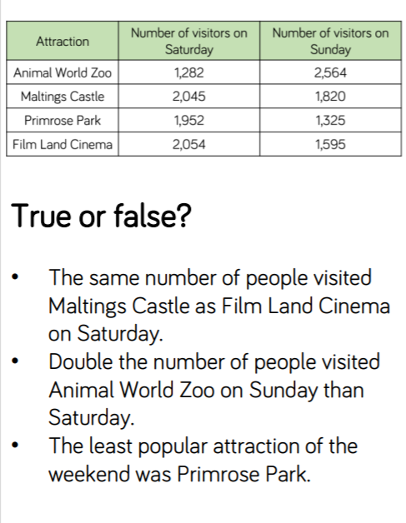Answer:

Day 3 – see attached

Day 4 – 3 activities set on Purple Mash to complete

Day 5 – Problem Solving Task:

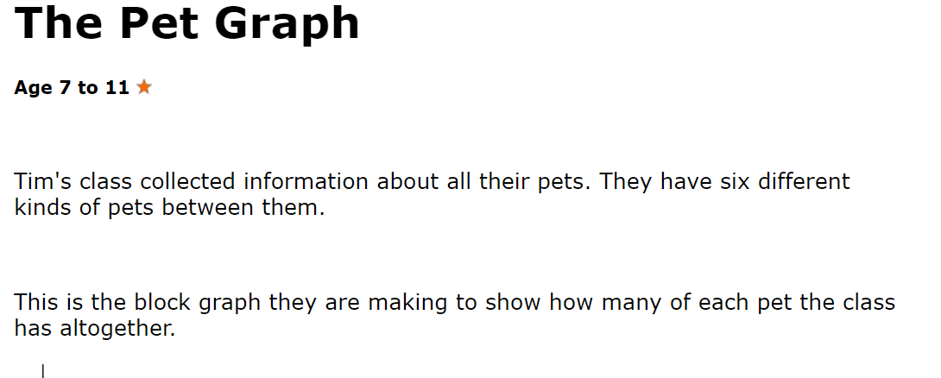
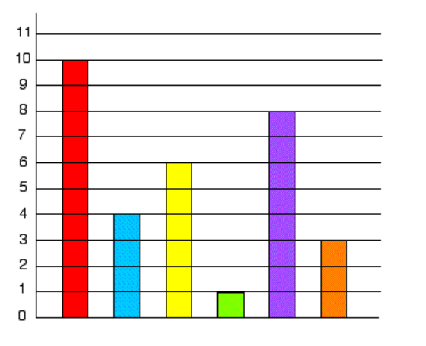
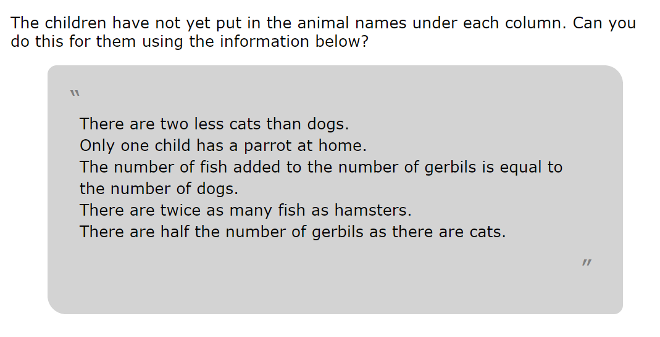

Possible solutions:
https://nrich.maths.org/247/solution

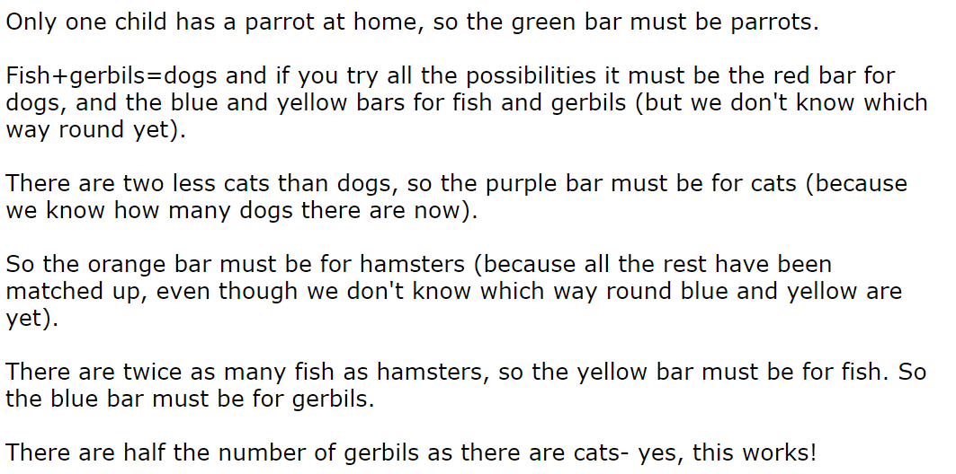
For other problem solving challenges, please go to:
https://nrich.maths.org/search/?search=bar+chart&tab=1&fs=111110001000111

