Maths wb 8th June

Maths will continue looking at place value in numbers up to 50 and work this week will focus on comparing numbers.

Task 1 – see separate resource

Task 2 – see resources below

Task 3 – see resources below

Task 4 – see separate resource

Extension tasks – see resources below

Task 2

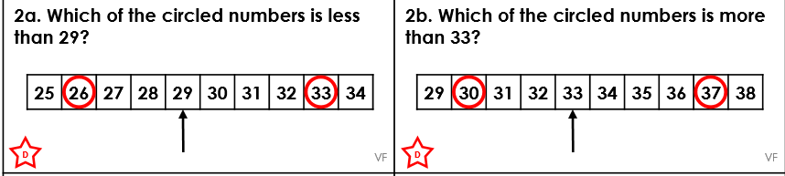

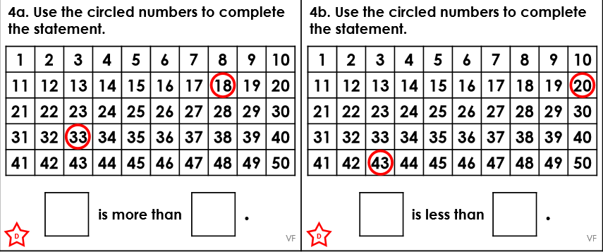

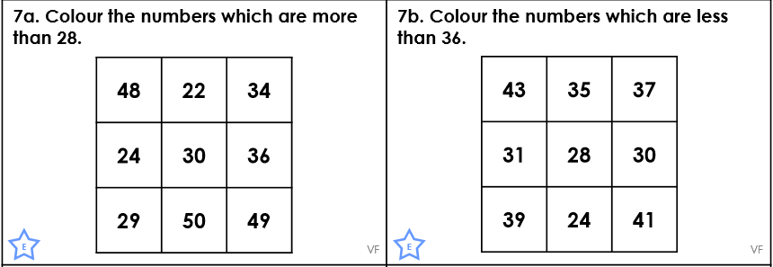

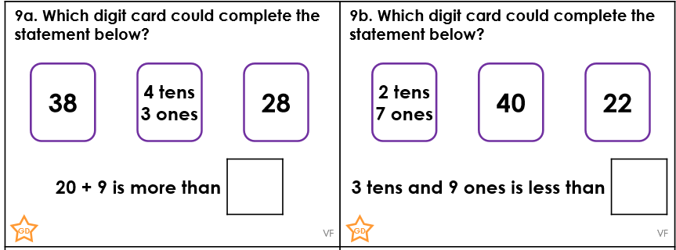

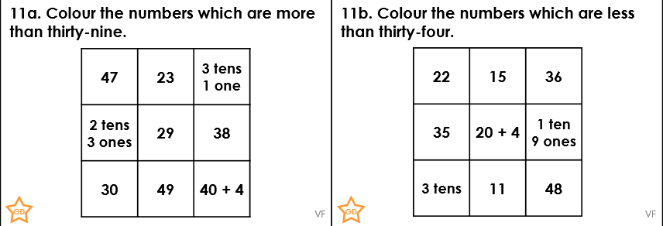

Problem solving

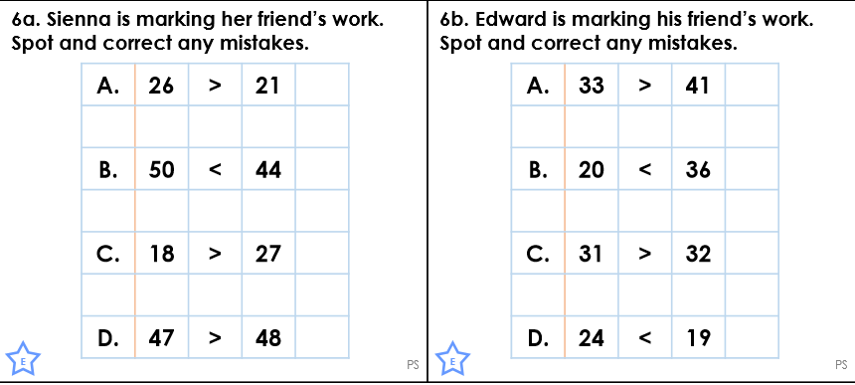

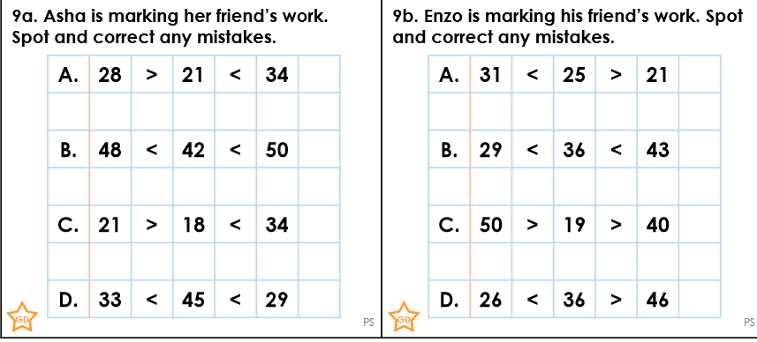

Task 3

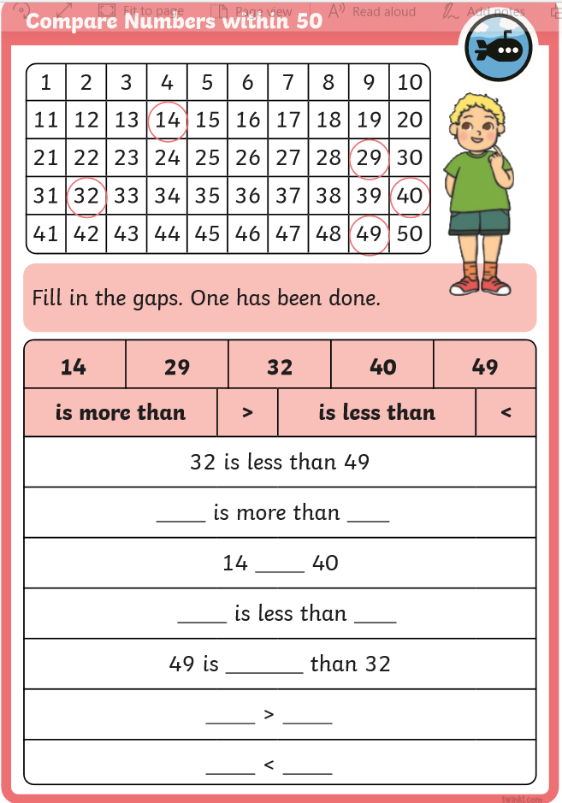

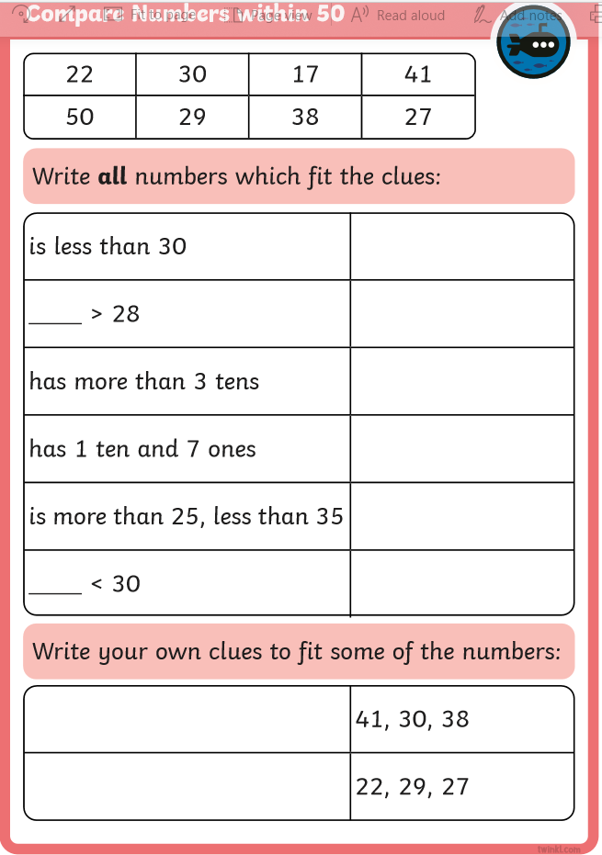

Extension

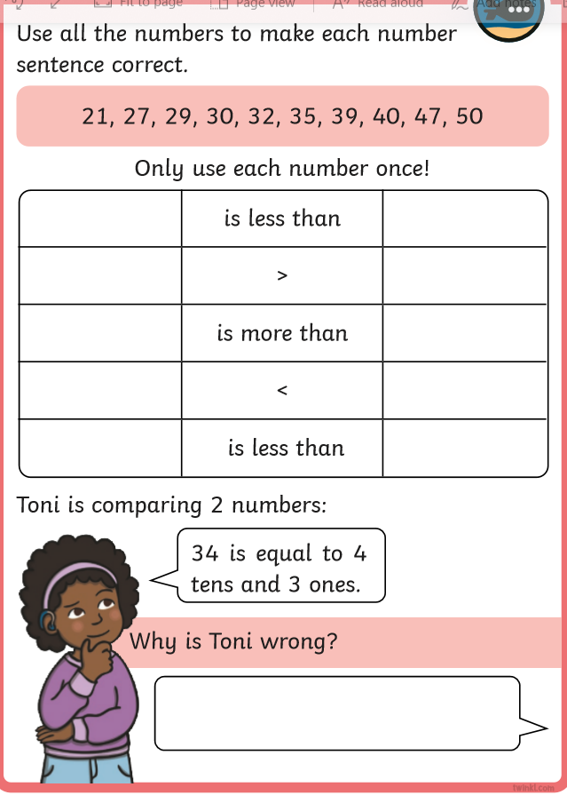

Answers to Tasks 2, 3 and extension

Task 2 Answers





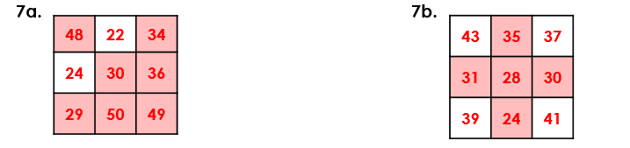



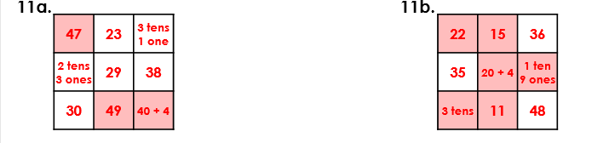

Problem Solving Answers





Task 3 Answers

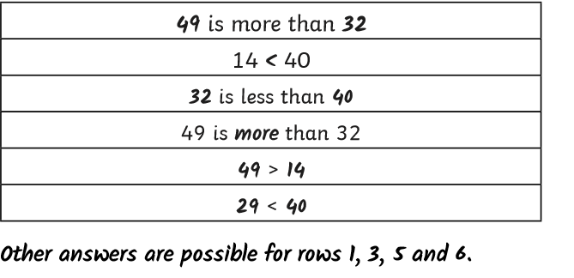

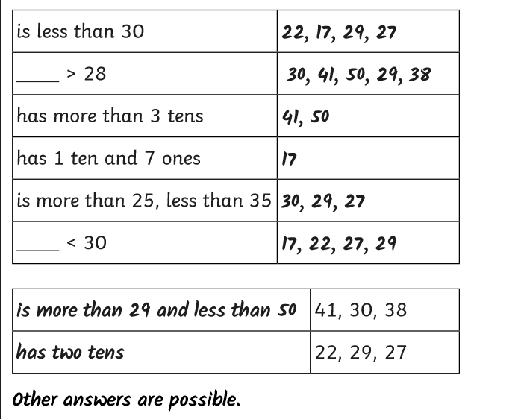

Extension part 1 Answers

