**Home learning wb 29th June**

For maths this week we will be looking at counting in 5s. Have a look at the counting in 5s video and then try the tasks below/attached.

Task 1 – see attached

Task 2 – see below – practising counting in 5s, 10s and extension of counting in 3s.

Task 3 – see below – practising counting in 5s along with some problem solving style questions.

Task 4 – see attached – this is the place value to 50 consolidation pack.

**Task 2**

Using your understanding of counting in 2s, 5s and 10s to answer problems.

|  |
| --- |
| There are 5 crayons in a box.  How many crayons in 2 boxes?  How many crayons in 5 boxes?  How many crayons in 3 boxes?  How many crayons in 10 boxes?  How many crayons in 6 boxes? |

There are 10 sweets in a bag.

How many sweets in 2 bags?

How many sweets in 6 bags?

How many sweets in 4 bags?

How many sweets in 7 bags?

How many sweets in 10 bags?

**Extra challenge – looking at 3 fish in a tank**

|  |
| --- |
| There are 3 fish in a tank.  How many fish in 2 tanks?  How many fish in 4 tanks?  How many fish in 5 tanks?  How many fish in 7 tanks?  How many fish in 10 tanks?  How many fish in __ tanks? |

**Task 2 answers**

**Counting in 5s:**

**10, 25, 15, 50, 30.**

**Counting in 10s:**

**20, 60, 40, 70, 100.**

**Counting in 3s:**

**6, 12, 15, 21, 30.**

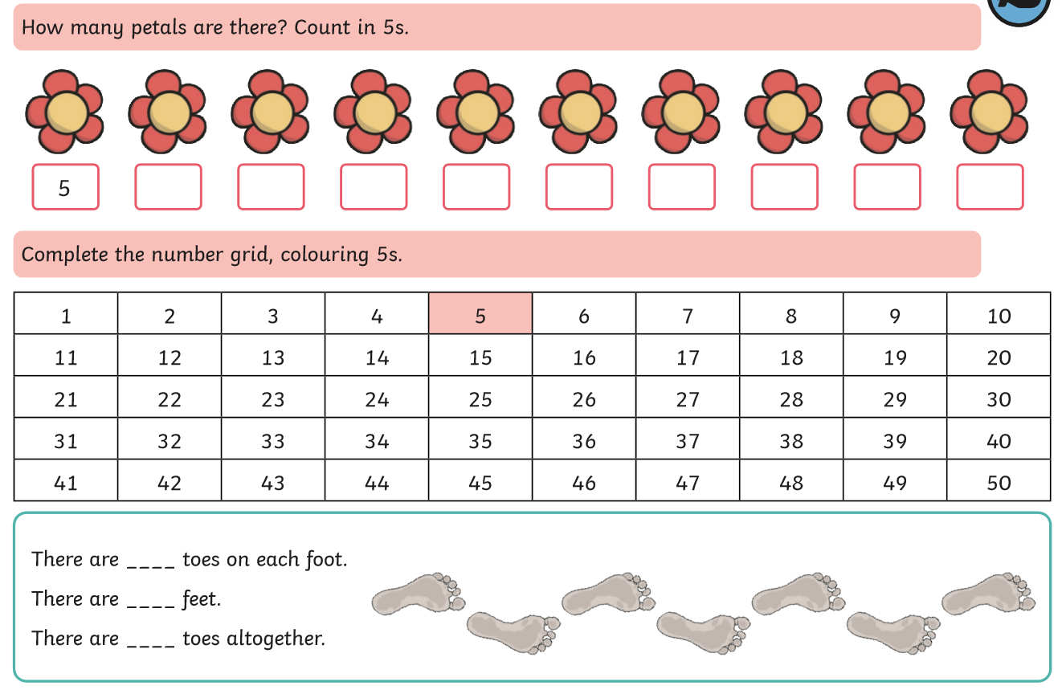**Task 3**

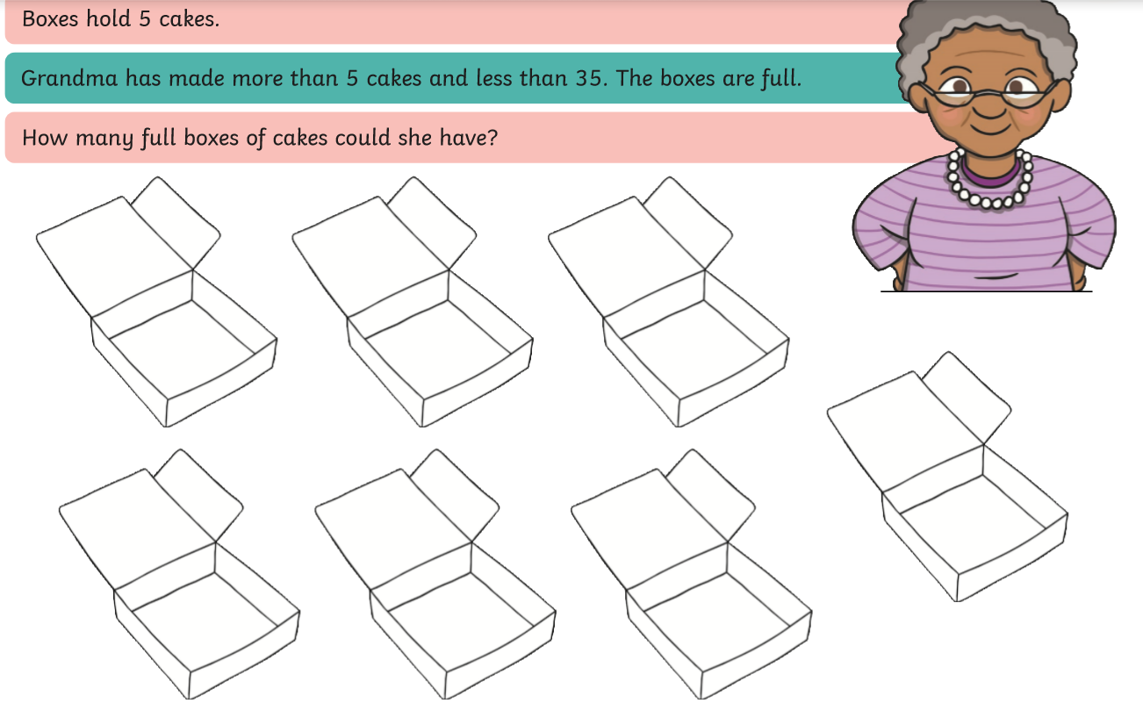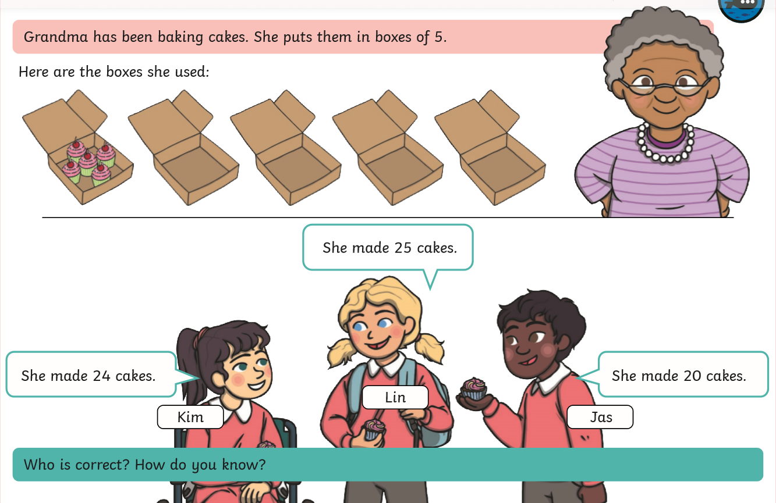

**Task 3 Answers**

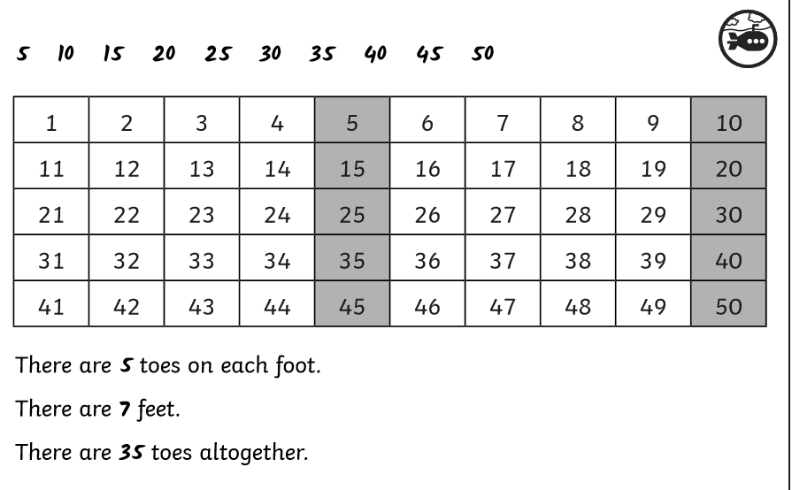

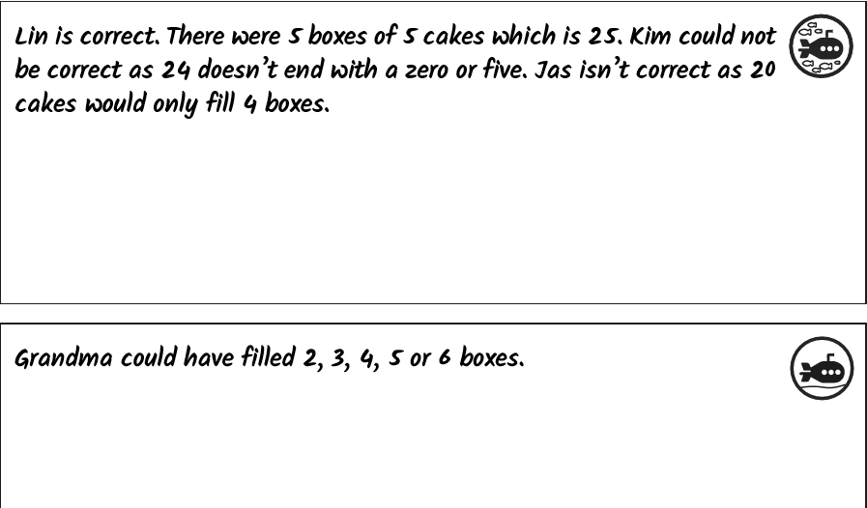

**English wb 29th June**

For English this week we will be using the short story, ‘The Magic Porridge Pot’. Have a watch of the video where I will be reading the story and introducing the tasks below.

Story:

**The Magic Porridge pot**

Once not twice but once upon a time there was a little girl called Poppy who lived with her poor old mother.

Early one morning she was walking in the woods when she helped an old lady carry her bags home. So the kind old lady gave her a magic porridge pot.

‘Say the words, Cook little pot, cook’ and it will give you hot porridge. But once you have eaten enough, say ‘Stop little pot, stop.’ Or it will carry on cooking.’

Poppy ran home and showed her mother.

‘Cook little pot cook.’ Said Poppy.

Soon the pot was full of hot, sweet porridge.

‘Stop little pot, stop.’ Said Poppy, and the porridge stopped cooking.

One day Poppy was visiting her grandmother when her mother felt hungry.

‘Cook little pot, cook.’ Said her mother.

Soon the pot was full of sweet porridge as hot as boiling soup.

Unfortunately, she could not remember the words to make the pot stop!

Oh dear there was porridge, porridge everywhere –

The porridge poured out of the pot,

On to the floor

Up the stairs

And out of the door

And the rooms

And down the lane

Until there was porridge porridge everywhere.

When Poppy came back she shouted out, ‘Stop little pot, stop.’

Luckily, the pot stopped.

In the end everyone had to eat porridge for a whole month and they lived happily ever after.

**Tasks**

1. Watch the video and listen to the story, following along using the writing or the attached story map.
2. Create your own story map for the story or your own actions as I read the story on the video
3. Think about what you would like the magic pot to make. If you had a magic pot, would you want it to be a magic porridge pot or something else? Draw a picture of your magic item and label it or write some sentences explaining what you get it to make.
4. Film yourself retelling the story with actions or rewrite the story and make some changes. E,g, change the name of the character, you could change who the character lived with, you could change it from a magic pot to a magic saucepan or a magic oven to make something to fit in with your imaginary recipe you wrote for Task 3. You could rewrite the story as a story map, film yourself saying it and then send it to me or write it out as a story using the original example to help (like we did for the 3 little pigs writing).

|  |  |  |
| --- | --- | --- |
| Character  *Little girl called Amy – 10 years old.* | Who does the main character live with?  *Lives with her kind granny and sister.* | What magical cooking item is your character given?  *Magical silver saucepan* |
| What does the cooking item make?  *stew* | What do you need to say to the item to cook and stop?  *Cook super saucepan cook.*  *Stop super saucepan stop.* |  |

|  |  |  |
| --- | --- | --- |
| Character | Who does the main character live with? | What magical cooking item is your character given? |
| What does the cooking item make? | What do you need to say to the item to cook and stop? |  |

**Start of my story rewrite**

Once upon a time there lived a little girl called Amy who lived with her kind granny and sister.

Early one morning she went for a walk to the shops and she saw a poor old lady hobbling along. So Amy helped her all the way home. In return for her kindness the old lady gave Amy a magical saucepan.

Say the words, ‘Cook super saucepan cook and it will give you steaming stew.’ Once you have had enough, say the words, ‘Stop super saucepan stop.’ Now you will never be hungry again.

**Phonics**

If your child is not confident with particular graphemes work through these activities:

* Phase 3 ‘ow’ real and nonsense words colouring
* Continue reading through a couple of the power points each week – they focus on a singular grapheme and give you lots of examples of words containing that grapheme.

If your child is confident with different graphemes, I am attaching a phonics screening check for you to work through with your children. It should show you which graphemes they are most familiar with and which ones on their sound walls they need to continue to practise.

The website is here should you want to make some more yourself for practise at home.

<http://www.oxfordphonicschecksupport.co.uk/?> Go to generate your own phonics screening check and you can create your own.

Phonics activities attached:

* Extension for ‘ow’ – grapheme word sort activity
* Phase 5 animal mosaic pictures – children need to read the different words accurately, work out whether they are real or nonsense words and then colour in each square with the correct colour.

Spellings activity:

* See the Year 1 common exception words activities for different games you could play to practise reading and spelling common exception words

There is also a reading task attached, Scarlett’s birthday for you to work through.