While you are at home pick 1 or 2 activities a week to complete.
Computing  The BBC have a set of games designed to teach children to touch type. If you have a laptop or PC search for BBC Dance Mat to help practice your skills. Try to do a little bit everyday. If you can master this skill, it will be really helpful to you as you get older, so it’s really worth some perseverance to get good at it! | 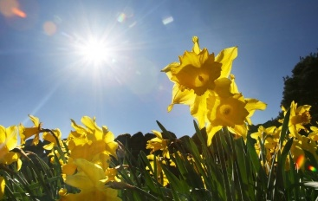  Art  On a day when the weather is good, choose a place outside to sit and sketch what you can see. Take your time to really look at your subject and think about proportions and shapes. When sketching do so very lightly in pencil so that you can rub out any parts you want to change. Really look at the details, for example if you are drawing a plant or tree think about the texture and shading needed to form the shape. To extend this further try colouring in your sketch. Most of all take your time on this task so that you can really capture what you are looking at. | RE  Choose one of the world religions (Christianity, Judaism, Islam, Hinduism, Sikhism, Buddhism and Humanism) and do some research into what their holy traditional building is like. You could draw a picture and label it or even make a model! To extend this you could investigate the similarities and differences between their holy buildings in the UK and those in the country where the religion started. If you did a map for the geography test can you find the location of the country where the religion you chose was started?  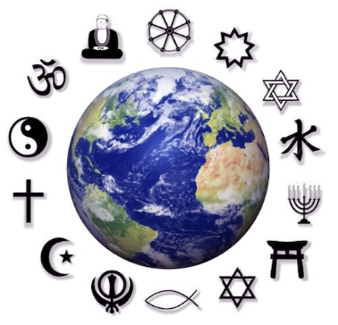
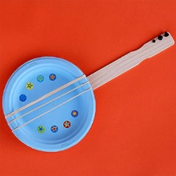  Music  Can you make an instrument? Perhaps you could use items you have at home like tub's or bottles. Or you could make something out of recycling. Can you make your instrument make more than one sound? For example if you have a margereen pot and put different elastic bands around it do they make different noises? See how creative you can be and make your own music. | Science  Can you make a rocket? If so, how far can you propel it? Can you make your go further than anyone else's and how? Once you have designed and made your rocket record what you did and how far it went. Don't forget to tell us what you would do differently next time to make it go even further?  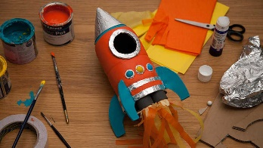 | Geography  With the bizarre weather we have been having I thought we could take a positive from the rain and make a rain gauge! You could use the link below as guidance:  https://www.science-sparks.com/weather-make-a-rain-gauge/  You could take weekly measurements and present your data on a graph.  Extension challenge – compare your results to the rainfall in different countries at this time of the year.  