Choose 1 or 2 activities a week to complete.
French  How many things in your house can you name in French?  Perhaps you could draw a picture of it with a label.  e.g  Chair – Chaise  Look at the French vocabulary sheet to help you with this task. | PE  Create your own PE challenge game.  List and number 6 activities such as skipping or step ups for 30 seconds.  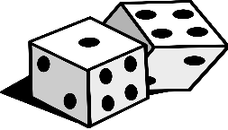  This Photo by Unknown Author is licensed under CC BY-SA  Then role a dice to choose what order you do the activities in.
Art  Picasso was a Spanish artist who lived between 1881 and 1973. He is known for his abstract work which became known as Cubism. When he painted people or objects, he broke them up into different blocks. To learn more about him, have a look at https://www.bbc.co.uk/bitesize/clips/zq34wmn  Can you either copy one of Picasso’s painting or create your own original artwork using his Cubist style? | Geography  Last week we asked you to practice learning Europe’s capital cities and flags.  Now we would like you to remember the continents of the world.  There is a video you might like to watch here:  https://www.bbc.co.uk/bitesize/topics/zvsfr82/articles/znm7vk7  Once you have found all the continents can you think of an imaginative way to help you remember them? Perhaps you could draw a map of the world and some separate labels for each continent and practice matching them up correctly? Maybe you could research the climate across one particular continent?
DT  Make a cereal box marble maze.  Cut one side off a cereal box and build a maze for the marble to travel through.  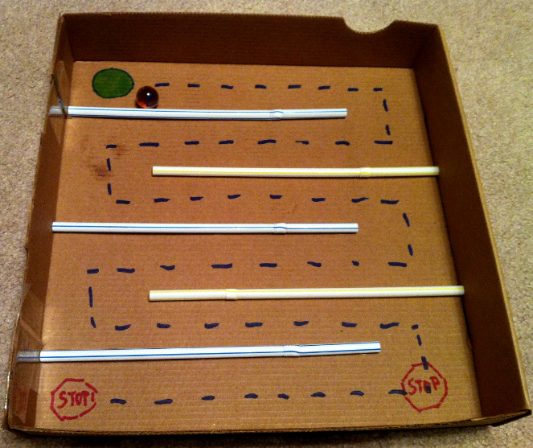  How tricky can you make yours? | PSHE  We have all had to be very resilient during lockdown; not seeing friends and family and not being able to go to school. Can you list 5 ways you have been resilient for example missing out on a birthday party or other celebration?  Talk to someone about your list and how you have made the best of this difficult situation. With permission perhaps you could call a grandparent, aunt or uncle, I’m sure they would love to get a phone call from you and to hear about you list.

