Choose 1 or 2 activities a week to complete, 15th – 26th June.
Computing:  The BBC have a set of games designed to teach children to touch type. Go to:  https://www.bbc.co.uk/bitesize/topics/zf2f9j6/articles/z3c6tfr  to practise your skills. Try to do a little bit every day. If you can master this skill it could be helpful to you as you get older, so it's really worth some perseverance to get good at it.  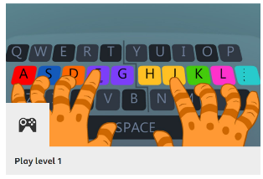 | Art  On a day when the weather is good, choose a place outside to sit and sketch what you can see. Take your time to really look at your subject and think about proportions and shapes. When sketching do so very lightly in pencil so that you can rub out any parts you want to change. Really look at the details, for example if you are drawing a plant or tree think about the texture and shading needed to form the shape. To extend this further try colouring in your sketch. Most of all take your time on this task so that you can really capture what you are looking at. | RE  Choose one of the world religions (Christianity, Judaism, Islam, Hinduism, Sikhism, Buddhism and Humanism) and do some research into what their holy traditional building is like. You could draw a picture and label it or even make a model! To extend this you could investigate the similarities and differences between their holy buildings in the UK and those in the country where the religion started.  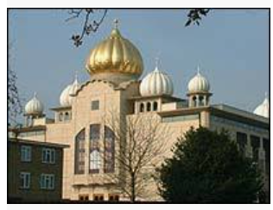
Science  Can you make a rocket? If so, how far can you propel it? Can you make your rocket go further than anyone else's and how? Once you have designed and made your rocket record what you did and how far it went. Don't forget to tell us what you would do differently next time to make it go even further?  https://spacecentre.co.uk/event/space-crafts/?fbclid=IwAR2hbRbbg1FNwRkz8RvpYrLCqB-J8Es28FggrndPfcTTzp-jECWxsiZ-YNw  shows you how to make your own rocket at home using Sellotape, scissors, a tube, paper and colouring pens.  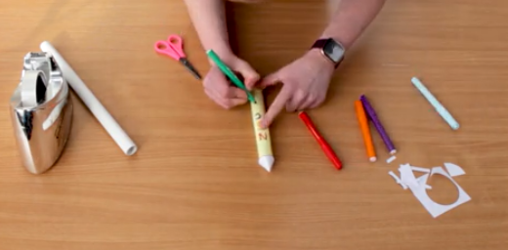 | Physical Education  Challenge your family to a game of activity Monopoly, as suggested by our School Sports Partnership.  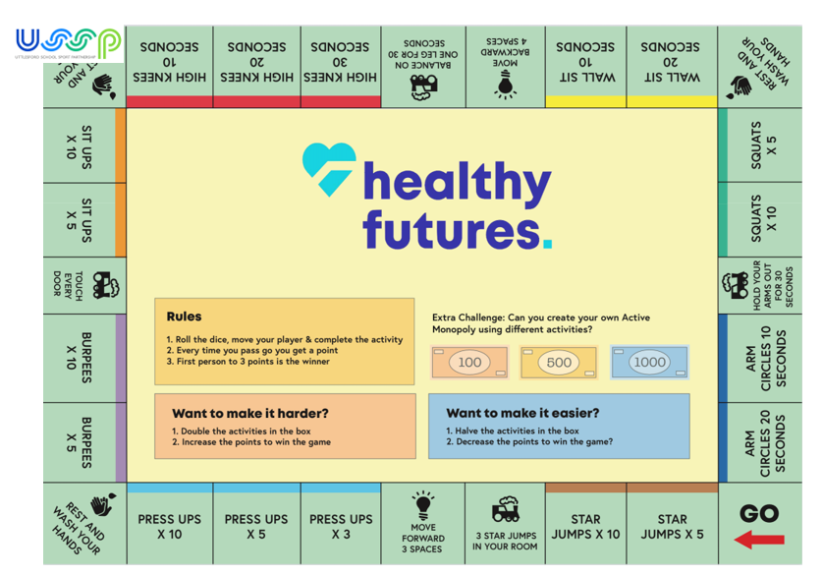 | Geography  Can you identify the countries in Europe? Can you name their capital cities? What do their flags look like? If you have been abroad on holiday perhaps you can find the places you have been. Or perhaps you have always wanted to do somewhere. Where is that on your map?  You could test yourself by using:  https://www.bbc.co.uk/cbbc/quizzes/european-countries-quiz  