English wb 8th June
For English you will be continuing to look at sentence structure – looking at exclamation marks and question marks this week, beginning with a couple of grammar tasks before then completing a short writing task.
There is also a reading task – see comprehension.
Task 1 – circle all the exclamation marks in the text and birthday picnic task – rewriting the sentences as they should be written with capital letters and exclamation marks
Task 2 – Question or not task. Sentences are missing capital letters and either a full stop or question mark at the end. Can you complete them correctly?
Task 3 – Land of Snow. Can you rewrite the passage putting in full stops, capital letters, exclamation marks and question marks if needed.
Task 4 – Write 4 or 5 sentences describing something exciting such as something you have done recently, making sure you use exclamation marks to show excitement or surprise. You could write about your favourite holiday or your pet – something interesting to you where you can practise using exclamation marks.

Task 1
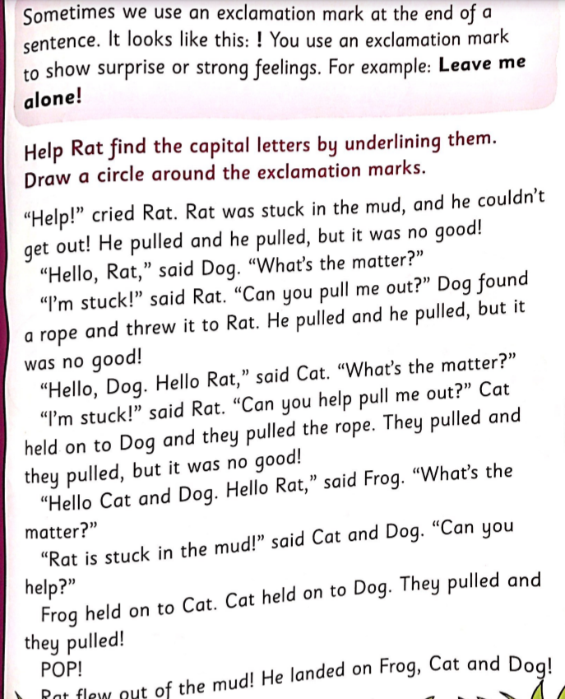

Task 1 part 2
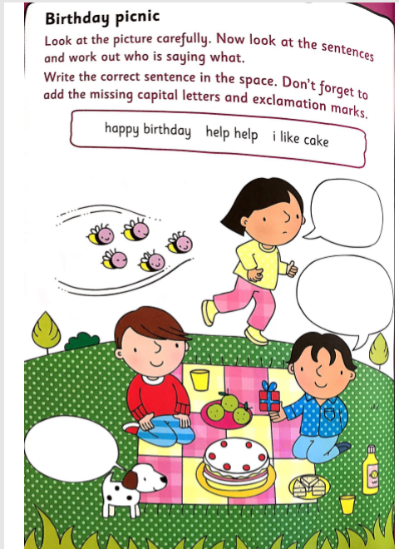

Task 2
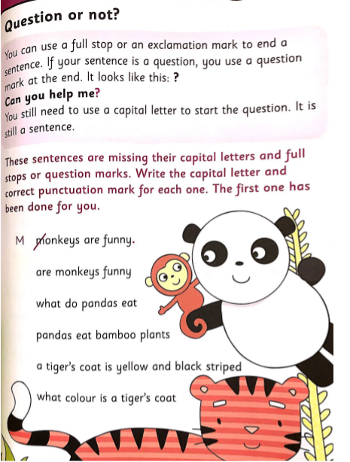

Answers:
Are monkeys funny?
What do pandas eat?
Pandas eat bamboo plants.
A tiger’s coat is yellow and black striped.
What colour is a tiger’s coat?

Task 3
