Dear Year 4,
I have enjoyed speaking to many of your families this week, and I know Mrs Waterman and Mrs Aves have too. We are calling families on a 2 week rotation; so if we didn’t manage to speak to you within the fortnight that has just passed please get in touch if you have any concerns or queries. Our new two week rotation begins Monday 15th, so it may well be we contact you this week too depending on how our rotas work.
Please tell your children that they are all amazing; that I am so proud of them all and I miss them all so much. It has been lovely to continue to receive emails of their work, though once a week to summarise their work, or share with me a favourite piece or activity would be preferable please. I have really enjoyed seeing how you may be focussing learning following their own hobbies and interests too - the work I set is by no means compulsory and I think it is important that they share any successes and proud moments with me, whatever they are.

For English this week we are going to look at something a little bit different. The website below ‘Autorfy’ has a wide range of 10 minute challenges that are added to on a daily basis.
https://authorfy.com/10minutechallenges/
The 10 minute challenges are set by bestselling authors and illustrators, and will ‘provide a daily dose of fun and creativity’.
I am sure that there is something here to appeal to you all. There are over 40 different tasks available to you, from creating your own monsters and comic strips, to writing postcards and letters. Try to complete at least one a day and try to cover different types of writing genres / styles over the course of the week.
I had a try at the challenge set by Steven B and Steven L to create my own guest for the Nothing to See Here Hotel. It was hard to only write a paragraph, there was so much more I could have said. I took my time creating a picture of my guest, and then completed the writing challenge within the 10 minutes afterwards.
I hope you have lots of fun! You may find that you are inspired to read books by one of the authors you look at.
There are no new spellings set on Purple Mash this week. Instead, I would like you to use spelling frame, and test yourself on all the Year 3 and 4 Common Exception Words across the week. (https://spellingframe.co.uk/)
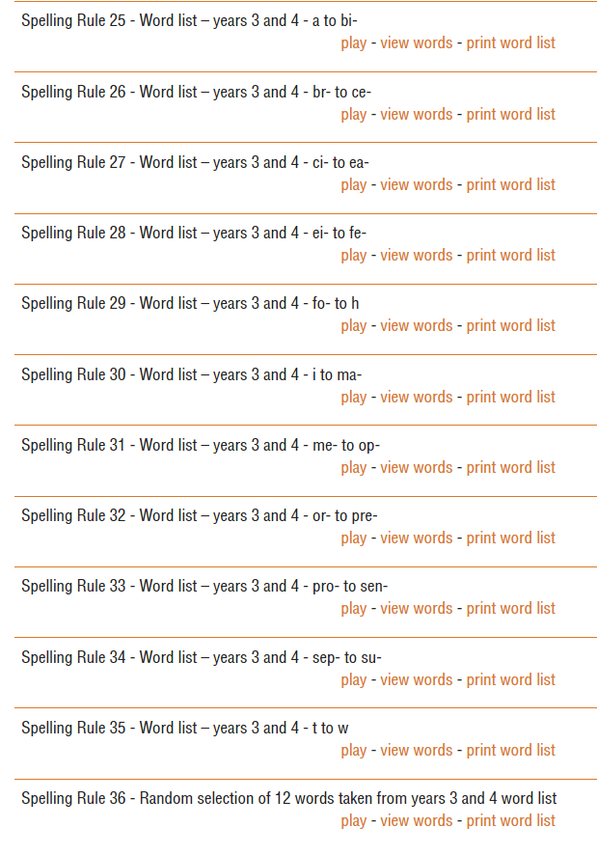
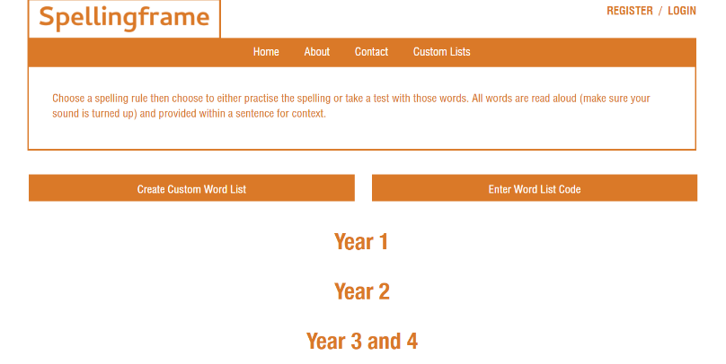

Select the Year 3 and 4 link, and then scroll down the next page until you find spelling rules 25-36. They words are arranged into alphabetical order groups. Choose one, and then select ‘Play’.

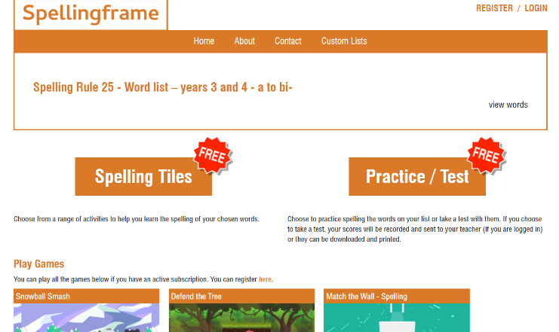
You will then see a screen that looks like this. Spelling Tiles and Practice/Test are free to use without a subscription.
(Spelling Tiles contains 5 different activities you can choose to practise the words, if you would like to – though I am more focussing on the tests for you this week.)
If you select Practice/Test you can then undertake a test, which is the part I would like you to do. There is no need for you to report back to me your scores for each test; but if you spell any incorrectly, write them down, and then they can become your spelling list for the following week. The same activities are on offer in Year 5 and 6, so if you are now very secure in the 3 / 4 words, you can now practise the 5 and 6 ones.

The Summer Reading Challenge, from The Reading Agency has launched online. For more information, please visit:
https://summerreadingchallenge.org.uk/parents-carers
It usually launches at the start of the summer holidays, though this year is live early.

