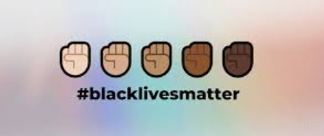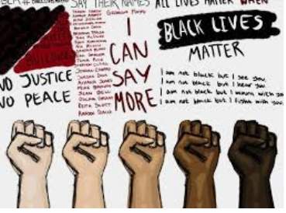

There has been lots of news about racism, protests and marches all over the world in support of BLM – Black Lives Matter and anti-racism. This is such an important social issue and something we should all be talking about in our families and within school. If we were all together in class, I would be having lessons on all the issues relating to this and we would be debating and discussing (which we do brilliantly in year 5!).
I am so passionate about this issue that I thought we could still address this through our home schooling.
This is what I would like you to do:

- Watch the various clips on the children’s Newsround site: https://www.bbc.co.uk/newsround/52965984

The short videos from the Blue Peter presenters are informative too:
https://www.bbc.co.uk/cbbc/watch/bp-advice-for-helping-to-stop-racisim

- Talk to your family members, have a dinner time chat about what you have learnt from the videos. What are your experiences? What are your opinions? Most importantly, what do you think could and should be done to make a change?

THEN, this is the exciting part! I would like you to enter the 500 words competition (previously run by BBC radio 2, now taken over by Chris Evans) which this year is focusing on Black Lives Matter.

I can hear some of you say “500 words…that’s loads!” It’s about one side of A4, so just a little bit of writing each day.

https://www.express.co.uk/celebrity-news/1299115/chris-evans-virgin-radio-500-words-bbc-project-black-lives-matter-special-latest-news

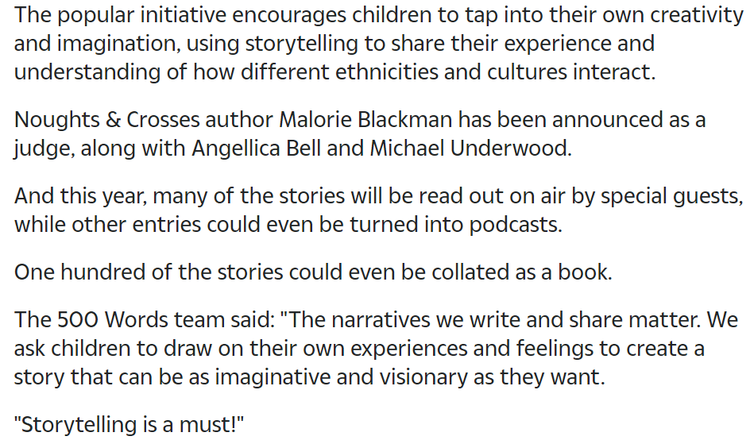

So, this is what you could do:
- Write an imaginative story with the theme being racism, prejudice, equality.
- Write a biography from the perspective of someone who has experienced prejudice; what would they have felt, what was the situation; were they in school, in an after-school club? How did they deal with it? How was the situation resolved? Do you know someone who has experienced racism? Could you interview them?
- You could just write down all your thoughts in a diary style piece. How does this matter effect you? How does it make you feel? What do you think should happen? How could society change? What should we all do to make the change? How could schools help?

You could go to the link below and listen to some ‘familiar faces’ read some of the winning stories. This may give you some inspiration!
https://www.bbc.co.uk/programmes/p08h07lr

Let’s get started:
- Watch the clips I’ve highlighted above.
- Jot down all your thoughts, feeling, ideas.
- Decide what format you would like your 500 words to take, then start planning.
- Formulate your plan; if you’re writing a story think about the story mountain – this will help you.
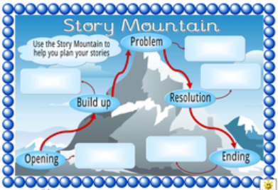
- Now get writing! You could plan your week like this:

Monday: Watch clips and have discussions – formulate your ideas.
Tuesday: Start planning.
Wednesday: 200 words.
Thursday: 200 words.
Friday: 100 words and editing.

The competition doesn’t officially start until Monday 29th (today), so I don’t have detail about where to send your entries….I will let you know when I find that out. If you really dislike competitions, that’s fine, just write your piece and send it to me!

Here are some links to some lovely books that may inspire you. They maybe a little young but the message is strong!
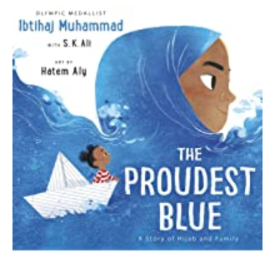
https://www.youtube.com/watch?v=XJiTBmfy-LI
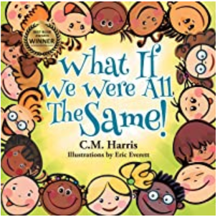
https://www.youtube.com/watch?v=PIR4zZvrOkI

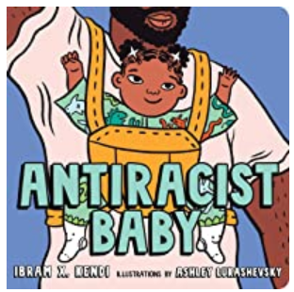
https://www.youtube.com/watch?v=PHVP-Ex4pM4

Fleur Easts rap is a powerful message too - https://www.youtube.com/watch?v=Jv5C1Q_h6BQ
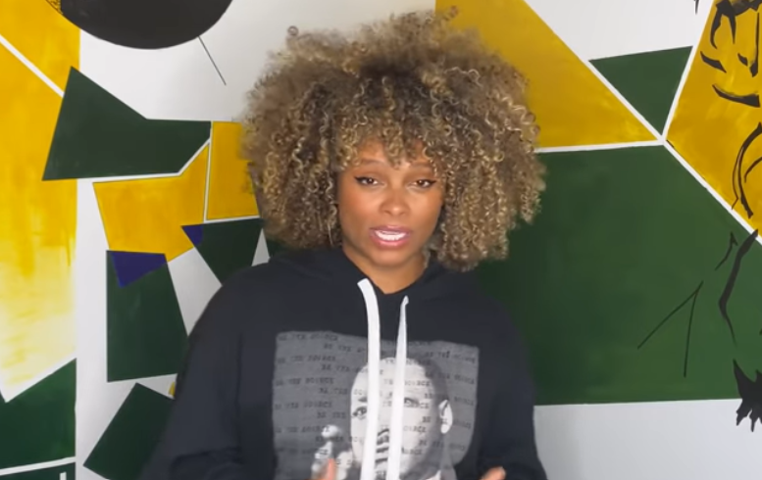

Below is a link to a huge list of books you could take out of the library or purchase from Amazon….I’ll be purchasing a few and I’m happy to share!
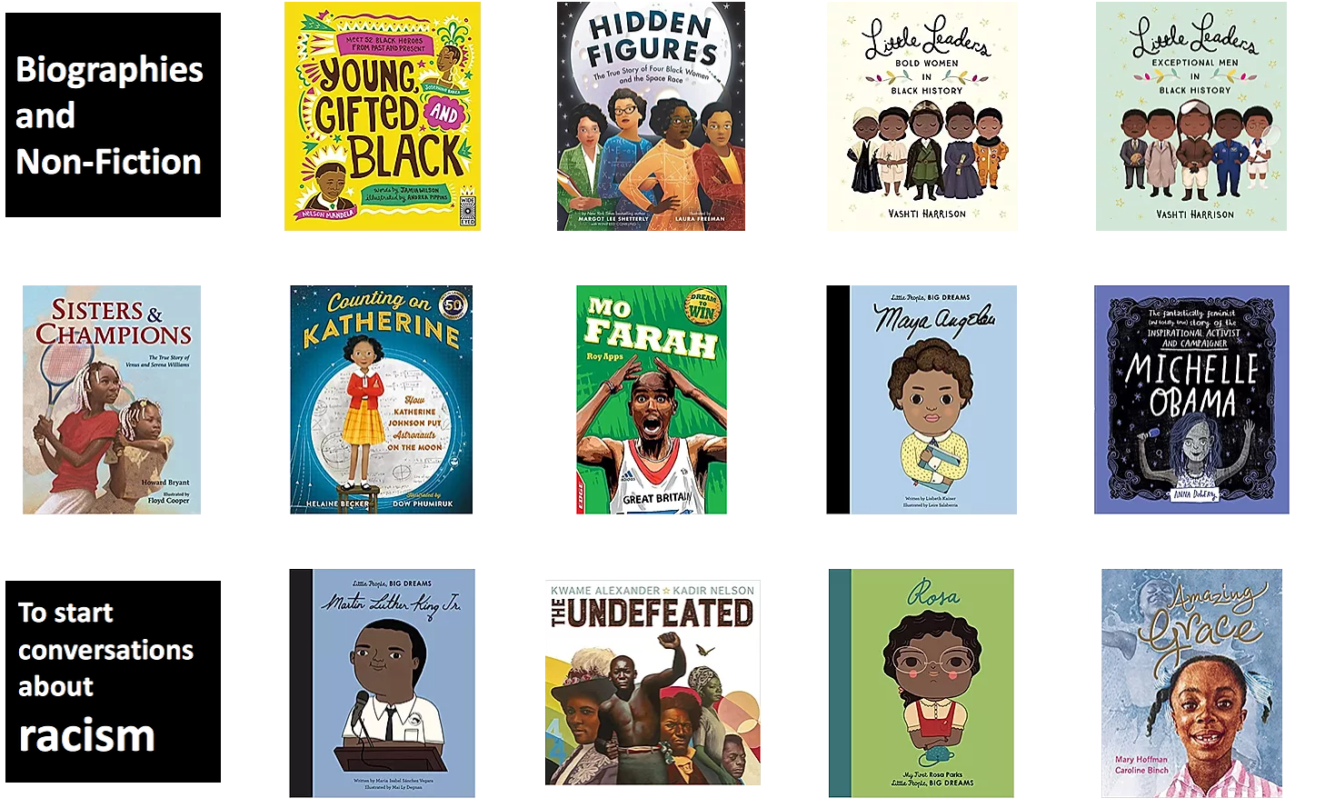
https://www.booksfortopics.com/black-lives-matter

I have also had a go too. See my work in the resources pack.

Have fun with your writing this week and I really look forward to reading your work.

