**Afternoon Activities**:

**French**

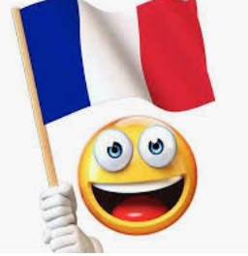

School and hobbies

<https://www.bbc.co.uk/bitesize/articles/zmt74xs>

Watch the on-line teaching video and carry out the activities.

**Emoji Quiz**

[https://www.bbc.co.uk/cbbc/quizzes/bp-tricky-emoji-quiz?xtor=CS8-1000-[Discovery_Cards]-[Multi_Site]-[SL07]-[PS_CBBC~N~~O_EmojiQuiz]](https://www.bbc.co.uk/cbbc/quizzes/bp-tricky-emoji-quiz?xtor=CS8-1000-%5bDiscovery_Cards%5d-%5bMulti_Site%5d-%5bSL07%5d-%5bPS_CBBC~N~~O_EmojiQuiz%5d)

Try this fun quiz with your family!

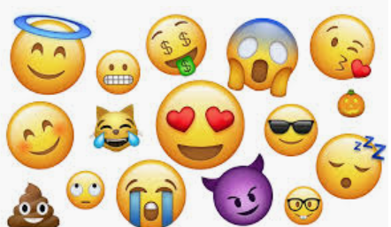

**Could you make a tumblewing Glider?**

How long could you keep yours in the air for?

<https://ioi.london/latest/make-your-own-tumblewing-glider/?gclid=CjwKCAjw8pH3BRAXEiwA1pvMsWn0ECZFpqGCCTfEyKGvs69NBgtaTE1FOipdArE8BY9mhbwiOinsyBoCqboQAvD_BwE>

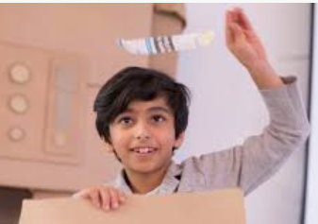

**Computing**

The BBC have a set of games designed to teach children to touch type.  If you have a laptop or PC go to BBC Dance Mat Typing <https://www.bbc.co.uk/bitesize/topics/zf2f9j6/articles/z3c6tfr> to practise your skills.  Try to do a little bit everyday.  If you can master this skill it will be really helpful to you as you get older, so it's really worth some perseverance to get good at it.

**Use your spelling words this week in your PE session – spell out the word and carry out the activity!**

