Afternoon Project:
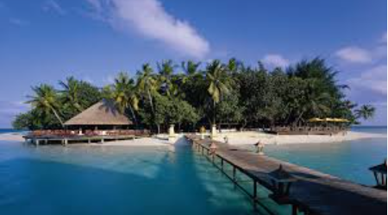
Holiday escapes.
I would like you to create you most magical holiday destination! Could you design you own island?
Think about the following:
- The climate.
- What accommodation would you stay in – draw the accommodation.
- What foods/restaurants are available – make a menu to include your most favourite foods.
- Activities: what is there to do? Make a leaflet that could be issued to guests about the fun things people could do on your island; cycling, boating, a theme park, skate park, football pitches……
- Are there evening activities? Shows, disco’s, talent shows?
- What wildlife lives on your island? Could you draw or cut out some images from magazines and make a poster.
- You could make a promotional video for your resort.
- How about making a collage of you Island?
- Could you create a map of your holiday resort, using symbols and a key?
