EXTENSION:
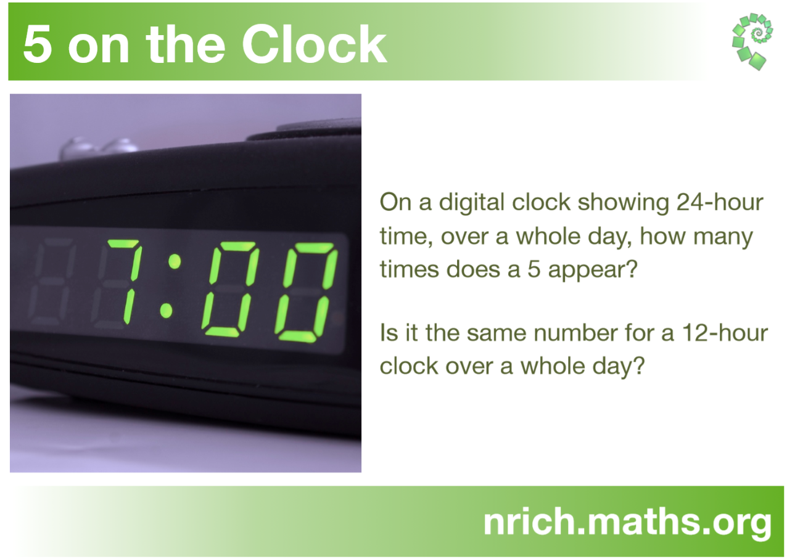

Go to the link below for various extension activities with a focus on time.
https://www.mathsisfun.com/time-zones-world.html

