L.O. To describe positions on the full coordinate grid (all
four quadrants), predicting missing coordinates using the
properties of shapes.
(
mastery
)

(

,

)

(6
,
3)

A

B

C

x

y

Here are 4
identical

rectangles
on coordinate axes.

Write the coordinates of points A, B and C.

(

,

)

(

,

)

A =

B =

C =

A

(
-
20,10)

(40,20)

B

M

y

x

M

is the
midpoint

of the line
AB
.

Write the
coordinates

of the point
M
.

(

,

)

M =

(
-
5)
5
,

(
-
5,15)

(
-
,
5
-
5)

C

B

A

(

,

)

Here are 2
identical

squares

on coordinate axes.

Write the coordinates of points A, B and C.

(

,

)

(

,

)

A =

B =

C =

L.O. To describe positions on the full coordinate grid (all
four quadrants), predicting missing coordinates using the
properties of shapes.
mastery with greater depth
(
)

(

,

)

(9,4.5)

A

B

C

x

y

Here are 4
identical

rectangles
on coordinate axes.

Write the coordinates of points A, B and C.

A =

B =

C =

A

(
-
5)
,
10

(20,10)

B

M

y

x

M

is the
midpoint

of the line
AB
.

Write the
coordinates

of the point
M
.

M =

(
-
2.5,2.5)

(
-
7.5,7.5)

(
-
2.5
,
-
2.5)

C

B

A

Here are 2
identical

squares

on coordinate axes.

Write the coordinates of points A, B and C.

A =

^{B =}

C =

(

,

)

(

,

)

(

,

)

(

,

)

(

,

)

(

,

)

L.O. To describe positions on the full coordinate grid (all four quadrants), predicting missing coordinates using the properties of shapes.
Teacher’s notes
Answers: Mastery: 1) A = (-6,6) B = (-6,-3) C= (6,-6) 2) M = (10,15) 3) A = (5,-5) B = (5,-15) C = (-5,-15)
Mastery WGD: 1) A = (-4.5,13.5) B = (-9,-4.5) C= (-4.5,-13.5) 2) M = (5,7.5) 3) A = (2.5,-2.5) B = (2.5,-7.5)
C = (-2.5,-7.5)
Useful interactive games for teaching coordinates:

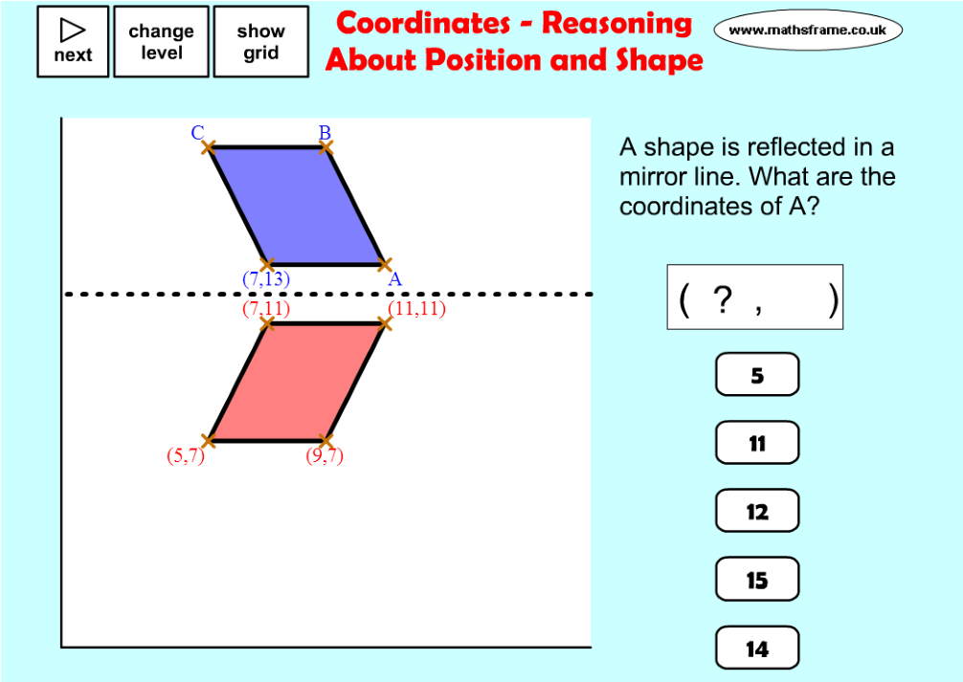
http://mathsframe.co.uk/en/resources/resource/153/
coordi-
nates__reasoning_about_position_and_shapes
Choose to solve problems either in the first quadrant or in all 4 quadrants.

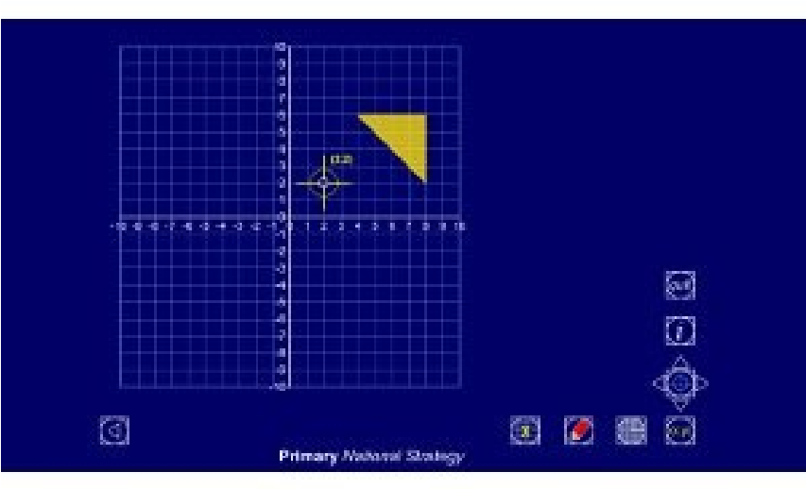
http://mathsframe.co.uk/en/resources/resource/79/itp_coordinates

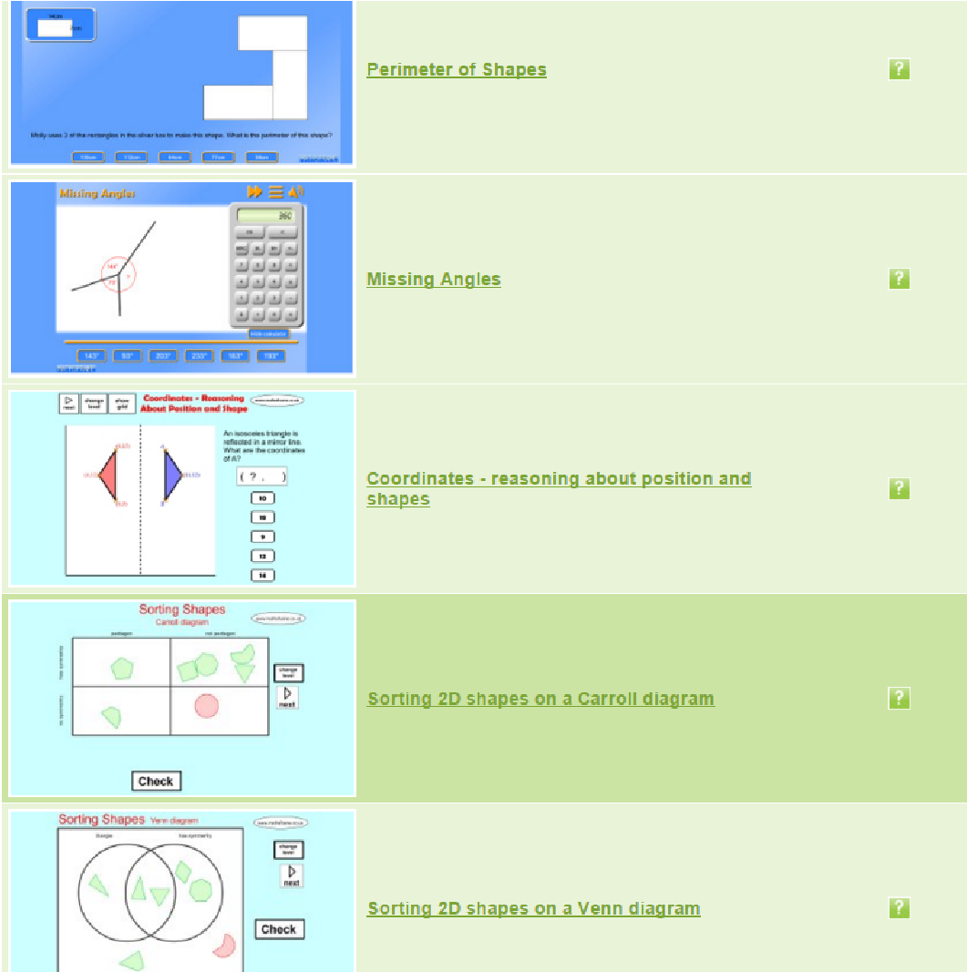
http://mathsframe.co.uk/en/resources/category/19/ shape_and_space

A variety of games to teach geometry.

