Thursday:

Varied Fluency:
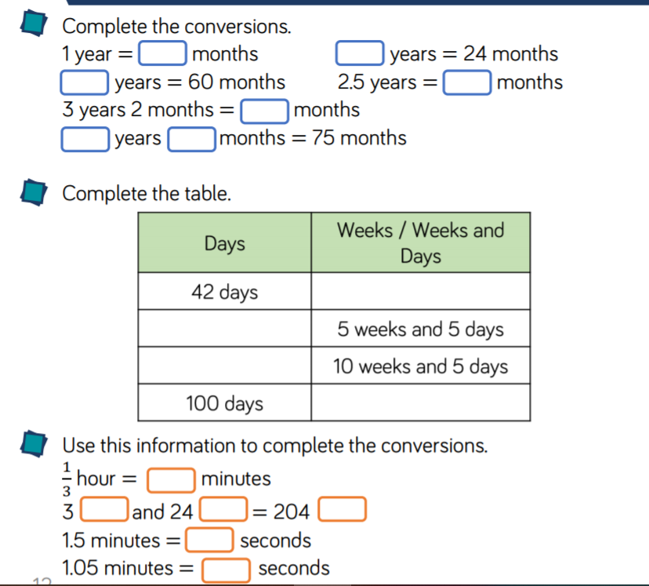

Reasoning & Problem Solving:

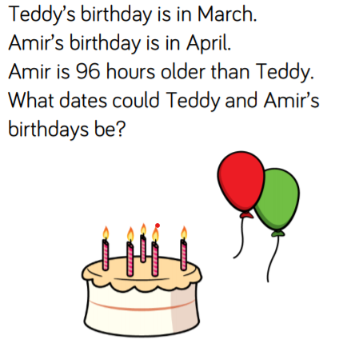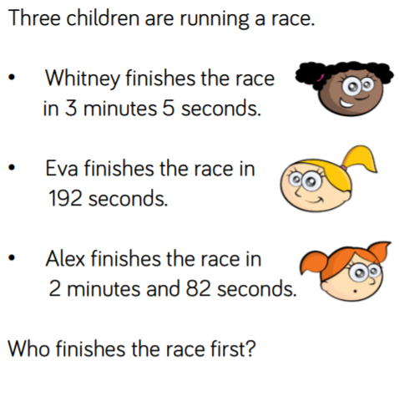

ANSWERS:
Reasoning & Problem solving:

