Maths: TIME.
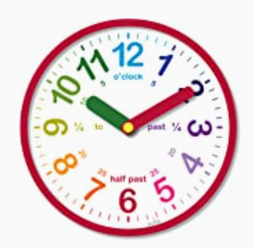
If you are not confident telling the time, please use this week to practise; wear your watch, look at clocks in the house, get other people to regularly ask you the time, be aware of time in your day – how long does it take to do certain activities?
MONDAY:
The Year 5 Timetable!
As we have been thinking about sport/PE in school, I would now like you to consider our daily timetable.
What would your perfect day be in school?
- Could you design how the day would be organised?
- Remember – the day starts at 8.45 and finished at 3.15.
- You must include breaks.
- You could extend this and plan the WHOLE WEEK!
- Could you use you IT skills and create a table indicating the times/activities?

TUESDAY:
Worksheet on time (included in folder).
WEDNESDAY:
Purple Mash activity – converting 12/24 hour time.
THURSDAY:
Worksheet fluency/reasoning and problem solving on time (included in folder).
FRIDAY:
Problem solving questions on time (included in folder).
Extension activities are available in the folder.

