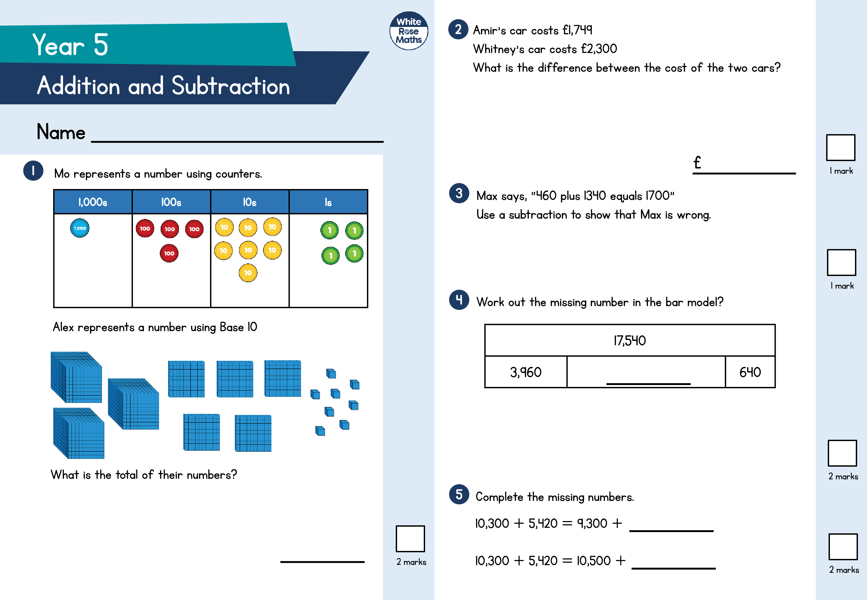

Circle how confident you feel with addition & subtraction.

1

2

3

4

5

Not

confident

Very

confident

6

2

marks

2

marks

7

8

10

11

2

marks

marks

2

The

numbers in this sequence decrease by the same amount

each time.

Complete the sequence.

,290 63,390 62,490

64

On Saturday a zoo has 50,285 visitors.

O

n Sunday the zoo has 10,500 more visitors than Saturday.

The zoo keeper says, “We have had over one hundred

thousand visitors across the two days.”

Do you agree? Explain your answer.

8

9

6

2

−

1

3

4

9

8

7

7

3

Complete the missing digits.

+

+

+

+

+

=

1,200

=

1,900

=

Find the missing sum.

Work out

,000

10

−

4,318

126,000

+

7,500

1

mark

9

1

mark

Work out the missing number.

84

,503

−

=

,125

68

+

3,900

2

marks