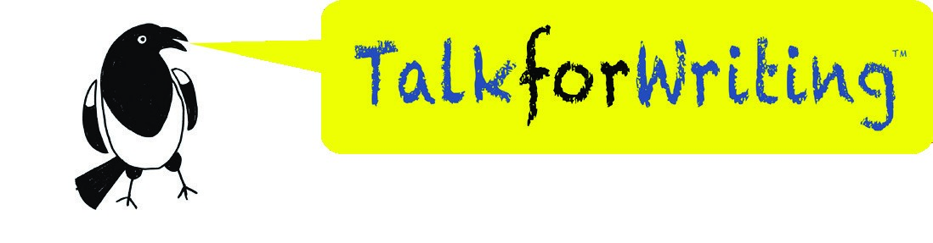
The Game
Talk for Writing Home-school booklet
by Maria Richards
© Copyright of Maria Richards and Talk for Writing 2020.

No part of this publication should be placed online, shared or reproduced without permission.
www.talk4writing.com
Year 5

The Game
Year 5 Workbook
By Maria Richards

Welcome to The Game workbook.

Inside, you will find lots of things to work through that will help you with your reading and writing skills and build on the work you do at school.

© Talk for Writing
Stimulus – The World of Jumanji

In 1981 Chris Van Allsberg wrote a book called Jumanji. In the story, a brother and sister discover a game that turns fiction into real life. Whatever square you land on in the game, brings a new challenge to overcome. Worst still, the challenge becomes a reality for everyone around.

If you have access to the Internet, type this into Google:

https://cutt.ly/JtxrUyf
This is a link to the original movie trailer for Jumanji in 1995 and you can see the consequences of playing the game!

First check with an adult that it’s ok to do this.

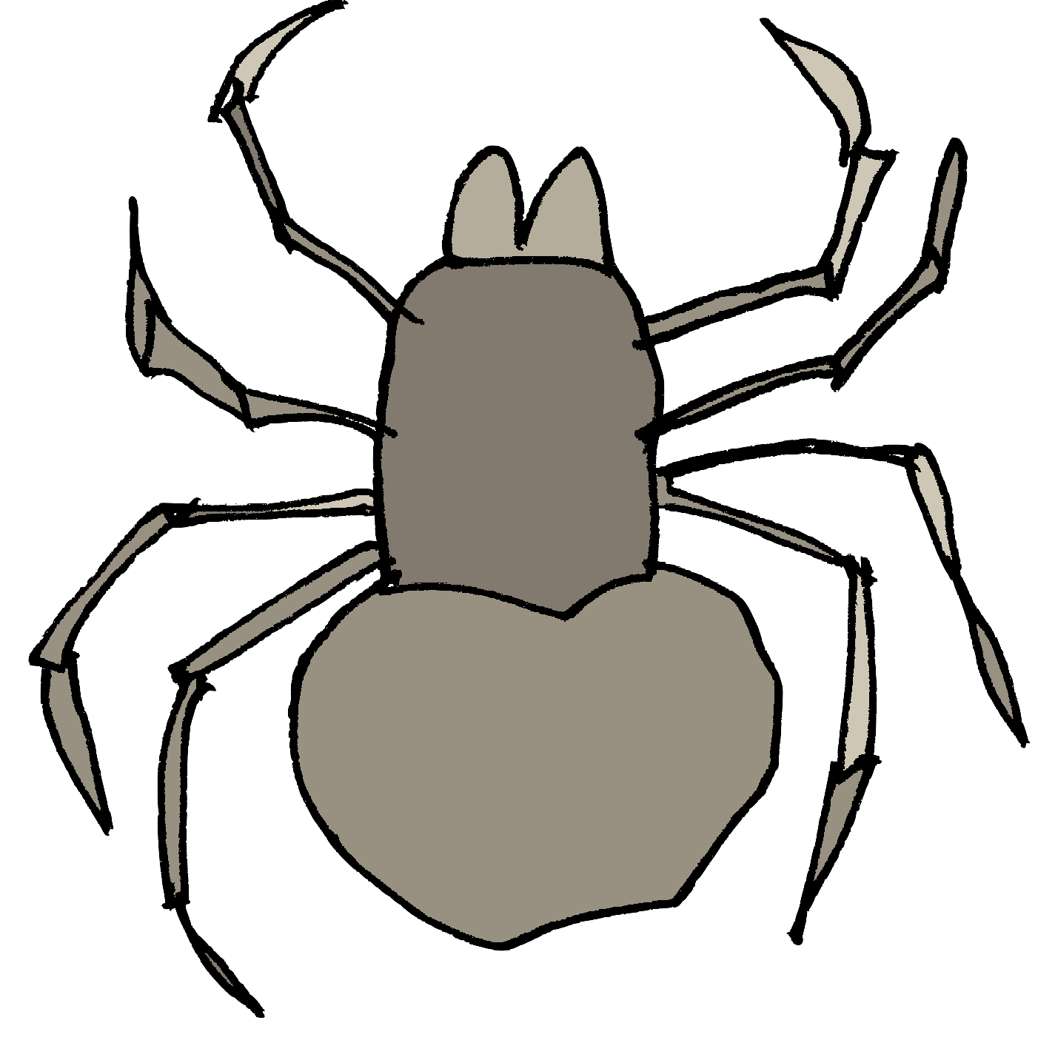

Get Plotting!
Now let’s take a look at a story that follows the same plot idea as Jumanji. The Game is a finding tale and has this simple underlying plot pattern:
Basic story structure | Structure of a finding tale
Opening | Introduce the main character/s (MC)
Build up | MC goes somewhere and finds an unusual/amazing/important object
Problem | Something goes wrong – it is the fault of the object
Resolution | MC puts back/hides/throws away the object – the problem is solved
Ending | All is well again and lessons have been learnt
You can listen to a recording of The Game story below here: https://soundcloud.com/talkforwriting/game/s-7MBlxRcz8zL

The Game
Danny and Susie were bored. It was wet play again and it felt like they hadn’t seen the playground for weeks. Rivers of greasy rain streaked the classroom windowpanes and pooled to make gigantic puddles in the centre of the netball court. Another lunchtime inside was clearly stressing Mrs Allbright, as she seemed to be tense and a bit more snappy than usual. She sat at her desk with a steaming cup of tea and marked books with the ferocity of a wild beast. To top it all, every good game was being used and only the tub of dominoes was left. Everyone knew that half of them were missing and the other half had been chewed by the school ‘Reading Dog’. Danny and Susie searched the classroom for something to do.
To their dismay, the comic box was empty, the iPads had been snapped up by Freya and her gang and Billy seemed to have started a resurgence of the game Slap, which didn't look like fun at all. As the two friends
© Talk for Writing
squeezed past the art table to get to the wet-play books, a tatty, cardboard box fell from the top shelf of the bookcase. Susie picked it up.

“I’ve never seen this game before,” she said, wiping the dust from the unusual lid. It was embossed with intricate patterns and around the edges were pictures of animals, insects and other strange creatures.

“An animal game? Boring!” said Danny, already losing interest.

“Oh come on, let’s play. There’s nothing else to do,” suggested Susie, smiling widely and shaking the box.

They sat down in a quiet corner, lifted the lid and took out the board.

What next? We’ve stopped at an interesting part of the story. Summarise below what you think could
happen next.

I predict…

Now let’s find out how close your predictions were. Read on!

“Looks simple enough,” said Danny, ever impatient, as he set the counters onto the start line. They were jungle animals: a rhino and a jaguar. He also shuffled the game cards and laid them in a neat pile. “Let’s just start and learn as we go.”

Susie went first. She grasped the dice and threw them down onto the centre of the board. An eight! She moved her rhino eight paces, to land on an orange-coloured square. It showed a picture of a giant Tarantula. She lifted a game card and read it out. “If you do not catch this beast,

then you’re on the menu for its next feast.” She stared at Danny and shrugged. “I don't get it!” she said.

At that moment, the table began to shake, the windows rattled and the floor vibrated. Everyone stopped what they were doing and the room fell silent.

“EARTHQUAKE!” shouted Billy, bursting into laughter. He soon stopped, as in a blink of an eye, an enormous spider, bigger than a horse, shot out of the game and landed in the centre of the crowded classroom. Everyone froze. Its enormous, hairy legs were tensed, ready to pounce and its whole body seemed to pulse. Eight, bulging eyes scanned the room and then …

It sprung into action. It crushed the tables, smashed the windows and flung children all around the classroom with a flick of its legs. It powered towards Mrs Allbright as she stood rooted to the floor in terror. The room was filled with shrieks of panic and despair.

“What shall we do?” shouted Danny desperately, pressing himself tightly against the wall.

“Read the instructions,” ordered Susie. “We have to stop it!”

Quickly, they scrabbled around to find the box underneath all the mess. They rescued it from under a pile of maths books and scanned the upturned lid to read the instructions. All the while, the spider got closer and closer to their teacher. It stretched out its forelegs, ready to grab her. Her eyes widened in horror as she realised what was coming next.

“It says we’ve got to throw two sixes to end the game,” screeched Danny, looking pale. Susie grasped the dice again. She threw and she threw and she threw. No luck. She glanced up and saw the spider had her teacher in its grasp. Its striped legs were holding her in a vice-like grip. She threw again and then again, faster and faster each time and then, just as she was losing all hope, TWO SIXES!

Suddenly, out of nowhere, there was a loud hissing sound. It pierced the air and everyone covered their ears. A flash of light streaked through the classroom and the game rattled into life. It started to suck everything into a vortex in the centre of the room: the mess, the children, the spider, Mrs Allbright. There was an almighty boom and then … nothing.

Danny and Susie opened their eyes. Everything was back to normal; even Mrs Allbright was back in her chair, marking with the ferocity of a wild beast. Then the bell went.

“Pack up, Class 5!” ordered Mrs Allbright. “Science starts in two minutes and we’re looking at animals in their habitats.”

Susie looked at Danny and raised her eyebrows. They carefully packed the contents of the game back into the box. Everything went in except the dice and the animal counters, which Susie wrapped in a paper towel and placed into the bin instead. They put the lid on the box and lifted it high up onto the bookshelf. They never wanted anyone to play that game, ever again!

Everyone settled down to afternoon lessons. Everyone, that was, except Billy. He had spotted something on top of the bookshelf that he’d never noticed before and he intended to investigate it, the very next time they were in for wet play …

© Maria Richards 2020

What Do the Words Mean?
Go back through the story and underline any words you don't know the meaning of.

Now let’s investigate some of them together.

The Sentence Challenge:

Take a look at the definitions of the following words from the text. Take each word and put them into new sentences. How many sentences can you create?

… rain streaked the classroom windowpanes

To streak along – to move rapidly

e.g. John streaked along the pavement towards the crowd.

Now

write

your

new

s
entences
:

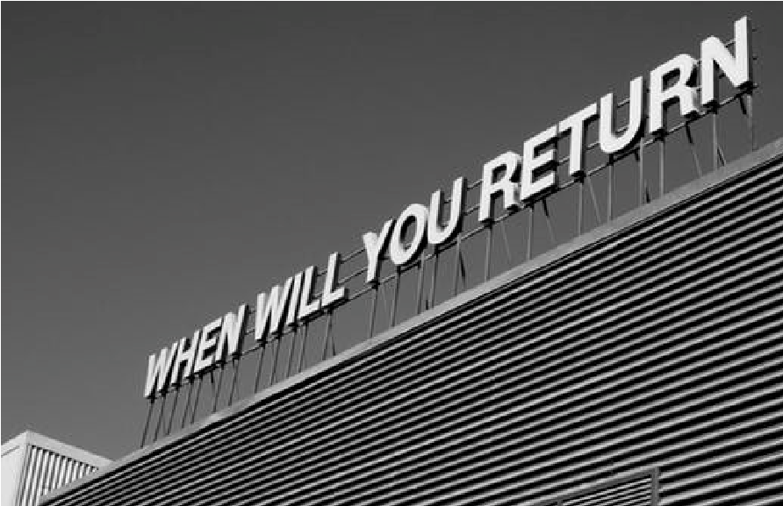
… a resurgence of the game slap

A resurgence – something that returns or starts again after disappearing for a while

e.g. The teachers have seen a resurgence of skipping games in the playground.

Now

write

your

new

s
entences
:

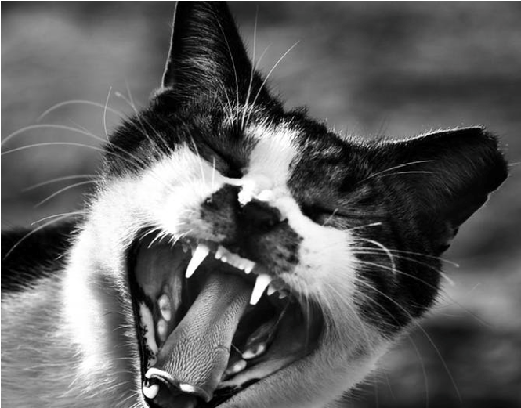
… the ferocity of a wild beast

Ferocity – extremely fierce (fierce =
strong, powerful, violent or frightening)

e.g. We were surprised by the ferocity of the storm.

Now write your new sentences:

Likes, Dislikes, Puzzles & Surprises!

Now you have read the whole story, what did you like & dislike? What puzzled you (what questions do you have – why, what, how …) and
what surprised you?

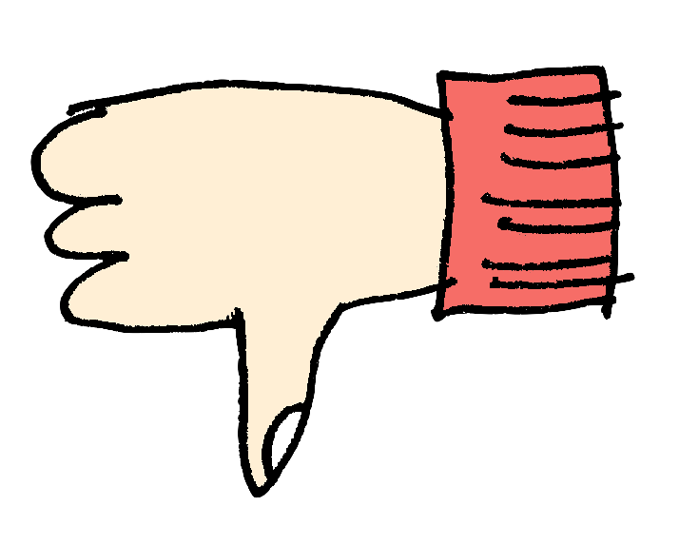

I

liked

…

I

disliked

…

I

would

like

to

know

…

I

was

surprised

…

Let’s Think About the Text a Little More

We’re going to reread the text carefully and answer some comprehension questions about The Game.

- Does The Game remind you of any other stories that you know? List
them

below.

- Danny and Susie had a good choice of things to do at wet play time.
Is that TRUE or FALSE? Circle the answer

- Find and copy a word that is closest in meaning to disappointment.

- Write down two things that children are doing in the classroom.

5.

Is

Mrs

Allbright

the

teacher

in

the

class?

YES

or

NO?

(
Circle

one)

What

are

the

clues

to

suggest

this?

- Why might another lunchtime inside be stressing Mrs Allbright?

- Look at this comment from Danny:

“An animal game? Boring!” said Danny, already losing interest.
Why might Danny think the game would be boring?

- What were the three signs that something bad was going to happen once the game started?

- List the things the spider did once it was out of the game:

- The text says: “Her eyes widened in horror as she realised what was
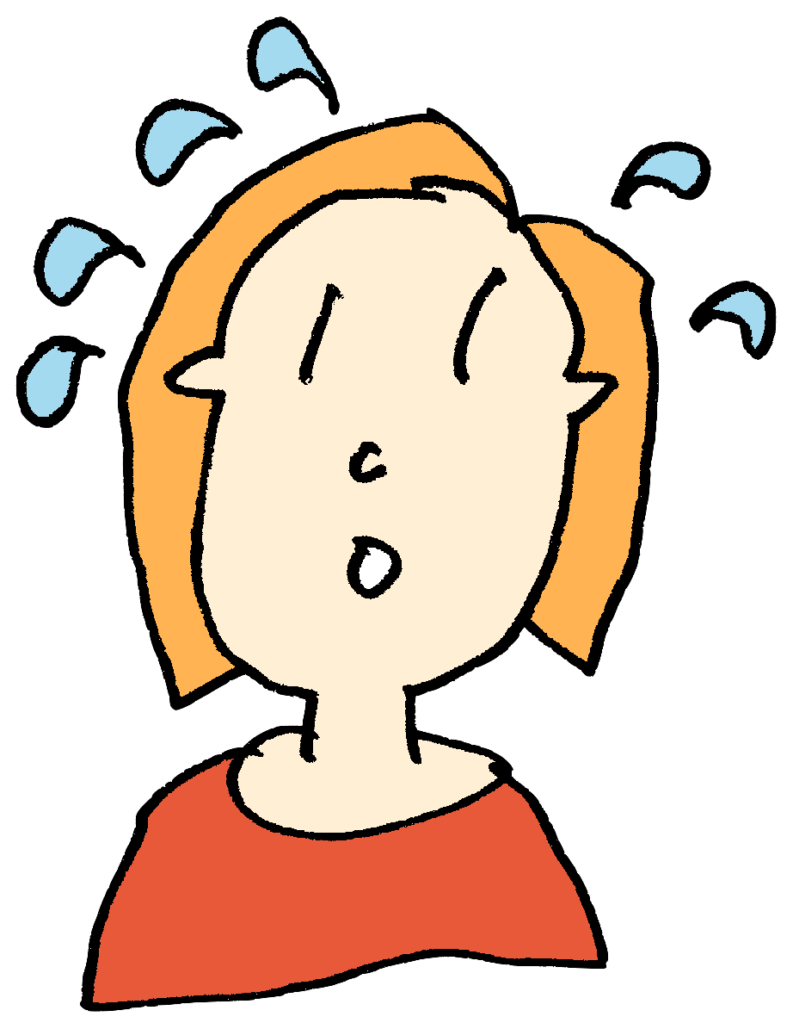
coming

next.
”

What

might

Mrs

Allbright

be

thinking

at

this

point?

11.

Why

did

Susie

put

the

dice

and

counters

into

the

bin?

12. Billy spotted the game on the shelf at the end of the story. What do you predict might happen the next time it’s wet play?

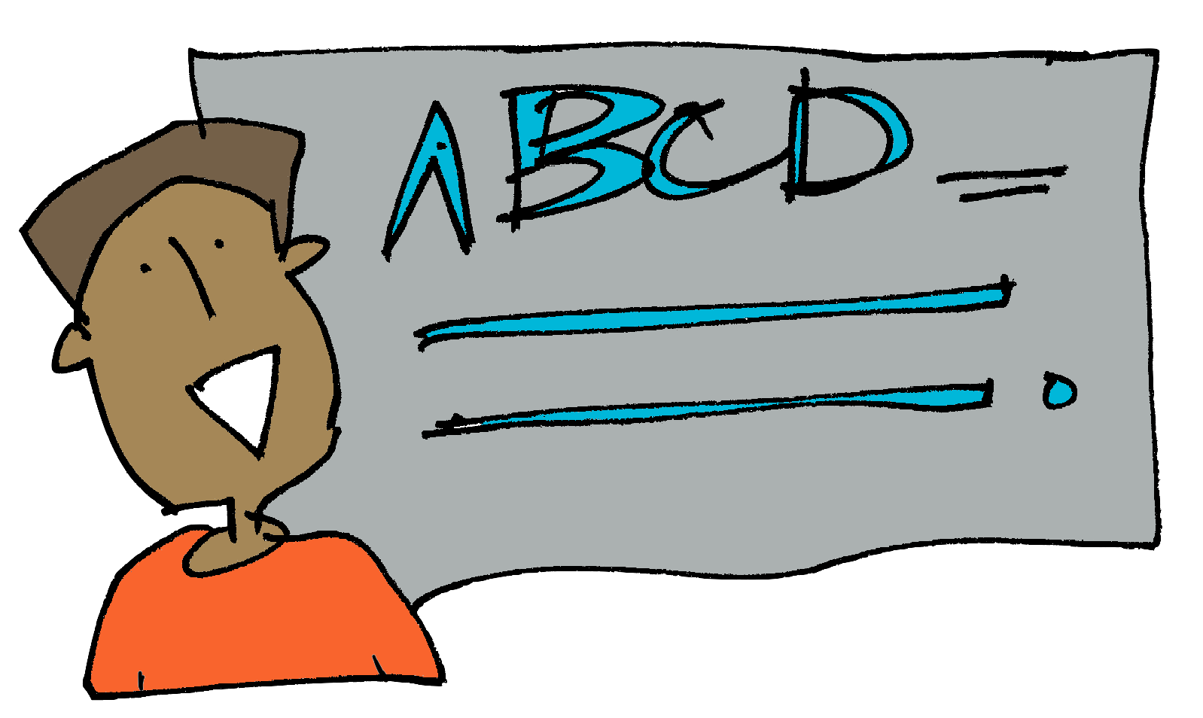
Now for Some Grammar

1. Relative clauses
These clauses give more information about somebody or something in a sentence. They begin with a relative pronoun like which/who/whose/ that.

Let’s add some relative clauses into sentences that could be used in our story.

This is the Drop-In Game:
We’re going to drop a relative clause into sentences using who.
For example:
Mrs Allbright was marking books.
Mrs Allbright, who was tired and cross, was marking books.

Now you drop in a clause into the sentences below, using who:

Danny was looking out of the window.

Susie ran to the door with the box.

Freya watched The Voice on the iPad.

Now have a go at dropping a relative clause into the sentences below using which. For example:

The desks were covered in board games.
The desks, which were bright blue, were covered in board games.

The board game intrigued Susie.

The netball court looked slippery.

The dominoes were in the basket.

Now for some sentence imitation:
Let’s try using some sentence patterns from The Game and create new sentences using the same structure.

- Opening a story with names + a short sentence

Danny and Susie were bored.
____ and ____ were _____.
Try your imitations: e.g. Gaby and Jonathan were excited.

- Sentence of 3 for description

It crushed the tables, smashed the windows and flung children all around the classroom with a flick of its legs.

It___________ , ___________ and ___________.
Try your imitations: e.g. It ran down the road, crossed the bridge and jumped into the boat.

Write Away!

Now let’s concentrate on writing a story. Before we start, let’s do some warming up, so we’re ready
to be creative!

The Adjective Game

Adjectives describe a noun, for example:
The red car drove down the misty lane.

You can change the mood of your writing by choosing your adjectives carefully. Read this description of the Tarantula.

The handsome Tarantula looked at the children. Its glistening, hazel eyes scanned the room. Delicate hairs covered its plump body and swayed like shimmering grass. Its solid legs, like thick branches, stood strong.

The spider sounds quite pleasant. However, if we change the adjectives, you can make it sound much more scary. Give it a try! Fill in the gaps with an adjective that will help to make the spider sound gruesome.

The __________Tarantula looked at the children.

Its _________ , ________ eyes scanned the room.

_________ hairs covered its _________ body and

swayed like __________.

Its ______ legs, like ____________, stood strong.

You could also change the verbs (underlined in bright blue), to make it sound even scarier! Write a new verb underneath the original one.

It’s now your turn to be an author. Let’s look at the problem section of The Game. We’re going to re-write it with new ideas. The problem:

At that moment, the table began to shake, then the windows rattled and the floor vibrated. Everyone stopped what they were doing and the room fell silent.

“EARTHQUAKE!” shouted Billy, bursting into laughter. He soon stopped, as in a blink of an eye, an enormous spider, bigger than a horse, shot out of the game and landed in the centre of the crowded classroom. Everyone froze. Its enormous, hairy legs were tensed, ready to pounce and its whole body seemed to pulse. Eight bulging eyes scanned the room and then…

It sprung into action. It crushed the tables, smashed the windows and flung children all around the classroom with a flick of its legs. It powered towards Mrs Allbright as she stood rooted to the floor in terror. The room was filled with shrieks of panic and despair.
“What shall we do?” shouted Danny desperately, pressing himself tightly against the wall.
“Read the instructions,” ordered Sally, “We have to stop it!”

What other problems could the game cause? What else could come out of the game and what would it do?

Keep the classroom setting the same for now and plan a new idea below. You can make notes or draw what will come out of the game and what it will do once it’s released.

Instead of: | Your ideas:
… crushing the tables
… smashing the windows
… flinging children round the room
… grabbing the teacher
… extra ideas

Using the ideas & sentences from the problem section of The Game, on a separate piece of paper, try out your new plans.

Follow this pattern:

Start with the first strange events as a sentence of three and then show how the children react:

At that moment, the table began to shake, the windows rattled and the floor vibrated. Everyone stopped what they were doing and the room fell silent.

At that moment, …

Next, introduce the new threat. Tell us where it came from and what it looked like:

In a blink of an eye, an enormous spider, as big as a horse, shot out of the game and landed in the centre of the crowded classroom. Everyone froze. Its enormous, hairy legs were tensed, ready to pounce and its whole body seemed to pulse. Eight bulging eyes scanned the room and then …

In the blink of an eye, …

Where else could this happen? Try a new setting for The Game. Change the classroom setting to somewhere else. Where could this happen? Plan a new idea below. You can
make notes or draw. What will come out of the game in the new setting and what will it do once it’s released?

Instead of: | Your ideas:
… what comes out of the game?

… what will it do?

… extra ideas

Now write your new problem, set somewhere else: start with the first strange event, then introduce the new threat and finally describe what the threat does. Do this on a separate piece of paper.
Get Plotting Again!

Now let’s write a brand new finding tale. It doesn't have to be set in school or involve a game. I have put a few of my ideas below to help your thinking. You could even write the prequel of the story about what happens when Billy investigates the game the next time it’s wet play!

Think about: | Your ideas
Where could the story take place?
e.g. a field, a football match, a restaurant, at home – where else?

What could the object be?

e.g. a book, shoes, wand, a phone, a bucket, a pen - what else?

What happens when the object is found?

e.g. events in the book come to life, shoes turn you into different people, wands cast disastrous spells, phones turn people into robots – what else?

Now add your ideas to the boxed-up planner, based on The Game, so you can plan your whole story:

Introduce the main characters (MCs)and where they are
MCs find something they have not seen before
The object that has been found causes strange
things to happen
MCs work out how to stop the strange things
Everything is back to
normal

Are you ready? Then

- write it,  read it
- and check it!
- See you at the end!

Well

done!

Now

that

you

have

a

new

story,

why

not

publish

it?

Below

are

some

simple

instructions

for

making

a

mini

book

from

a

piece

of

A4

paper.

If you have access to the Internet, type this into Google:
https://cutt.ly/QtvAkwq

Here, you can watch a mini-book being made and follow the instructions.

Or try this:
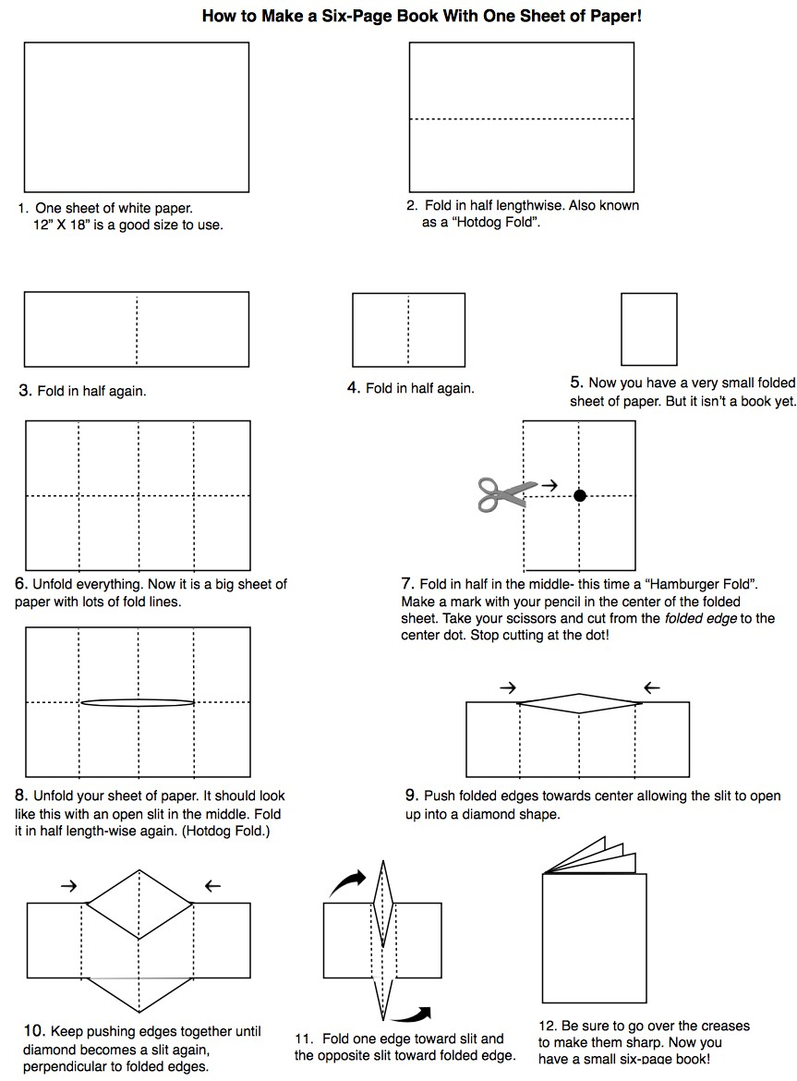
© 2012 Book-making Activity for Tell Me About Your Day Today created by Lauren Stringer, www.laurenstringer.com

Make your book and illustrate it – enjoy!
We’ve reached the end of our journey. I hope you’ve had fun!

I

really

enjoyed

…

I would rate my journey through this booklet (tick hot or cold):

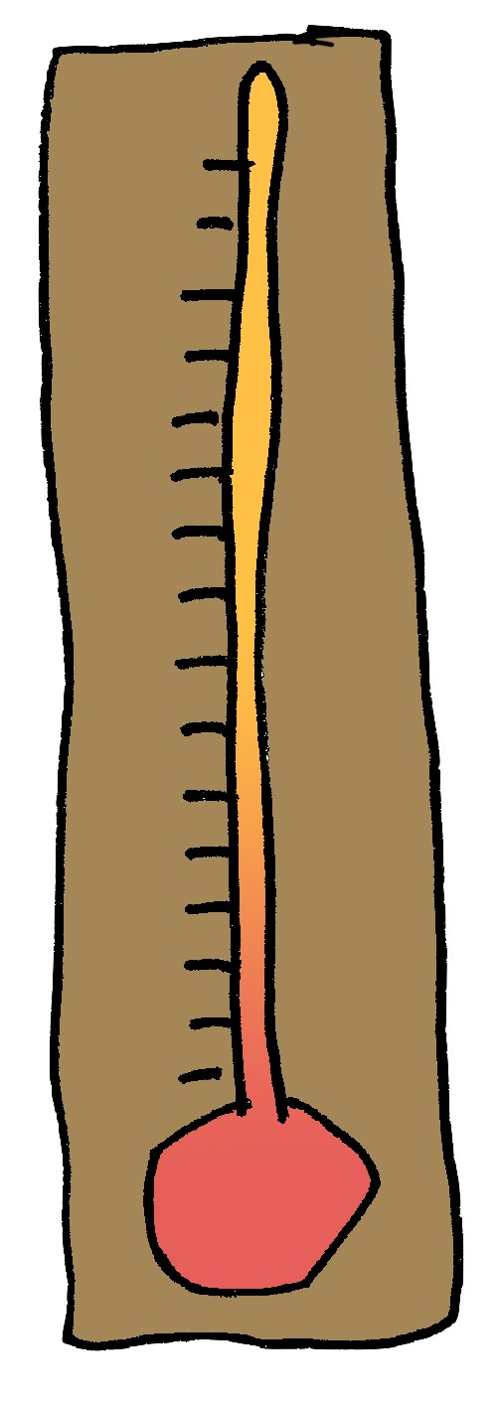
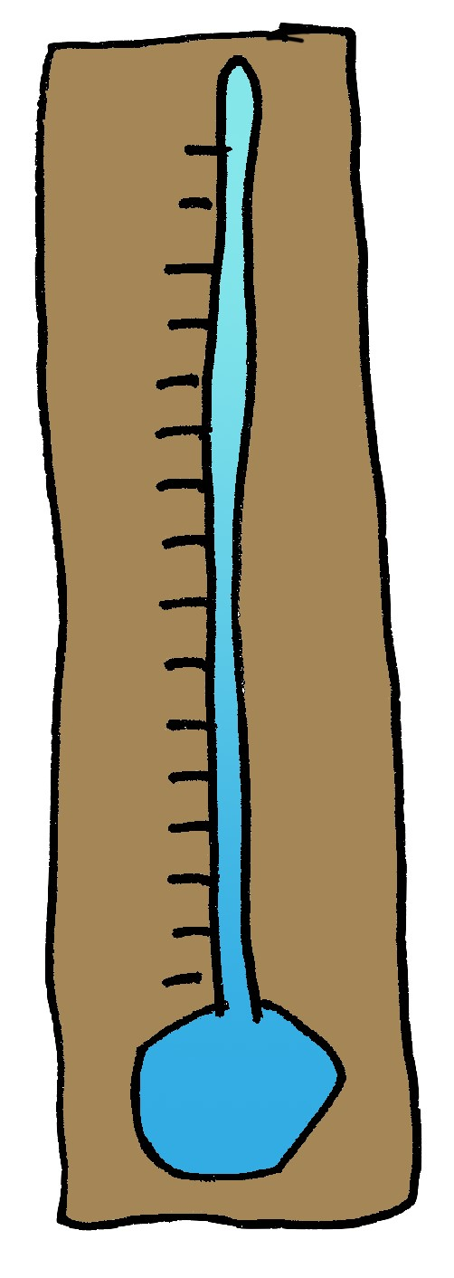

This

workbook

has

helped

me

learn

…

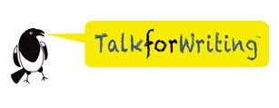
© Maria Richards for Talk for Writing

Maria Richards, former teacher and National Strategy Literacy Consultant, now works with Talk for Writing to help schools develop the approach.

To find out more about Talk for Writing, visit www.talk4writing.com.

This resource is copyright. All materials herein, texts and supporting resources are copyright to Maria Richards & Talk for Writing. They are to be used to support children/staff/parents in home-learning ONLY and not for commercial gain or for training or sharing widely, in their original form or any variations. They must also not be shared online or on any social media platforms.

Thanks to Jon Ralphs, Lauren Stringer, graphics authors Dinosoft Labs on Flaticon.com and photographers Markus Spiske, Frans Van Heerden and PC from Pexels.com, for sharing their content.

