English:
This week is all about sport.
- Could you watch the short video from litfilmfest – go to this film
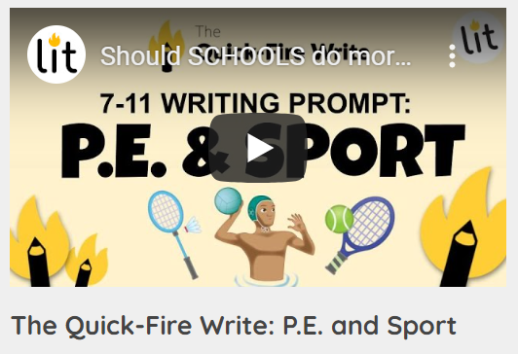

- Watch the film and answer the four questions. Could you include modal verbs in your writing?

- I would like you to write a formal letter to Gavin Williamson (no need to actually send!) – secretary of state for Education with your proposals for PE in schools –
- Do you want more PE time?
- What would the lessons look like; what sports should be covered?
- Do you believe PE should be scrapped in order to have more time for Maths for example?
- Should the government fund after school activities/clubs for children and why?
- remember the style of language we used when writing formally in class.
- Remember to set your letter out accurately. Watch the BBC bitesize video link below to support you
https://www.bbc.co.uk/bitesize/topics/zv7fqp3/articles/zkq8hbk

PUNCTUATION:
I have included an exercise on the use of commas in this week’s folder for you to complete.
SPELLINGS:
These have been set on Purple mash or spelling frame if you are using this. PLEASE don’t give up on your spelling practise, you have all worked so hard on this and I really would not want you to fall behind. Do a little every day and make it fun!
READING:
Please make time to read every day, even if it is just for 10 minutes. It’s important to increase your reading stamina, being able to read longer pieces and talk about what you have read.

