Wonderful Year 5’s,

How are you all? I’ve had a new picture of Hope sent to me; look how big she’s getting!

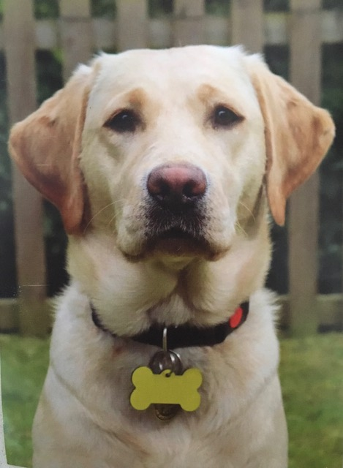

I have had a chat with a few of this week, as have Miss Clarke and Miss Gilbert which has been lovely. Some of you seem to be struggling a little, as home schooling is continuing. That’s understandable and you shouldn’t feel too bad about that. You have come this far and been truly awesome and the Summer holidays are in sight……keep going!

I am open to your ideas and suggestions…..if you have any creative ideas for lessons, please let me know!

Keep me up to date with events. I love hearing from you, not just academic news but the other activities you’ve been doing.

Stay well everyone and try to keep in touch with your friends!

Love

Mrs B, Miss Clarke and Miss Gilbert. xx