Colour all the pictures that have the ‘ue’ grapheme in
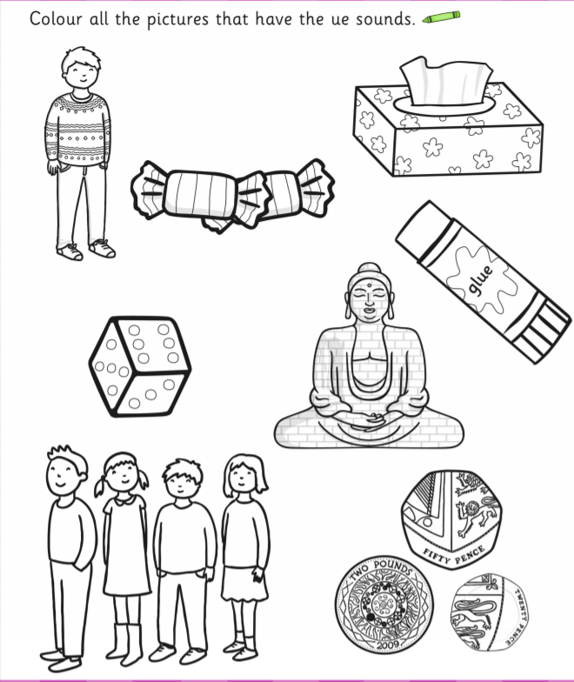

Answers: tissue; glue; queue; statue;

Draw a picture that has the ‘ue’ grapheme in it

Write a sentence about your picture below:

