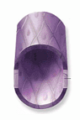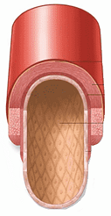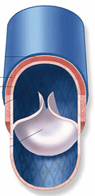

**Capillary**

**Vein**

**Artery**

Transfer oxygen from the blood to muscles and organs.

Blood is under low pressure here so relies on muscle movement and a series of valves to move it along.

Has thin walls only one cell thick. This is so that the oxygen can be easily exchanged through the walls.

Had thick walls to help it withstand the pressure the blood is pumped at.

Carries the blood back to the heart.

Carries blood from the heart.