The heart
The heart is a muscle in your chest made up of four chambers.
- The right atrium
- The left atrium
- The right ventricle
- The left ventricle
The heart is located just off the centre on the left side of the chest. It is protected by your ribs and pumps blood around the body.
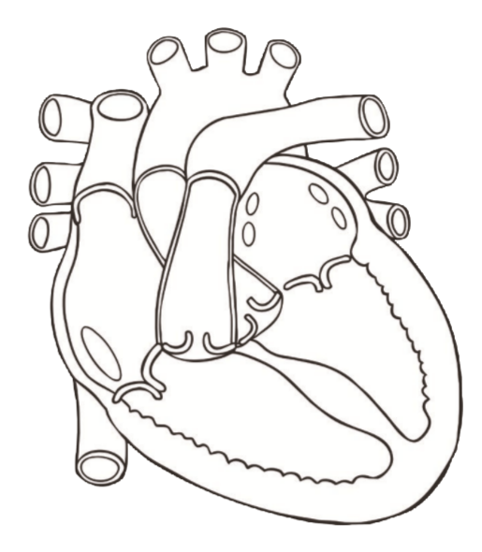

left atrium

left ventricle
right atrium

right ventricle

The heart pumps blood to the lungs where it picks up oxygen before traveling back to your heart. The heart then pushes the blood around the body using its thick muscle walls. These muscles contract to push the blood out to the body. Arteries take blood away from the heart to every part of the body so your muscles and organs can use the food and oxygen they need to work. Veins carry blood back to your heart when all the oxygen has used so blood can be pumped back to your lungs again to pick up more oxygen.
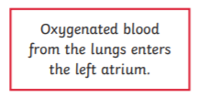
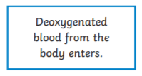

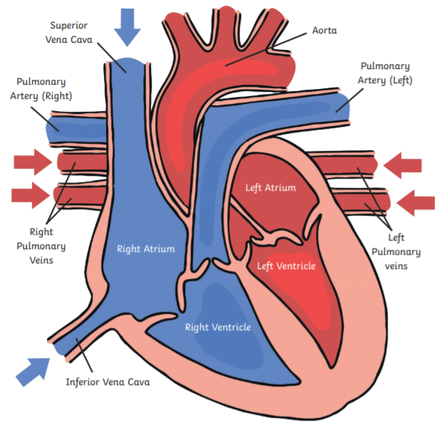

Useful links and videos
https://www.bbc.co.uk/bitesize/clips/zncg9j6
https://www.youtube.com/watch?v=huzs3Q4-CGc
https://www.youtube.com/watch?v=tg_ObDJEaGo
https://www.youtube.com/watch?v=f9ONXd_-anM

